Library Advisory Committee Meeting
October 23, 2008

Staff Present: Rudy Bratcher, Susan Burgoon, Sherri Clowe, Jana Comerford, Dr. Nichol Dolby, Becky Easton, Ann Hamblin, Mark Hanna, Kaki Hoover, Priscilla Hunt, Bobby Hyndman, Karen McIntosh, Margeanne Moore, Frank Sobey, and Margie Waguespack

College Librarian Mark Hanna opened the meeting at 3:00 p.m. welcoming many new members after introductions were made.

Mark demonstrated, with the following charts, why the Library makes certain decisions and/or suggestions for future use.

- Two important areas to note from the survey conducted (which produced data for the charts in this report) are Library Instruction and Electronic databases. Note that the NetLibrary Ebook database has over 40,000 ebooks available for faculty and students.
- Ebooks are increasing in availability including free sources such as the Universal Digital Library which contains a variety of literature.
- AC will be adding several literary criticism databases in the near future.

Circulation Usage Chart
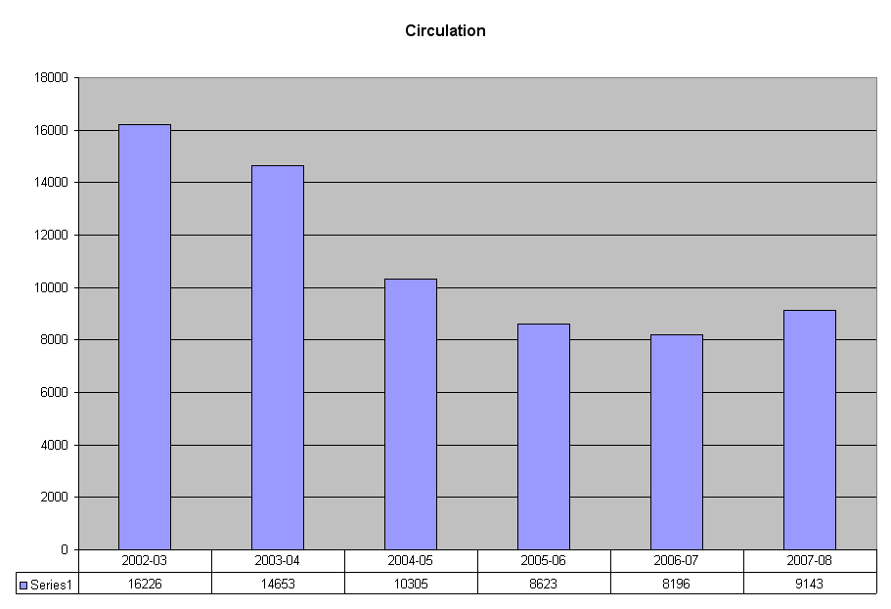

- The Library gave away “storage” books a few years ago. “Storage” books were defined as those not circulated in the last 15 years.
- The Library does purchase new materials (books) which increased last year due to an unusual circumstance. The West Campus programs needed new materials for their accredited programs and promised to ensure that students were strongly encouraged to use the new books.
- Print materials are not in danger of being discontinued completely.

Reserve Materials Chart
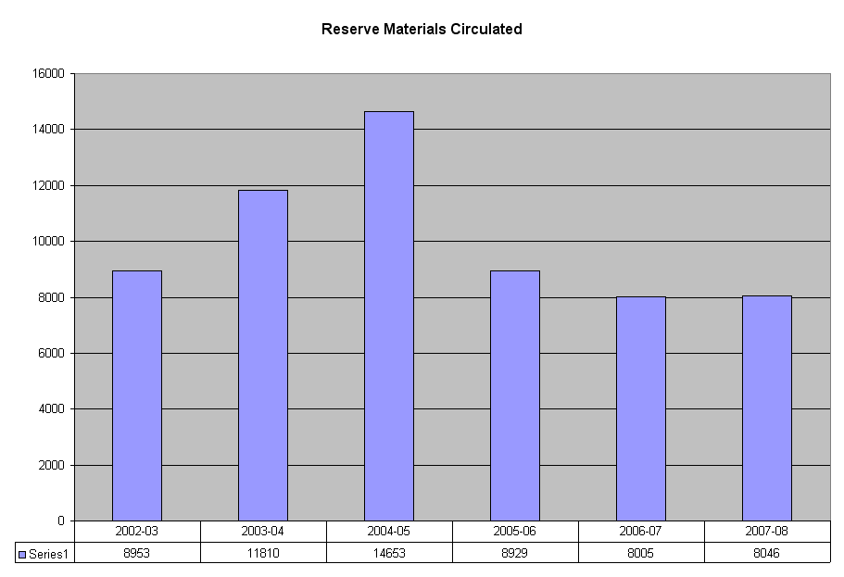
- This chart refers to materials placed on reserve by instructors for use by students.
- Historically, AC has had a large reserve material cache.
- Though the chart shows this collection has increased/decreased at times, the overall trend is down.
- Many libraries are switching to electronic reserve collections. However, concerns abound including whether the material is copyrighted or not, how to secure and/or restrict access, etc.
- The staff has researched several different ways to digitize these documents and secure them but a solution is still pending.
- Issues that continue to need to be addressed include: 1) interest by faculty who use reserve and 2) staff availability and time to accomplish the goal.

LLLC Reference Questions
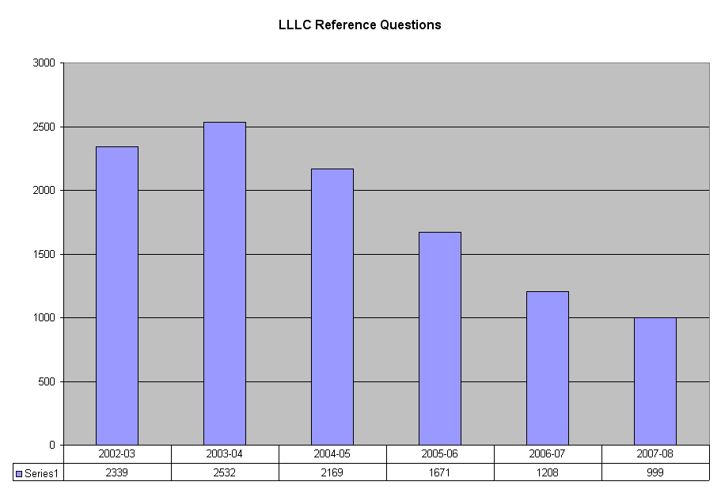

- These are questions or assistance of substance that require intervention by a trained Librarian.
- Trend is down. One reason is the excellent work that the AC Library staff has accomplished by placing help and tutorial guides on the website including a ready reference (like a FAQ).
- Additionally, library staff has provided outstanding training to faculty who then act as “trainers” to their students.
- This “train the trainers” role is widely accepted as a “best practice” by SACS allowing the Library to meet an accreditation goal.

Library Instruction/Event
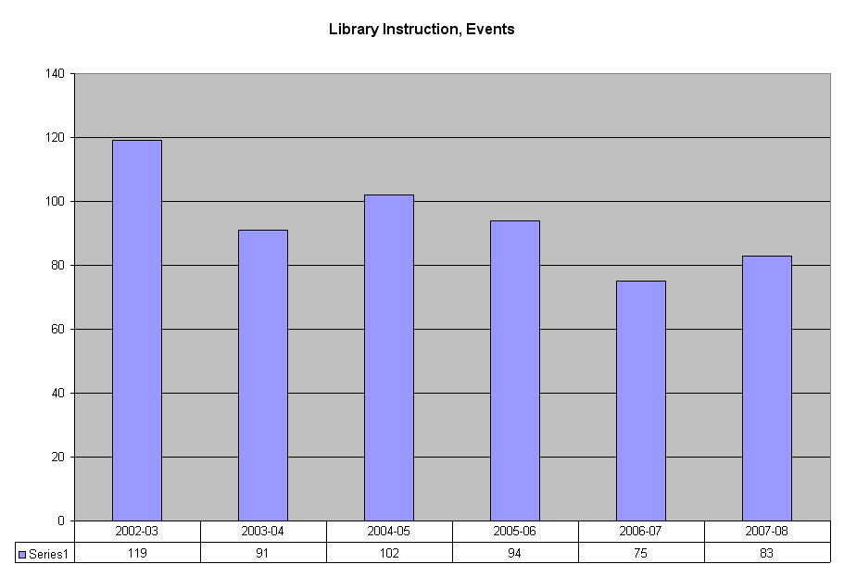

- Has been steady with new and repeat customers including new and part-time faculty.
- The Library does provide outcomes assessment to measure the success as part of PET goals.
- These classes are taught as a segment of the student success course quite often but have been a part of the AC Boot Camp only once.
- The Library continuously struggles to fight that impression with students that it is either the Library (and books) or Google.

Library Instruction Attendance
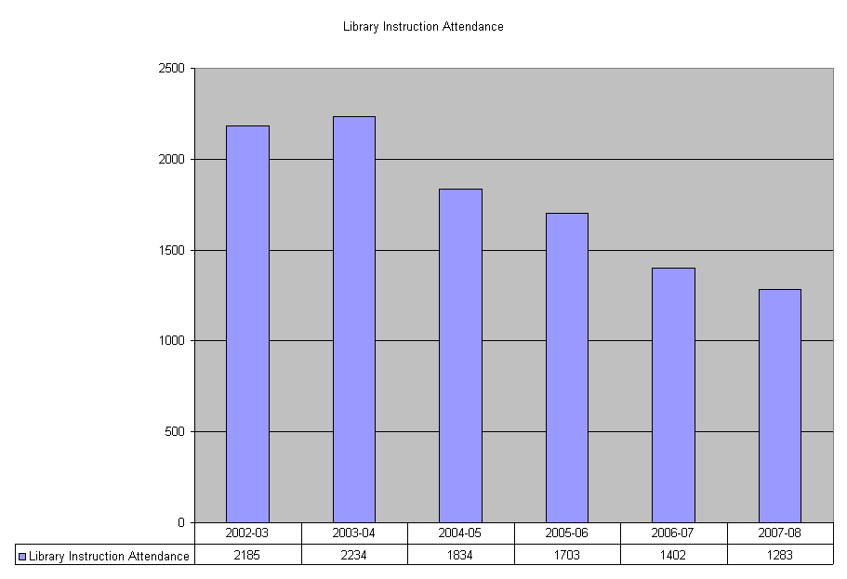

- This chart displays attendance in Library Instruction classes.
- When compared to the overall headcount of AC’s average of 10,000 students, the Library only interacts with a small fraction of students and that number is decreasing.
- How should we interpret this data? SACS states that the ideal situation is for the Library has an impact every single student.
- One difficulty with this mandate is demonstrating that students are using the Library (such as the online databases) and no tracking is currently available with precise data.
- The Library has, in the past, tracked the basic number of hits on the databases and AC Library online guide until last summer. A move by AC to the CMS system deleted that ability. Although the Library has requested that this problem be resolved, no action has been taken by IT.
- Faculty can assist by assigning work that requires at least one online database source supported by a citation of its location.

Computer Usage
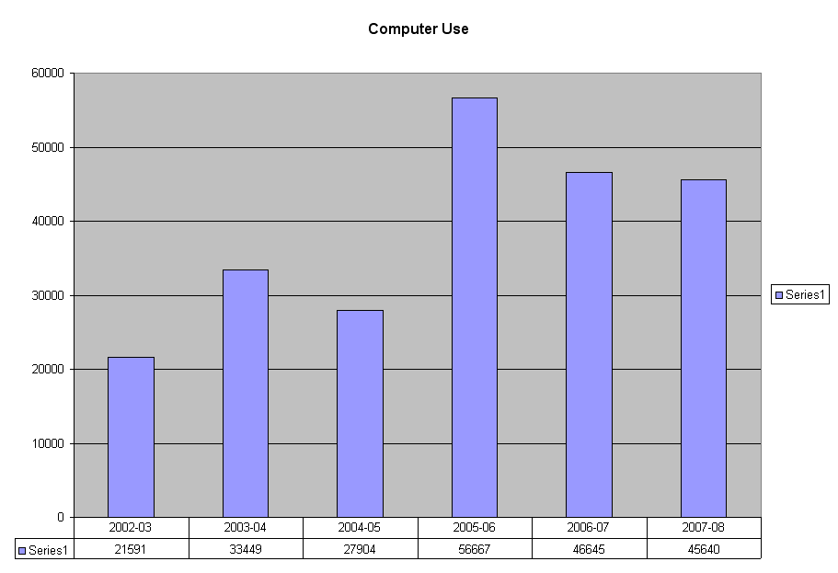

- This chart demonstrates computer usage on the 2nd floor Learning Commons.
- The major rise in usage came when Casey McGee’s lab (3rd floor) was incorporated into the Library’s Learning Commons.
- There is an expectation that usage will drop as wireless connections become more readily available across campus. Wireless in the Library (all floors) is expected soon.
- The goal is to counteract the trend by creating an inviting environment where students will desire to continue meeting.
- The Learning Commons has become the “guinea pig” for other labs across the AC campus by experimenting with new and/or different setups for hardware and software. For example, rather than having individual applications loaded on 30 different computers (which would require continuous updates), the applications are kept on one server and loaded individually to each computer as needed. This type of system is easier to maintain.

Library Main Page Hits

- This chart compares a 2-month period in 2007 and 2008.
- The largest usage is in the Electronic Databases – Find Articles.

ILL

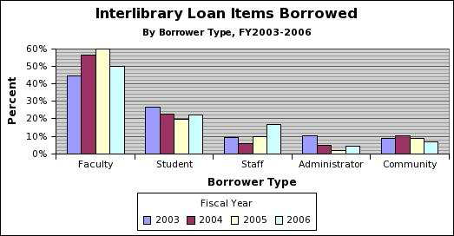
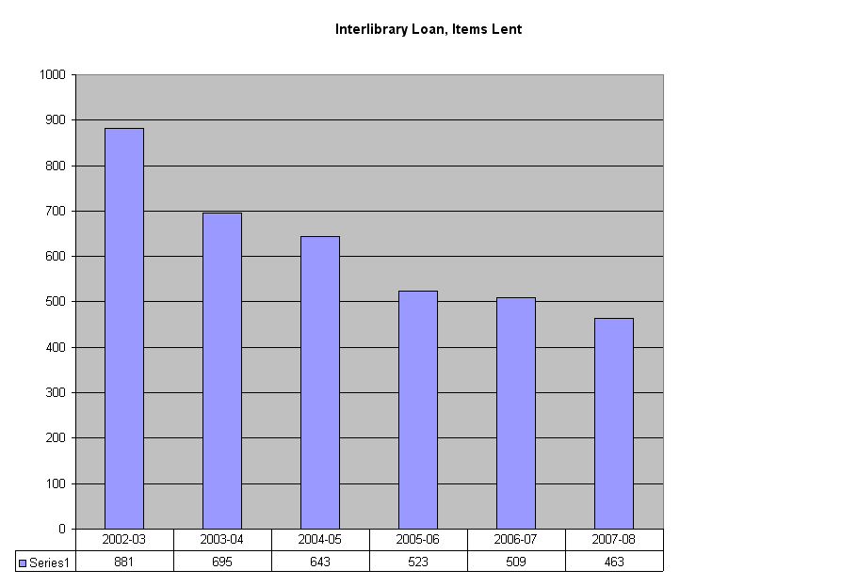
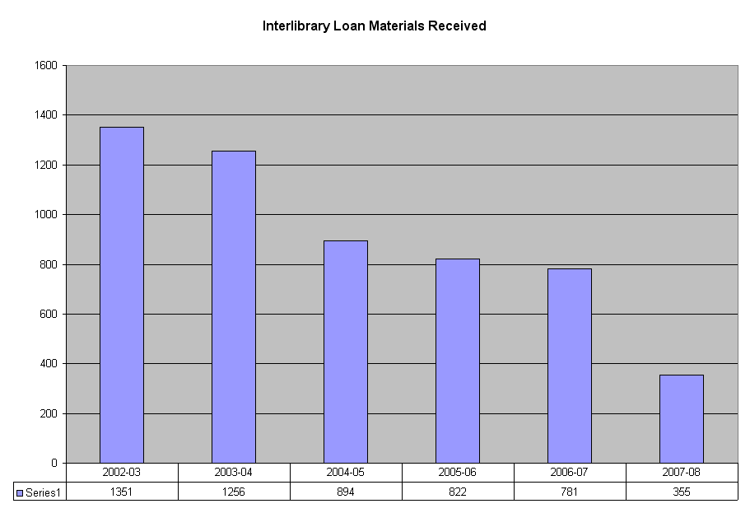

- Interlibrary Loan (ILL) is defined as lending between libraries.
- Trend is downward as fewer faculty members use the resource to further their research and/or obtain higher education degrees.
- As AC’s collection gradually becomes older and smaller with fewer new materials, the college loans out fewer items to other libraries.
- Furthermore, loans received from other participating libraries are declining considerably.
- The staff has been exploring options for how to manage, operate, and use ILL more economically.
- The cost of ILL’s courier service and software has increased from approximately $2300 to $4400 per year and is expected to continue to rise to as much as $7000 in the next year.
- This is a huge expense compared to the usage numbers.
- The state library is also exploring discontinuing this service.
- Additionally, at present, the majority of ILL requests are by staff pleasure reading, not faculty/staff teaching and/or research materials.
- One suggestion under consideration is to make ILL available through the Amarillo Public Libraries, rather than AC. ILL for articles and assistance on researching would still be provided by AC.
- Additionally, the library staff argues that AC students should not have to make use of ILL as the AC Library should be able to provide for the academic needs of its students.
- ILL policy is expected to change in the next year or two as the Library attempts to use its minimal resources (funds and staff) more efficiently and effectively.
- Mark and Karen are requesting advice and/or suggestions from the Advisory Board members and others on how best to approach this issue.
- Several board members stated that using the public library to obtain books would not be an inconvenient solution. Clarification was given to assure faculty that the public libraries can access academic library sources as well as WorldCat.

Other issues addressed in the meeting included:

- AC has received a science grant of $3.2M and the Library will be participating by setting up a computer lab for science programs in L207.
- This does not preclude L207 from other uses.
- The grant will provide state of the art technology and equipment in a location that has longer open hours than other locations across campus.
- No timeline has been given on this program.

In closing, Mark made the comment that he desires for the Library to serve as a center of activity for the campus – not just a warehouse of books. The meeting was adjourned at 4:15 p.m.

**PowerPoint presentation with charts is available is requested (allowing larger versions of the charts to be viewed).

