**Library Advisory Committee Meeting**

**October 15, 2010**

College Librarian Mark Hanna called the meeting to order at 9:00 a.m. and asked everyone to introduce themselves.

Kaki opened the meeting with a discussion about the Librarian position at West Campus.

* The West Campus has grown over the past few years but with the upcoming retirement of Librarian Lil Withrow, the Library would like the input of the Library Advisory Committee members on filling the position.
* The following possible position requirements were passed out for consideration and discussion:

*DRAFT version, oct 15, 2010*

Position Available: Instructor This is a full-time, 12-month position.

Department: Library

Deadline for accepting applications: open

Position Available: January 2011

Submit applications to: Human Resources

Responsibilities: Manage college library services in a branch campus location, co-located in a public library.

Conduct on-going needs analysis related to information literacy instruction, library services, and information sources. Collaborate with faculty to design and implement customized instruction designed to enhance student information literacy competencies. Deliver instruction in the classroom, online or individually. Provide research assistance and consultation to college students, faculty, administrators and staff. Identify and evaluate information sources to support the curriculum. Actively contribute to library strategic planning and assessment of student learning outcomes. Proactively market library services via outreach to the college community. Participate in library projects, college faculty committees and other college activities. Support program and college-wide accreditation requirements.

Position reports to the Associate College Librarian for Research and Instruction.

EDUCATION: Masters degree in Library Science or Information Science from an ALA-accredited institution

EXPERIENCE AND TRAINING:????

Knowledge, skills and abilities: Demonstrated ability to develop instructional content and deliver training using a variety of methods. Proven commitment to life-long learning. Understanding of trends in the profession and Association of College and Research Libraries Information Literacy Standards for Higher Education. Flexibility and willingness to adapt to change. Strong service orientation and excellent communication skills. Knowledge of learning styles and trends in higher education. Experience with library automation and online research databases. Experience with instructional technology and learning management systems preferred.

Some weekend and evening work is required. Supervision of student workers is possible. Some travel to other campuses may be involved. Must be able to move materials weighing up to 30 pounds and be able to bend and stretch to hookup equipment.

SALARY: Based on Faculty Salary Schedule. Excellent benefits.

* Kaki presented the following PowerPoint presentation highlighting the importance the West Campus Library plays in providing services to Amarillo College students as well as the challenges it faces.

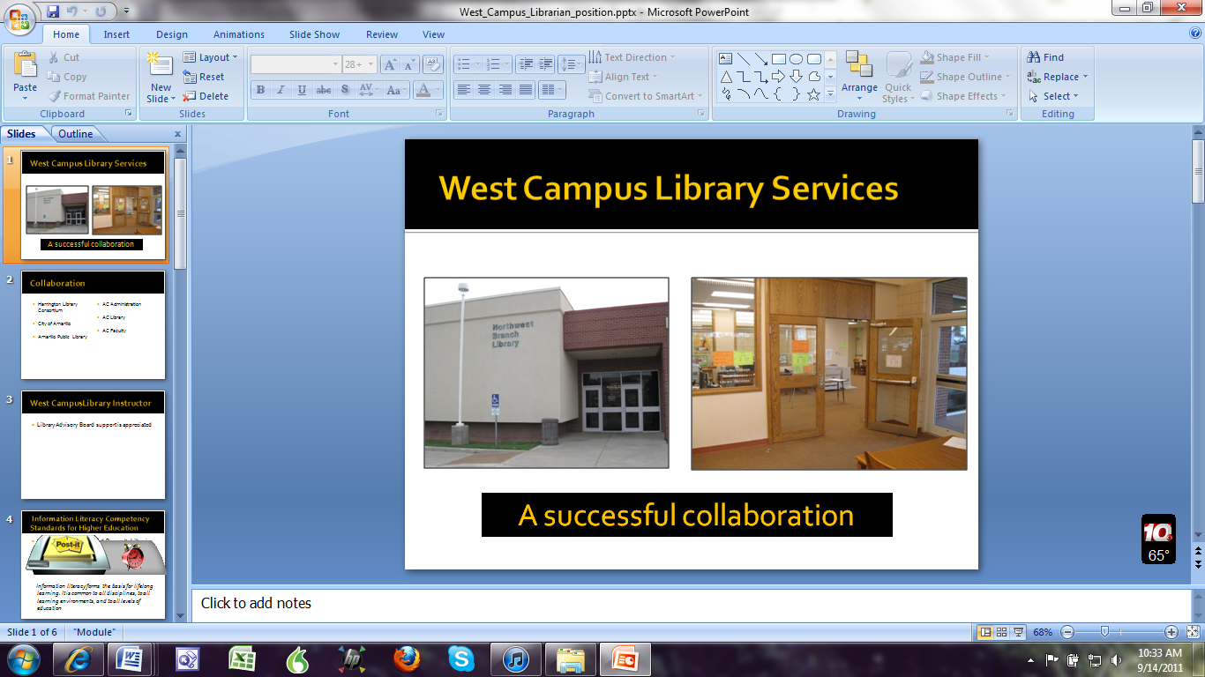

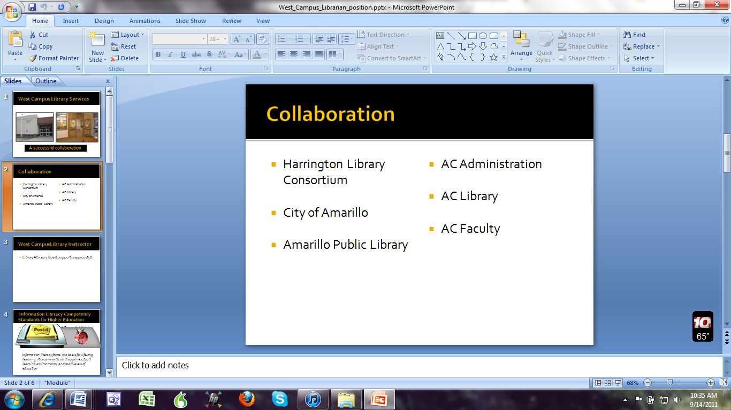

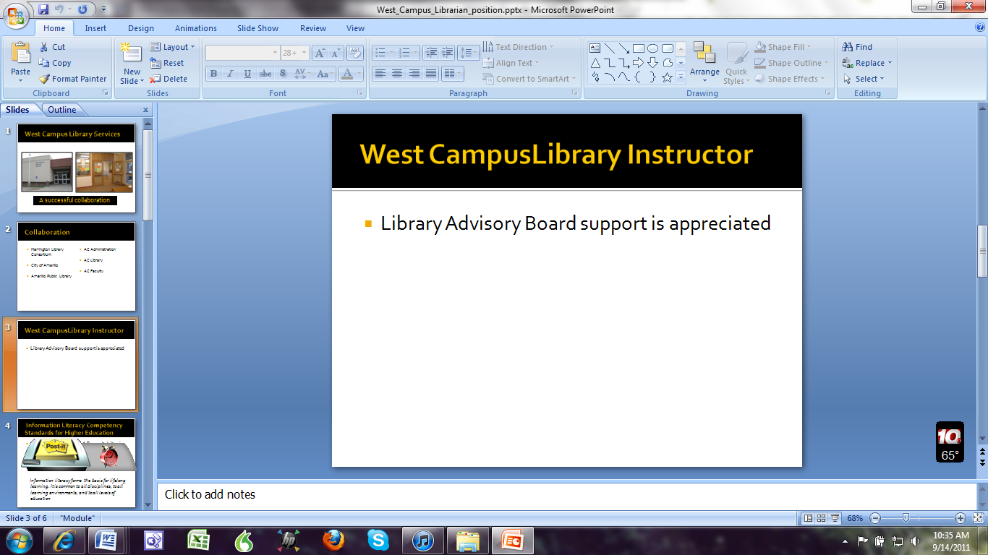

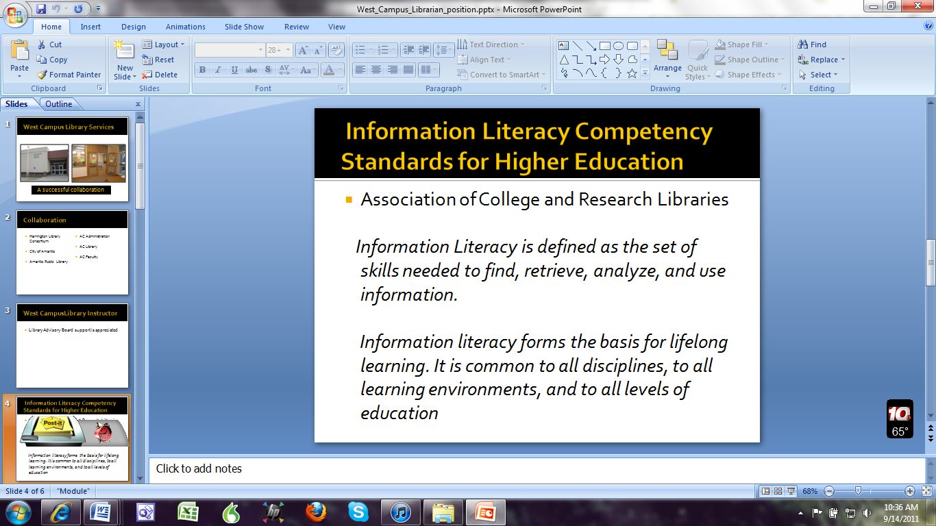

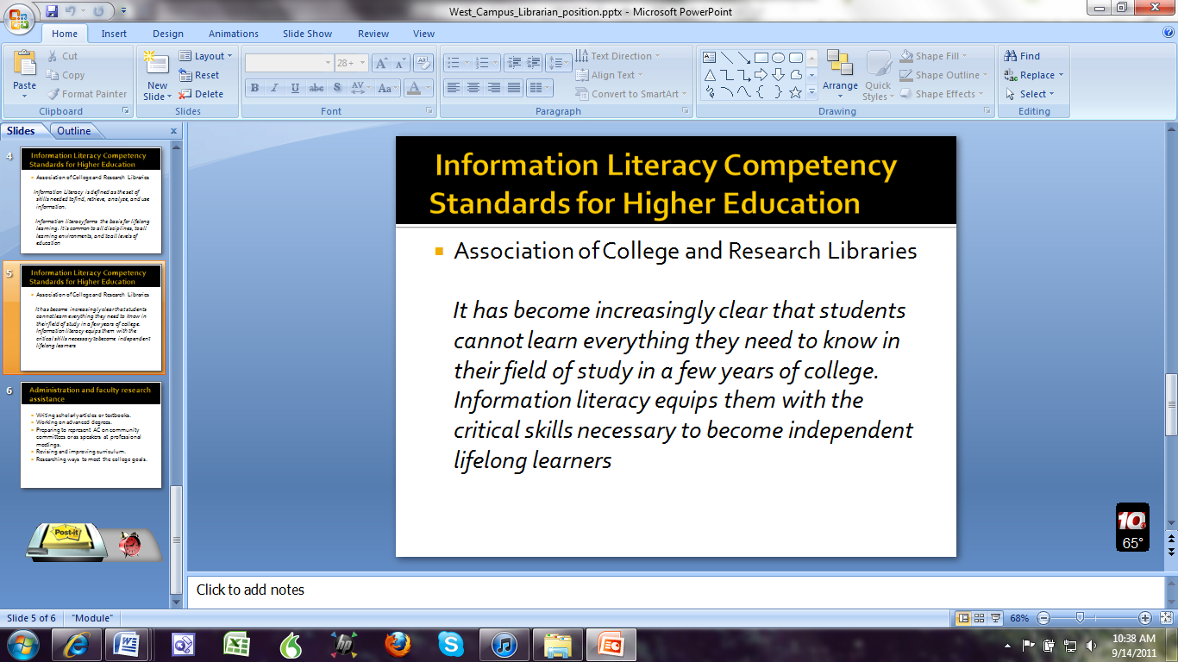

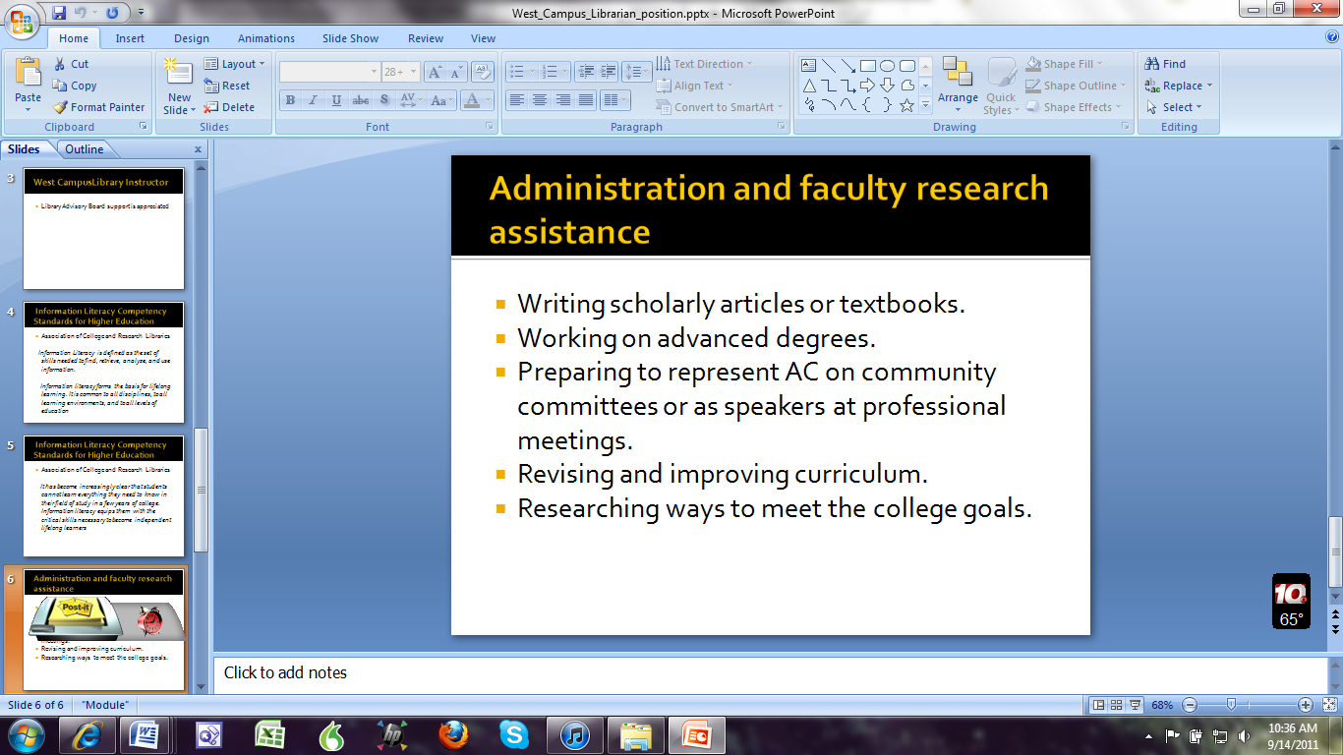

* It was highlighted strongly that the standards set by the Association of College and Research Libraries (ACRL) are extremely important.
* These ACRL standards are skills both faculty and students need to be lifelong learners.
* However, in reality, the librarians and faculty cannot teach the students everything they need to know within the couple of years of college but if they learn the skills of researching, then they can continue learning and be lifelong learners – that is our goal as librarians.
* A question asked by a committee member, is there any reason why the College would not fill the West Campus Position? The answer was budget concerns and/or finding a qualified person to fill the position. Therefore, the College might try to fill the position with two 19-hour part-time non-qualified personnel to just have warm bodies in the Library.
* It was pointed out that the AC/West Campus Library mission is very different from the public library of the West Campus Library (they are housed together on the West Campus).
* The Public Library agreement is very clear that is will not assist an Amarillo College student any more than they would assist any other citizen who would enter the library.
* In contrast, our Librarians seek to know a faculty member’s assignment and specific class in order to aid students in seeking out scholarly materials for their assignments whereas the public librarians would not be able to provide this service.
* In addition, our Librarians are key to providing departments with materials and the Library sources that obtain and keep Amarillo College’s SACS accreditation.
* A query was made whether the position could be filled with someone who has their Bachelors and working on an MLA for financial savings but this was not an optimum situation as the Library needs to have the best qualified person in this position as they will be working independently at West Campus and with some of the most highly visible programs for AC such as the nursing programs that use the library databases.
* The discussion came to a close and the vote was taken. It was unanimous in favor of hiring a full-time person who meets the qualification as generally outlined in the draft position handout above.

Jana Comerford took the floor to demonstrate some of the tutorials on the recently updated Library Webpage including those that are linked to particular assignments, critical thinking exercises, etc.

* Jana showed the Common Reader page where a tremendous amount of material has been added and encouraged the faculty not only to explore it themselves but to share the new information with their fellow faculty members in their departments.
* Demonstrated the “Get Help” section with the various tutorials such as how to evaluate a web page, subject guides, etc. Faculty can customize it for their students by requesting to add links and also adding a presence of the Library in their AC Online courses.
* “New to Research” and “Time Saving Skills” are examples of tutorials – these have sounds and photos and cover such areas like avoiding plagiarism.
* Jana encouraged the faculty to explore the website to see all the newest updates and tutorials on their own and see all the services and time saving handouts the Library provides for faculty as well as students.

Mark spoke with the Advisory Committee on the new Title V grant that was awarded to Amarillo College. The grant begins October 1, 2010 and Amarillo College will be hiring a project director for this grant.

* Title V is a federally funded grant effort to support schools with a sizeable number of Hispanic students (the cut-off is 25%) and Amarillo College has 29%.
* This does not mean that the grant is only for Hispanic students but will benefit all students.
* Emphasis is on the Center for Teaching and Learning (CTL). What does that have to do with the Library? Right now, the CTL is housed on the 1st and 3rd floors of the Library.
* On the 2nd floor is where, at present, AC is creating an audio/video production center for faculty
* The Title V grant is $250,000 per year for 5 years for a total of $3.5 Million.
* CEO for the College, Dr. Matney has some discretion on how the Title V funds are spent but the importance will be on the CTL in training, equipment, etc.
* It will also allow for some construction. Mark believes what Dr. Matney plans here is to create a better working space for CTL and the priority for space in the Library will be for CTL.
* Therefore, although the original planning was for CTL to be underneath the Business Building where the pillars were on the first floor, that idea was axed. Another idea was to take the first floor of the Library. This idea was opposed by the Student Government and Student Services since the Library had pushed to make the first floor an area for students to gather for student centered activities. This idea still has support from Student Services and others. The consultant architects who visited the Library also supported this idea.
* When the bond issue was passed and the Library was one area included as bond eligible but in the planning, the Library was delegated to the 5th year. In other words, we were the last priority. With cost overruns, etc., the likelihood of the Library receiving any funds for major renovating of the floors from the bond issue is very slight.
* Now with the Title V grant, every possibility is hopefully back on the negotiating table again. Planning is going on again and when a Project Manager is hired, Mark will be approaching the person and Dr. Matney with our requests. Mark wanted the committee to be aware of the ever changing situation.
* A question was asked about the Title V Grant. Will there be an opportunity for input from faculty? Mark’s response was, I hope so and he will push faculty input. The departments, Faculty Senate, etc. will also push for that as well. This grant is supposed is to be for faculty as well as for the CTL.
* Mark commented that the grant started in October 1, 2010 but construction will probably not begin for another year. Mark is looking for Dr. Matney to request new ideas for the Library and CTL rather than using the ones put forth from 2-3 years ago. Mark brought this information to the committee so they could be aware of the grant and its impact on the Library and faculty.
* The Title V grant is specifically targeted for students but also for faculty. One idea once considered for the First Floor was for all offices to disappear. The floor would get new carpeting, a more modern design, relaxation areas, a fireplace, etc. a quiet study area, a group study areas, technology available at the fingertips for group projects, a computer bar area with to hook-up with wire/wireless, and even a coffee bar. But where /should the CTL be?
* A member commented that they would like the first floor to be a friendly space but also a place for periodicals again. If students see others reading or the material are available, they might be more likely to read themselves.
* Mark requests that if any member hears any news on the Grant, please bring it to the attention of the Library staff, Mark, and the Library Advisory Committee.

Mark reminded committee members that if they have any needs from the Library and its staff for their classes and/or students to please let us know. This is a Library Advisory Committee – we want your “advice” including on how the space should be used, for what, etc. Please let Mark know. Ideas like where the 4th floor collection should be transferred to if CTL takes over?

A committee member asked what presently is in the Library. Mark reminded the members that he or any of the staff can make time to take anyone on a tour. However, the 4th floor is the traditional Library collection of books. We can do an online tour of the Electronic Online Databases at the end of the meeting for anyone now.

Another member inquired if the Library was looking for another partnership like the Library currently has with the Harrington Library Consortium or the Amarillo Public Library? Mark is looking for what the administration requires him to do. Karen McIntosh stated that maybe the College would look for something in between the current model of what we are running with the current collection. The collection is aging and we are already getting rid of a lot of the collection. If we did end up with a “closed” collection specifically tailored for your classes, it would be smaller – one that meets the needs of the students. An example would be the “Opposing Viewpoints” collection where the student can check out the book within the Library and have everything they need in one book for their English paper. It would also solve the security issue which is very difficult to meet on the 4th floor. That is the model Karen would like to see happen here at AC. For different example is at the University of Texas. Their undergraduate library is a Learning Commons like the 2nd floor where everything is only accessed by an online database. The question is how to have the same equity to meet both a physical on-campus student’s and online student’s need? There will be a bias towards online sources because it meets both needs.

Members can see all the constraints the Library has due to budgets and we need YOUR input to make good decisions. Karen explained the criteria she uses to determine whether to keep a book in the current collection or not: 1) Is the book used? 2) If so, it must be assigned in a class and therefore checked out and used fairly often. The Library cannot afford to have books that gather dust and a realistic examination of their use, i.e. used often or not, etc.

Mark pointed out that we have over 11,500 students to serve yet the Library has only12 staff members. Realistically, how many of those students can we have a relationship with? According to SACS standards, we are supposed to have a significant “outcome” – make a difference with each student, but how do we do that? We are trying with the tutorials and other ways but the Library needs the Library Committee’s input as well to help meet these goals effectively.

Mark can send you some of the ideas from other Libraries and he can also schedule tours with members as individuals or small groups.

One member commented that the Library Advisory members need to get the news out to departmental full and part-time faculty about what the Library offers. It was suggested that the members get their departments to have their departmental meetings in the Library and at the same time show the faculty the Library and its services. Jana Comerford added that she or any Library staff member could prepare and present a 5-minute presentation for the Library Committee member at their Departmental meetings at any location.

Another member requested that an email be sent to Advisory Board Members that they could forward on to their own department faculty. In effect, the news and information is coming from people within their own department rather than from the Library personnel.

Math does not use the Library much, one Committee member remarked, but Karen pointed out that what students use/need are books on Math Anxiety and faculty members can direct them to those sources within the Library.

Kaki reminded faculty again that the Library can be a presence in AC Online through the Resource tab – just contact her.

A positive note ended the meeting when Mark added that students consistently vote the library as the best service provided on campus.

The meeting concluded at 10:30 a.m.