Non-Instructional Annual Review
MOORE COUNTY CAMPUS
This document addresses the following SACSCOC requirements: CR 2.5, CS 3.3.1, and CS 3.5.1, CR 3.9.2, CR 3.13.3, and
FR 4.5
Purpose
Amarillo College non-instructional areas consistently review data and strive for improvement. The purpose of this review is to demonstrate how AC non-instructional areas support AC’s mission by “…enriching the lives of our students and our community.”
On an annual basis, the Program Review process will capture a holistic snapshot of strengths, weaknesses, and improvement plans based on institutional data and assessment information.
The information collected on this form will also serve to help your division complete the information required by SACSCOC for Amarillo College’s continued reaffirmation efforts.
Response Length Suggestion: Most responses should be 2-3 sentences. If available, you may also provide a link to other documentation that answers each question.
I: Identification
- Department Title:
Moore County Campus

- Department Purpose Statement:
To meet the educational needs of people in Moore County.

- Department Review Year (i.e. Most Recent Academic Year)
2014-2015

- Date of Submission:
8-17-15

- Lead Person Responsible for this Department Review:
Name: Renee Vincent
Title: Executive Director
E-mail: lrvincent@actx.edu
Phone Number: 806-934-7221

- Additional Individuals (Name and Title) Responsible for Completing this Department Review:
Melissa Bates, Assistant Director for Academic Services. Alexa Maples, Coordinator Student Support Services. Danielle Arias, Assistant Director for Continuing Education and Workforce Dev.
II: Existing Data (Not Survey, Focus Groups, and/or Interviews)
AC staff/administrators collect and evaluate data related to people served.

- What significant AC, state, federal, or other reports do you complete on an annual basis
and/or what significant quantitative data do you collect or review on an annual basis?
(Please provide links to data/report information or a succinct summary of your data findings.)
SSS Annual Performance Report
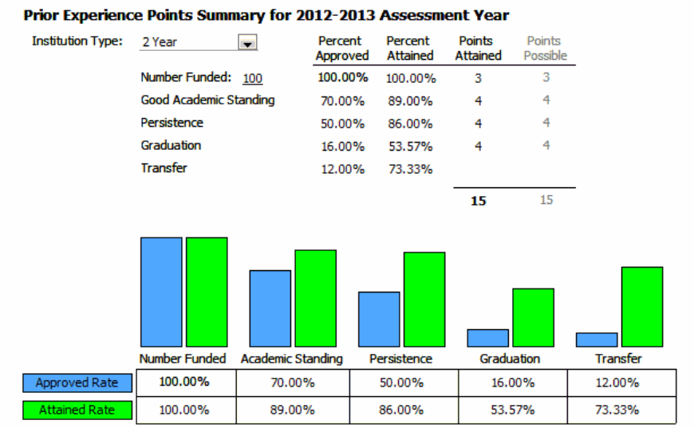

- Based on the past year’s data (referenced in Question #1), please evaluate your data and/or department.
(Place an ‘X’ in each text box that corresponds to your evaluation. You may delete or add rows.)
Data Reported/Collected  (Include Most Important Data) | Needs Improvement | Meets Standards | Exceeds Standards
- Graduation rate |  |  | X
- Persistence rate |  |  | X
- Good academic standing rate |  |  | X
- Transfer Rate |  |  | x

- (If applicable) If any area “Needs Improvement,” please explain why (i.e. Analysis).
NA

- (If applicable) Based on the data above, what changes do you recommend (i.e. Action Plan)?
NA

III: Existing Data (Based on Surveys, Focus Groups, and Interviews)
In this section, provide examples of ways you used survey data or qualitative research (interviews, focus groups, etc.) to make decisions.

PART A:
- Over the past year, did your area collect and/or review any survey data or
qualitative (focus group, interview, etc.) information?
(Place an ‘X’ in the text box that corresponds to your response.)
Yes  (If Yes, Proceed to PART A, Question #2) | No  (If No, Proceed to PART B)
X

- Summarize the most important information that was collected and/or reviewed and the results.
Student survey results from our AC-MCC Spring 2014 Student Survey indicated that students need nursing programs. In response to this information, we plan to offer nursing courses at MCC fall 2016.

The Spring 2015 Student Survey indicated that we needed a larger testing center on campus. We moved our Testing Center July 2015 to a larger room to satisfy this need.

3. (If applicable) Based on the data above, what changes do you recommend (i.e. Action Plan)?
We met with AC-MCC Nursing Task Force chaired by Jeff Turner, Moore County Hospital District CEO, spring 2015. Using Business Objects, we collected five years data, 2009-2013, for the top 10 counties in the Panhandle. The data supported the need for an A.D.N. nursing program in our area. Out of 526 declared A.D.N. majors, only 28 graduated in 5 years’ time. We developed a white paper proposal for submission to Dr. Richard Pullen, Interim Director of Amarillo College’s A.D.N. program to support establishment of an AC-MCC Branch Campus Nursing program Fall 2016. We plan to order supplies fall 2015/spring 2016 and work with Dr. Pullen’s team as well as our local hospital to set up a clinical lab and classroom to accommodate nursing students fall 2016.

Our testing Center will be monitored for any needed aesthetic changes. We will recruit more GED students to test on our campus 2015-16. The Testing Center hours were expanded last year to accommodate more testing, and more table space will allow for more testing to take place during the busiest testing times.

PART B:
Additional Comments Related to Surveys and Qualitative Research (Not Required):
IV: Institutional Initiatives
PART A –No Excuses:
Each department is expected to support student success initiatives.
- List 1 or more ways your department most focuses on any of the No Excuses goals/initiatives.
Improvement of tutoring services through the “Writer’s Corner” activities.

- Are there any changes your department has made over this past year to remove
barriers to students and further the No Excuses goals OR to move the needle toward fulfillment of the No Excuses goals?
    - If so, please explain.
    - If not, but you plan to make changes that aid students success, please provide
a few sentences explaining how you can better support No Excuses.
In order to ensure student success on campus we added more tutoring services. We implemented the Writer’s Corner and began tracking the tutoring services with ACCUTRACK.

PART B –Institutional Outcomes:
Each department is expected to provide quality student, customer, and/or client services.
- For this review year, what is/were your department’s most important goals (i.e. broad things you would like to accomplish)?
Improve student performance in writing.

- For this review year, what is/were your department’s most important outcome/s that can be specifically measured and help you achieve your goals? Provide examples of 1-3 outcomes.
(An outcome provides observable evidence that your student’s or client’s knowledge,
skill, ability, attitude, or behavior has changed as a result of your efforts.)
After advertising the new “Writer’s Corner hours to MCC students, 10% more students will utilize the writing services of MCC.

- How does your department assess the above outcome/s? What were the results of your outcome assessment? What do your results tell you?
A full year of data was unavailable in 2013-14.
2014-15 data as follows for number of students served in the Writer’s Corner:
For Fall 2014
- Total Unique Students: 37
For Spring 2015
- Total Unique Students: 30
Final Totals
- Unique Students: 67

- What change/s has your department made in the past year or do you plan to make based on your assessment of any outcome?
Hired full time English Faculty 6 hours per week to oversee “Writer’s Corner” tutoring. A peer tutor has been hired 19 hours per week to review student writing under the supervision of the lead English Faculty. Began tracking student tutoring sessions through ACCUTRACK beginning SPRING 2014.

PART C –Strategic Planning:
Each department is expected to support AC’s Strategic Planning initiatives.
- Identify at least one strategy or task from the Strategic Plan your area currently addresses/evaluates.
Goal 2 Ensure Student Access. Expansion of program offerings and opportunities for student less likely to obtain a post -secondary degree or certificate by opening a technical campus.

- (If applicable) What additional item/s should AC’s Strategic Plan address?
More creative and aggressive programming for dual credit and articulated courses is still in the planning stages due to a change of leadership at Dumas ISD.

PART D – Core Objectives (CR 2.10):
SACSOC guidelines require non-instructional areas to provide student support programs, services, and activities that are consistent with its mission and that promote student learning and enhance the development of its students.
At Amarillo College, a component of student learning is found present in the existence of AC’s General Education Competencies. Due to recent mandate changes set forth by the Texas Higher Education Coordinating Board (THECB), AC has adopted the following General Education Competencies: Communication Skills, Critical Thinking Skills, Empirical and Quantitative Skills, Teamwork, Social Responsibility, and Personal Responsibility.

Although these competencies obviously relate to academia, many non-instructional areas also support some or all of these objectives.

Some Examples of Ways Non-Instructional Areas Can Support Student Learning:
Personal Responsibility: Any service that provides materials/information related to financial literacy, life planning, etc. to students could relate to personal responsibility. Also any measure of student personal responsibility (e.g. percent of students not dropped for non-pay, percent of students who pay their rent to AC housing on time, etc.) relates to this topic.
Social Responsibility: If students are able to serve or learn about ways to serve their community or world, this could relate to social responsibility.
Communication, Critical Thinking, and Empirical and Quantitative Skills: If a department teaches a skill/topic within the classroom or through a published document geared toward students, this skill/topic could relate to communication, critical thinking, or any of the other objectives—depending on the skill/topic being taught.
Teamwork: Any student organization/framework where students must work successfully within a group could equate to teamwork.

- Does your area work (in-person, through publications, or through some other means) with students to learn/accomplish any of the following objectives?
Objective | Yes  (If Yes to Any Area, Respond and  Proceed to Part D, Question #2) | No  (If No to All Areas,  Proceed to Part D, Question #3)
Communication Skills | yes
Critical Thinking Skills | yes
Empirical & Quantitative Skills | yes
Teamwork | yes
Personal Responsibility | yes
Social Responsibility | yes
- For each objective that received a “Yes” response, provide a bulleted list identifying how
your department addresses each particular objective with AC students, any assessments related to your objective (if applicable), and any results related to your assessment
(if applicable).
- Assessments can be indirect (e.g. surveys, focus groups, etc.) or direct.
Communication- Writer’s Corner tutoring. Student submission to “Writer’s Block.”
Critical thinking Skills-FYS class (Successful completion of course)
Empirical & Quantitative Skills-tutoring (ACCUTRACK)
Teamwork-Peer Leader (Pre and post survey results
Personal Responsibility-resume building
Social Responsibility-Service Clubs (hours of service)

- Please indicate (place an X in the corresponding box/es) the mode of delivery by which you offer any support programs, services, and activities, to students.
In Person | Web | Phone | E-mail | Live Chat
x | x | x | x

4. Do you have plans to expand your learning objectives and/or modes of delivery? If so, how do you plan to expand these objectives/delivery modes? If not, why not?
Yes. We would like approval to deliver online courses based at MCC.

V: Policies and Procedures
Amarillo College’s non-instructional areas consistently have procedures in place that promote student confidentiality, staff efficiency, student success, and accountability.

Each non-instructional area will respond to the Core 5 (first 5) “Policies and Procedures” questions if they are pertinent to their area. If a department has additional questions they would like to include for accountability or some other purpose, they will also include those questions on this section of the form.

- Please explain how your area supports the security, confidentiality, and integrity of student records and maintains special security measures to protect and back up data (CR 3.9.2)
Follow FERPA. Student records are kept in locked cabinets. Documents that have personal data are shredded after use.

- How do you ensure that all of your employees are aware of student complaint procedures and
that the procedures are handled in a way that is in accordance with the institutional policy of complaint procedures being reasonable, fairly administered, and well-publicized (CR 3.13.3)?
Staff is trained on the Student Rights and Responsibility policy for Amarillo College.

- Has your area made any departmental changes based on student complaints? If so, what
changes did you make (FR 4.5)?
N/A

- Have you addressed any local, state, audit, or federal compliance issues that have caused you to make an adjustment to your department and/or a policy change? If so, please explain.
No

- Have you made any changes to your department’s policy or procedures over the past year that
are otherwise not addressed in this review? If so, please explain.
No

VI: Conclusions
- What is the biggest issue/obstacle that your department currently faces?
Please explain the issue, point to evidence supporting why your issue is important (addressed in this document or elsewhere), explain how you would like to fix the issue, and explain any budgetary constraints.
Ability to offer courses and programs that our community needs such as online courses and unique or specific programs for the MCC service area.

- Additional Comments Pertinent to this Annual Review Evaluation (Not Required):

