**Instructional Program Review  
Radiation Therapy**

This document addresses the following SACSCOC requirements: CR 2.5, CS 3.3.1, CS 3.5, and FR 4.1.

Purpose

Amarillo College instructional programs consistently review data and strive for improvement.

The purpose of this review is to demonstrate how AC instructional areas support AC’s mission by “*enriching the lives of our students and our community*.”

On an annual basis the Program Review process will capture a holistic view of a department’s/program’s strengths, weaknesses, and improvement plans based on institutional data and assessment information.

The information collected on this form will also serve to help your division complete the information required by SACSCOC for Amarillo College’s continued reaffirmation efforts.

**Response Length Suggestion: Most responses should be 2-3 sentences.   
 If available, you may also provide a link/reference to other documentation that answers each question.**

I: Identification

1. **Department or Program Title(s)** (Department Chairs List Dept.; Coordinators List Program)**:**

|  |
| --- |
| Radiation Therapy, Tony Tackitt |

1. **Department and/or Program(s) Purpose Statement:**

|  |
| --- |
| This course of study at Amarillo College is designed to provide the opportunity for each student to obtain the basic “entry-level” skills and knowledge expected of a beginning staff radiation therapist. The curriculum combines technical and academic courses which will enable each graduate to gain a working knowledge in radiation therapy |

1. **Program Review Year (i.e. Most Recent Academic Year)**

|  |
| --- |
| 2014 |

1. **Date of Submission:**

|  |
| --- |
| 5-25-2015 |

1. **Lead Person Responsible for this Program Review:**

|  |
| --- |
| Name: Tony Tackitt  Title: Program Manager, Radiation Therapy  E-mail: tmtackitt@actx.edu  Phone Number: 354-6063 |

1. **Additional Individuals (Name and Title) Responsible for Completing this Program Review:**

|  |
| --- |
| None |

II: Program Enrollment and Success Data

Use baseline data that will enable you to determine the status of your program (compare the most recent data to previous year data, compare your program to any existing state standards, or consider any other relevant factors). Please use Firefox or Chrome browser to open links.

1. **Based on the most recent reported data, please evaluate your program(s).**

***A .Overall Program Data*** (Complete this section if your dept. produces any certificate and/or terminal degree.)**(Place an ‘X’ in each text box that corresponds to your evaluation.)**

|  |  |  |  |  |
| --- | --- | --- | --- | --- |
| **Student Data Reported/Collected** | **Needs Improvement** | **Meets Standards** | **Exceeds Standards** | **Not Applicable** |
| a. Employment Rates/Wages  ([EMSI](https://actx.emsicareercoach.com/), [College Measures,](http://esm.collegemeasures.org/esm/texas/) [CREWS](http://reports.thecb.state.tx.us/approot/thecb_tcr_ews/figure2.htm), [Perkins](http://www.thecb.state.tx.us/apps/Perkins/perkdata.cfm)) | X |  |  |  |
| b. [Completion](https://iresearch.actx.edu/html/databook/dbtbl4g.html) | X |  |  |  |
| c. [Licensure Pass Rates](http://www.txhighereddata.org/reports/performance/ctclbb/licensure.cfm) |  |  | X |  |
| d. Retention ([FA-SP](https://iresearch.actx.edu/html/databook/dbtbl2ke.html)) and ([FA-FA](https://iresearch.actx.edu/html/databook/dbtbl2ke-f.html)) |  |  | X |  |
| e. [Grades A-C](https://iresearch.actx.edu/html/databook/dbtbl2ge.html) |  |  | X |  |
| f. [Annual Enrollment](https://iresearch.actx.edu/html/databook/dbtbl3a.html) | X |  |  |  |
| g. [Survey, Focus Group, & Related Data](http://www.actx.edu/iea/index.php?module=article&id=61) |  |  | X |  |

**Based on the data in Part A, respond to the following two questions:**

1. Identify one area in which your program(s) excel.

|  |
| --- |
| Licensure pass rates: 100% for the past 3 years, 97% for the last 25 years cumulative (national average is in the low to mid 80 percentile range) |

1. Identify one area in which your program(s) need to most focus for the next few years.

|  |
| --- |
| Annual enrollment |

***B. Course-Specific Data*** (Complete this section to evaluate the courses that fall under your dept./program.) **(Place an ‘X’ in each text box that corresponds to your evaluation.)**

|  |  |  |  |
| --- | --- | --- | --- |
| **Student Data Reported/Collected** | **Needs Improvement** | **Meets Standards** | **Exceeds Standards** |
| a. Grades A-C (IDS - Race/Ethnicity) |  |  | X |
| b. Grades A-C (IDS – Age) |  |  | X |
| c. Grades A-C (IDS – Gender) |  |  | X |
| d. Grades A-C (IDS – First Generation) |  |  | X |
| e. Grades A-C (IDS – Pell) |  |  | X |
| f. Grades A-C (IDS – Full/Part-Time) |  |  | X |
| g. Course-level Enrollment (IDS) |  |  | X |
| h. Survey, Focus Group, & Related Data |  |  | X |

**Based on the data in Part B, respond to the following two questions:**

1. Identify two courses that are doing well.

|  |
| --- |
| RADT 2401 (Oncology I), RADT 2309 (Dosimetry II) |

1. Identify two courses in which your dept./program(s) needs to most focus for the next few years.

|  |
| --- |
| RADT 2407(Dosimetry I), RADT 1401 (Intro) |

III: Institutional Initiatives

PART A – No Excuses:

Each department/program is expected to support student success initiatives.

**List 1 or more ways your program(s) most focus on any of the** [**No Excuses goals/initiatives**](http://www.actx.edu/iea/index.php?module=article&id=83) **and how you have helped AC fulfill its No Excuses goal.**

|  |
| --- |
| In addition to my responsibilities as the sole full-time faculty for the radiation therapy program, I have been an instructor in the FYS curriculum-- which has brought about a more acute awareness of the goals and initiatives related to No Excuses--many of which I have implemented into our radiation therapy curriculum (e.g. discussions of No Excuses principles with students early in the first semester of their curriculum as well as having the West Campus Counselor meet with radiation therapy students and discuss opportunities, resources, etc. available to students at Amarillo College. |

PART B – Strategic Planning:  
 Each department/program is expected to support [**AC’s Strategic Planning**](http://www.actx.edu/iea/index.php?module=article&id=10) initiatives.

1. **Identify at least one strategy or task from the Strategic Plan your area(s) currently addresses/evaluates.**

|  |
| --- |
| 3.2 Support college and career readiness efforts  I, as the sole appointed faculty, am involved in teaching FYS on a regular basis, and am an enthusiastic supporter of FYS principles. My program is a skills program aimed at addressing a specific field of health service. |

1. **(If applicable) What additional item(s) should AC’s Strategic Plan address?**

|  |
| --- |
|  |

PART C– General Education Objectives   
SACSCOC requires that the College prove attainment of general education competencies by all students. AC has adopted the below objectives for our core curriculum assessment, but you may add additional objectives you teach. Additionally, AC expects that learning objectives are present and are being evaluated in all courses.

1. **Provide a listing of which courses in your department/program(s) teach these general education objectives. For assistance in identifying educational objectives in non-core courses, refer to the** [**ACGM**](http://www.thecb.state.tx.us/AAR/UndergraduateEd/WorkforceEd/acgm.htm)**/**[**WECM**](http://www.thecb.state.tx.us/AAR/UndergraduateEd/WorkforceEd/wecm/)**.**(List individual course prefix, state “all courses”, state “N/A” for an objective, etc.):

|  |  |
| --- | --- |
| **Objective** | **Course(s)** |
| Communication Skills | * RADT 1266, RADT 1267, RADT 2266, RADT 2367, RADT 2366, RADT 1401 |
| Critical Thinking Skills | * RADT 1266, RADT 1267, RADT 2266, RADT 2367, RADT 2366, RADT 1401, RADT 1142, RADT 1271 |
| Empirical & Quantitative Skills | RADT 1401, RADT 2403, RADT 2407, RADT 1142, RADT 1271 |
| Teamwork | * RADT 1266, RADT 1267, RADT 2266, RADT 2367, RADT 2366, RADT 1401 |
| Personal Responsibility | * RADT 1266, RADT 1267, RADT 2266, RADT 2367, RADT 2366 |
| Social Responsibility | * RADT 1266, RADT 1267, RADT 2266, RADT 2367, RADT 2366 |
| Note: May Insert other Objective(s) |  |

1. **Briefly explain how your department/program(s) have recently (i.e. past year) identified and ensured that these general education objectives are taught throughout each course section.**

|  |
| --- |
| Teaching FYS has helped me see these issues from a different perspective, and I have integrated some FYS principles into many of my classes.  Additionally, the program has undergone a programmatic accreditation Interim Report during this last year—during which the program identified courses focusing on critical thinking and other skills. |

1. **What method(s) are your faculty using to assess the required objectives in your courses?**(List individual course prefix, state “all courses”, state “N/A” for each method, etc.):

|  |  |
| --- | --- |
| **Method** | **Course(s)** |
| Capstone Project/Exam | **RADT 1271** |
| Embedded Questions | **RADT 1191 ,RADT 1271, RADT 1142, RADT 2407** |
| Licensure Exam | **RADT 1271** |
| Portfolios | **RADT 1271(job interview portfolio, resume’, mock interview, cover letter, etc.—as well as a portfolio required to be submitted for application to the program)** |
| Projects/Essays | **RADT 1271** |
| Testing (i.e. course-based testing; finals) | RADT 1401, RADT 2403 ,RADT 2407, RADT 2309, RADT 1142 |
| Note: May Insert other Method |  |

1. **Briefly address any improvements made in your department/program(s) based on your data findings.**

|  |
| --- |
| Improvement in RADT 2407 Math section by utilizing “Flipped” classroom technique. |

1. **In which course(s) have you implemented critical reading and thinking strategies? What strategies did you use? How would you evaluate your success in implementing these strategies? Are there strategies you discovered that you would like to share with your colleagues? Do you feel that your department/program could benefit from more professional development in this area?**

|  |
| --- |
| In  Courses: RADT 1266, RADT 1267, RADT 2266, RADT 2367, RADT 2366, RADT 1401, RADT 1142, RADT 1271  In the 5 Practicum courses, critical thinking evaluated by clinical staff in and of each rotation written evaluation (3-4 rotations per semester). Capstone course (RADT 1271) evaluates critical thinking via national certification style examinations throughout the semester as well as “Exit Exams” as a capstone exam for the curriculum.  RADT 1142, and RADT 1401 (Intro) students must demonstrate an awareness of various educational modalities involving demonstration of critical thinking skills, and submit samples of graphic organizer tools demonstrating critical thinking. These tools include effective memorization techniques intended towards long-term (permanent/semi-permanent memory versus short-term memory skills. (This process will be expanding to other courses throughout the curriculum beginning next year.  **I have created lessons describing/demonstrating these graphic organizer tools and would embrace the opportunity to share these tools with my colleagues.**  RADT 2407 is, according to grades/student comments, the most challenging course in the major curriculum – especially with respect to mathematics. The program instituted “flipped classroom” techniques last year that were successful – as demonstrated by evaluations from students and grades on related quizzes/exams.  Additional professional development in the areas of critical reading and thinking would always be appreciated and embraced. Note: many current opportunities in these areas are not as accessible due to limited times (many healthcare classes are in afternoons and Friday mornings)/locations that are not as convenient (e.g. Washington Street Campus) |

PART D: Curriculum Assessment - Program Outcomes:  
SACSCOC requires each program to provide quality student, customer, and/or client services. Each program not directly responsible for core curriculum courses must still annually identify at least one direct outcome within their program, provide results, analysis, and improvement plans related to that outcome.

1. **For this review year, what were each program’s most important goal(s)   
   (i.e. broad goals you wanted to accomplish)?**

|  |
| --- |
| 1. Be in a position to be able to implement online program in the near future   * *Continue online development with an eye towards maintaining accreditation and increasing enrollment with online options for students. Target for 100% online program: Fall 2016* * *Purpose and Rationale for online delivery: a 15 page (with extra pages of exhibits) document was submitted with this year’s budget explaining the purpose and rationale for needing to move to 100% online delivery of curriculum. In summary: as briefly described in IV. Conclucsions Part 3. later on in this report, enrollment has been limited by lack of hospital facilities in the local/regional area. The job market in the local/regional area has also become very tight, leading to increased attrition/lower graduate employment numbers from students desiring to stay in the local area but unable to find local employment. Moving our program to become the first accredited online program in the nation is expected to enhance outcomes related to attrition and employment-- as the program will be able to accept students in more employable regions of the country.* * *Note: the proposal for 100% online delivery was approved by the programmatic accrediting body, JRCERT and the program Advisory Committee*   2. Continue revising curriculum with an eye towards a more student-centered (vs. teacher-centered) curriculum.   * *Implementation has begun, most notably in the online course—which is well-suited to student-centered education, as well as traditional courses, which incorporate many “student-centered” activities.*   3 Over a five year period (data accrued 6-12 months post-graduation), certification exam pass rates will be satisfactory as demonstrated by a pass rate equal or greater to 75% over a 5 year period as evaluated by the ARRT certification exam 1st attempt pass rate.   * *Exam pass rate is 91% over five years, 100% over the most recent three-years.* |

1. **For this review year, what is/were each program’s most important measurable outcome(s)   
   that helped you achieve your goals (referenced above)? Provide examples of 1-3** [**outcome statements**](https://www.actx.edu/iea/filecabinet/117)**.** (An outcome provides observable, objective evidence that your student’s or client’s knowledge, skill, ability, attitude, or behavior has changed as a result of your efforts.)

|  |
| --- |
| Related to above stated goals,  Outcome statement for Goal #1: the program will develop at least 3 online classes as Master Courses during calendar 2015 ,and complete online Master Course development by end of summer 2016  Outcome statement for Goal #2: The program will ensure that all online courses will include “student centered” activities that encourage developing a sense of “student community” in the online environment.  Outcome statement for Goal #3: The first-time pass rate for the national certification exam (ARRT) will meet or exceed 75% over a five-year period. |

1. **Identify your results and analyze your data.**

|  |
| --- |
| **Goal #1:** The Program Director developed has 9 courses approved as online Master Courses for the curriculum.  Two classes have already been submitted and approved as online Master Courses during 2015, with at least 1 additional courses planned to be completed during the summer. The program has been completing online course development at a pace of four courses per year. At this pace, online curriculum courses will be completed by summer 2016.  Logistics of distance clinical education are actively being addressed, with most of the “ground rules” and documents already written.  Program is “on course” to be ready for Fall 2016 online delivery of the curriculum.  **Goal #2:** Online classes that have been developed thus far include many “student centered” activities that promote community development – including private Facebook group for students to post on a regular basis (graded) on issues not related to class/school, discussion boards, chat rooms (via BlackBoard Collaborate), etc.  Courses include many student-centered activities including a required private facebook group wherein students post on non-classroom activities of their day-to-day lives. Courses also include numerous chat assignments using Bb Collaborate, Discussion Boards, learning games, private Journaling of clinical experiences, etc.  Below are some samples of our private facebook group, chat icons (using Collaborate, though the chats are audio and are naturally not embedded in this document), a student journal sample and a sample discussion topic. Note: facebook student posts are to build community by including humorous, non-class-related content.  Pasted below are some screen-grab samples of student-centered activities in online courses:      Chat area sample:    Journal area sample:    Journal entry sample:    Partial list of discussion topics for an online course (RADT 1191):    Sample Discussion thread (partial):    Analyzing Data for Goal #2: Students typically relate that they do not like community-building student centered activities, however research indicates that such activities result in an overall increase in student satisfaction with the curriculum experience (it’s “easier” to sit in class and listen to lecture than it is to do groupwork together, but students remember the groupwork better and repot more generalized satisfaction as a result).  Interesting note: one student noted in class this year that she got to know her fellow students/classmates better in the online courses then in the face to face classes (as a result of the aforementioned required community-building interactions that are required that are not as prevalent in face-to-face classes)  **Goals #3:** Re: ARRT Exam pass rate, program is at 91% over 5 years and 100% over the last 3 years. National average is consistently in the low to mid 80 percentile range. The program appears to be doing well with respect to licensure exam pass rates.  National certification pass rate data verification provided in Section 5 that will follow |

1. **What key change(s) has your department/programs made in the past year or do you plan to make based on your assessment of any outcome?**

|  |
| --- |
| Program Director is undergoing extensive learning with respect to Bb and its offerings (including Collaborate and other features of Bb that aid in course development and can enhance student success).  No significant changes are expected resulting from licensure exam scores, as program pass rate exceeds standards, and is 100% for the last 3 years. However, online delivery nation-wide is expected to aid program outcomes related to employment, enrollment, and attrition. |

**5. Please provide supporting documentation with this review that relates to this outcome(s).   
 For example, if you’re using a rubric to assess student work, attach a copy of the rubric and** five student samples. **If you’re focusing on licensure exam data, attach a copy of your   
 pass rate results.**

**Note, as per Part D, item #1, the most important program goals are primarily programmatic rather than *directly* related to student outcomes—though program outcomes (e.g. attrition, employment) are tied in to the described major programmatic goals of 100% online delivery (but are not tied to grading rubrics, so rubrics are not applicable for these goals).**

**The Licensure Exam 5 year pass rate goal is more directly tied to more traditional outcomes. With respect to licensure pass rates, see documentation below confirming 91% pass rate for 5 year period 2010-2014:**

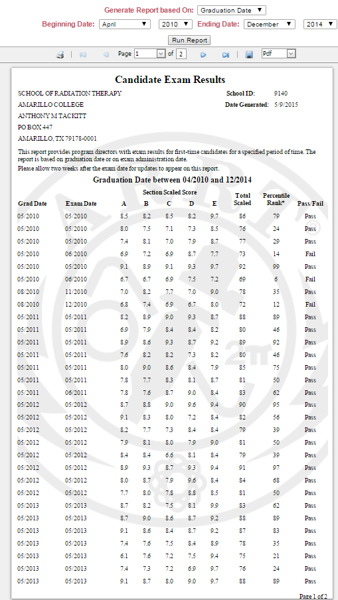

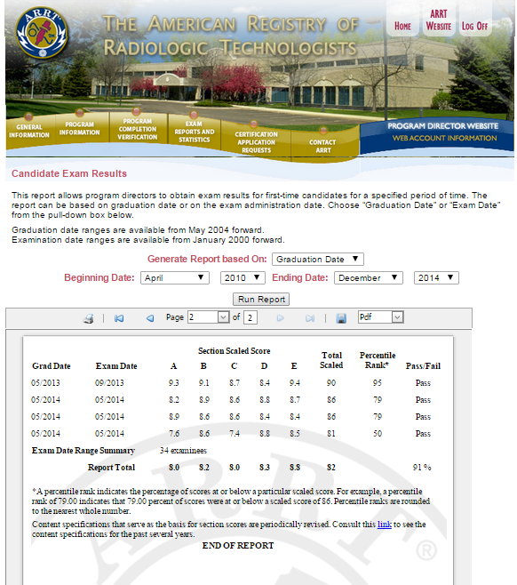

**FYI: Though not tied to the stated program major goals, the following is a sample of the grading rubric typically used for online Discussion Boards:**

Grading Rubric: 10 points

* Make initial post: 1 pt
* Make 4 replies: 2 points
* Thoughtful post/replies: 4 points
  + Very basic replies, “ok”, “uh-huh”: 1 point
  + Full phrases, but not really engaging: 2 points
  + Full sentences, satisfactory replies, but not always engaging: 3 points
  + Always thoughtful and engaging: 4 points
* Grammar/punctuation/spelling/not using texting or other inappropriate abbreviations (use complete sentences): 3 points
  + 3 or more errors described above: 0 points
  + 3 errors (as described above): 1 point
  + 2 error (as described above): 2 points
  + 0-1 errors (as described above): 3 points

IV: Conclusions

1. **How have you or your staff adjusted your pedagogy (method and practice of teaching) to   
   improve your academic quality and/or aid in some other area related to student success?**

|  |
| --- |
| Online course development has, of necessity, forced the program to develop and implement more student centered and community-building activities (as mentioned previously). In short, a course redesign has been taking place within the program with respect to converting all courses in a “skills field” to a completely online format. Thus, every course in the curriculum has been or is in the process of being redesigned/reformatted for complete online delivery.  The program has also benefited from the faculty participation in FYS course instruction, and being exposed to the student centered activities within that course that have served as a springboard towards various beneficial activities within the radiation therapy curriculum. Being inspired in part by the FYS course, the program has been writing many modules for online delivery that incorporate learning more about “Soft Skills”. Modules have been written for topics such as Soft Skills, Communication, Academic Integrity, Time Management, Wellness, Learning to Learn. Modules planned for future courses include stress/anxiety/wellness, diversity, relationships, professionalism, “About AC”, resume construction/job interviews, Holistic approaches, and more. |

1. **What program improvement opportunities are available to your staff (e.g. external curriculum committees, trainings, etc.)?**

|  |
| --- |
| Numerous opportunities for faculty growth are available through CTL and other workshops. Faculty is focused on workshops relating to technology in preparation for 100% online program delivery.  Obstacle: There is only one faculty, so there is no one that can sub for the teacher. Teaching load is frequently well in excess of 20 FTE load hours. In order to accommodate student needs with respect to taking general education courses, program courses are often in the afternoons and Fridays—which is when most workshops take place. |

1. **What is the biggest issue/obstacle that your program currently faces?**   
   **Please explain the issue, point to evidence supporting why your issue is important (addressed in this document or elsewhere), explain how you would like to fix the issue, and explain any budgetary constraints.**

|  |
| --- |
| Many obstacles exist. The biggest is various barriers limiting enrollment (local hospitals only do not allow us to take in anywhere near what we are allowed by accreditation standards). This dependence on local hospital whims is a major factor in the program needing to move to 100% online.  Additionally, there are two nonaccredited 100% online radiation therapy programs in the United States. These programs have been acting as “diploma mills” negatively impacting the job market and educational validity/professionalism in the field. Our program, upon becoming the first accredited 100% online radiation therapy program in the nation (as well as the first healthcare program fully online at Amarillo College) will offer a nationwide ACCREDITED option for potential students that can have a positive impact on professionalism (educational validity), as well as the job market/employment not only for the Amarillo College program, but for the profession as a whole.  The biggest obstacle for 100% online delivery is the Amarillo College budget process. Maintaining accreditation, while adding clinical sites and students as will happen with 100% online delivery, will require hiring a full-time Clinical Coordinator position. All other obstacles related to moving to 100% online delivery have been passed, including unanimous voted support by the program Advisory Committee, and detailed submission of the 100% online proposal to the programmatic accreditation agency, JRCERT, which approved the proposal.  Additional major concern: with only one faculty, this creates a concern with respect to program viability if that faculty is in some way incapacitated and unable to work. There is no “backup” in case of such a circumstance. This is another reason for moving to 100% online, as accreditation would require (as a result of increased enrollment and clinical sites) an additional full-time faculty. This would not only provide “backup” in case of medical or other emergency, but also allow program faculty to attend more workshops ,etc., by virtue of having personnel that could substitute for faculty. As of now, being the only appointed faculty, I frequently have to miss meetings, committee meetings, workshops, etc. because there is no one that can take my place in classroom lecture. |

1. **Additional Comments Pertinent to this Review (Not Required):**

|  |
| --- |
|  |