**Amarillo College**

**Employee Training**

**Datatel Colleague**

**Advising & Registration Modules**

**Version 4.3**



**Date Modified: October 17, 2011**

###### *Table of Contents*

LOGGING IN TO COLLEAGUE 1

REGISTRATION MODULES 1

Evaluation (EVAL) 1

Registration (RGN) 4

Removing a Class from the Schedule 6

Person Restrictions (PERC) 8

Registration Activity Monitor (RGAM) 9

Counselor Assignment (CNSL) 10

ADVISING MODULES 11

Proposed Student Program (PSPR) 11

Student Academic Credits Inquiry (XSTI) 12

Transcript Course Listing (TRCL) 13

Student Academic Transcripts (STAT) 14

Cumulative GPA 14

MISCELLANEOUS MODULES 15

Student Remark (STRK) 15

Student Schedule (STSC) 16

Registration Billing Summary (RGBS) 16

# LOGGING IN TO COLLEAGUE

1. Use a web browser such as Internet Explorer (currently, IE 9 is not supported) or Firefox 5.0 to open one of the following webpages:

<https://uilive.actx.edu> (live system)

or

<http://uitest.actx.edu:8084/test/index.htm> (test account for practicing)

# REGISTRATION MODULES

## Evaluation (EVAL)

A “Degree Audit” or “Student Evaluation” or simply an “EVAL” report lists all classes taken at Amarillo College to fulfill requirements for one of our degree plans. It also lists credit received through testing or from another institution. The report is current at the time it is printed and shows which classes need to be completed.

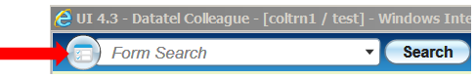

1. If needed, click the circular button (see illustration above) to use “Form Search.” You might have to erase the name of a previously-used module.   
     
   ***HINT****: Another way to select a form is to click the drop-down arrow at the end of the “Form Search” field and then click the desired form from the list.*
2. In the Form Search box, type **EVAL** and press ENTER .
3. Specify the person by one of these formats, and then press ENTER :
   1. John Public
   2. Pubic, John
   3. SSN without hyphens
   4. Colleague (or Employee) ID Number

***NOTE****: If you are presented a list of people whom which to choose, double-click the person to be used in this search.*

1. Double-click the active degree plan:
   1. The **Active** degree plan does not have an “End Date” (see arrows)
   2. The status for the appropriate degree plan will be “A”
   3. Do not use the “Continuing Education” degree plan

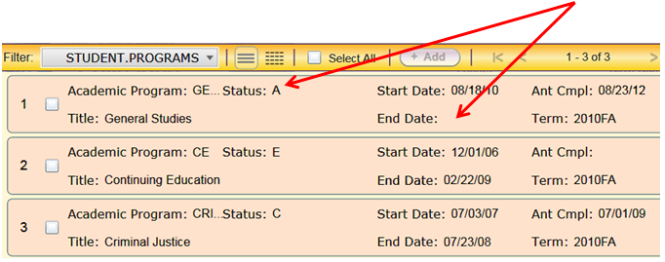

Don’t use Continuing Education

1. Press function key F9 . The text report will open in a separate window. The report cannot be maximized to “full screen.”

* A plain text report will open in a separate window.
* Use the scroll button on the mouse to look at more of the current page.
* Use the  icon in the upper left corner of the report to go to another page.
* At the bottom of the last page of the report, the “Notes” area lists codes that were used. The following table lists these codes.

|  |  |
| --- | --- |
| **Note** | **Meaning** |
| *NE | Non-course Equivalency |
| *S | Status – Items with this status may not be applied to the program |
| *S (D) | Dropped the class |
| *S (W) | Withdrew from the class |
| *TE | Transfer Equivalency (class was taken at another institution, and was accepted at AC |
| *PR | Pre-registered |
| *IP | In Progress |
| *RA | Replacement attempt (to replace a class in which a poor grade was earned) |
| *RP | Replacement pending |

1. Export to PDF to Print Locally

This version of Datatel Colleague does not allow local printing. We have to open the report in Adobe Reader, and then print from that application.

* 1. 
  2. Select font and font size if desired.
  3. 
  4. 

1. Close the plain text report to get back to Datatel Colleague.
2. Enter the name for another student, or close the module.

## Registration (RGN)

Use this module to register a student into a class.



1. If needed, click the circular button (see illustration above) to conduct a “Form Search.” You might have to erase the name of the module that was last used.
2. In the Form Search box, type **RGN** and press ENTER .
3. Pull up student via SSN (without hyphens), student ID #, or name search.
4. Double-click the student’s name from the list.

***NOTE****: When you register a student, make sure to ask the student for his/her phone number, address, and zip code to make sure you are registering the correct person. These will be listed at the top of the screen in the person area. If there is incorrect information listed, have the student contact the registrar’s office to get their information updated.*

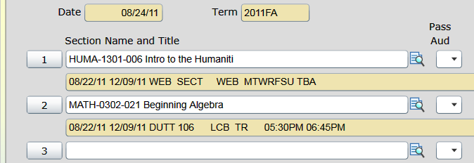

1. On the first **empty** “Section Name and Title” field, type the class information   
   (see examples below) and press the ENTER key:  
     
   ***NOTE****: If you do not see an empty row, click on one of the rows containing a current class listing. This will cause an extra “toolbar” to appear above the Term of the first listed class. This extra “toolbar” contains buttons that allow you to scroll to the next page of classes.*  
   1. The semester code followed by a space and the Course Name/Number.  
      (Example: 2011FA ENGL 1302 001)
   2. A forward slash symbol ( / ), followed by the 6-digit class ID number.  
      (Example: /123456)

|  |  |
| --- | --- |
| **Possible Error Messages Encountered During Registration** | |
| **Error Message** | **Meaning of the Error** |
| Failed eligibility rules | This has multiple possibilities:   1. Needs to be greenlighted (**You can fix this**) 2. No academic program assigned (**Sent the student to the registrar**) 3. Needs to update admission application. This means that the student has not been enrolled in an academic class in the past year. (**Send the student to the registrar**) |
| Must enroll in a developmental reading, writing, or math class for the current term | The student has not satisfied requirements of the Texas Success Initiative, TSI (formerly TASP)  (**You can fix this**) |
| You are not allowed to register in the “Pre-registration” time period | The IT department has not officially opened registration yet. You may need to specify the correct term.  (**Registration will have to wait until it is opened**) |
| You are not allowed to register in the “Add/Drop” time period. | Registration time has ended for that class in the current semester. (**Send the student to the registrar**) |
| Section xxxxxx is “Closed” (22/22). Enrollment not allowed. | The class that you chose is already maxed out on enrollment.  (**Choose another class**) |

***NOTE****: CEU’s will automatically fill in for Continuing Education classes.*

1. Press the function F9 key (or click on the  button) to continue.

### Removing a Class from the Schedule

**BEFORE the Schedule has been Saved**

If you just added a class to a student’s schedule, but have not saved the schedule yet, the class can very easily be removed from the schedule.

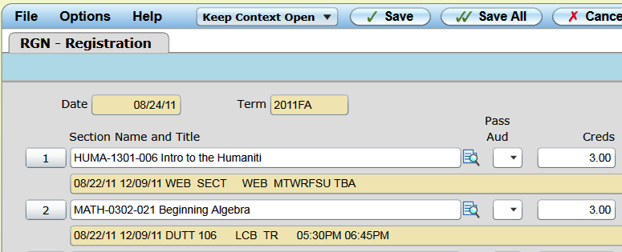

***NOTE****: Example: In the illustration above, we will remove the class   
“MATH-0302-021 Beginning Algebra” from the student’s schedule.*

* As circled in the illustration above, click the numbered button in front of the class that was just added by mistake.
* Press the  two times to remove the schedule.

**AFTER the Schedule had been Saved**

If you had added a class to a schedule, and saved the registration schedule, you cannot simply click the number and then use the delete button to get rid of the class.

1. Access the RGN module (steps were described in the previous section of this manual.
2. Click the  icon at the right side of the class that is to be removed from the schedule.

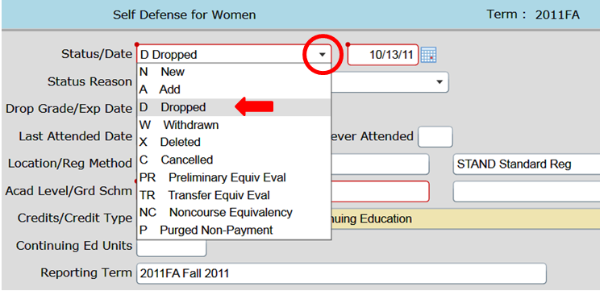

1. As circled in the illustration above, use the drop-down arrow for the “Status/Date” field to click the option for “D – Dropped.” (Always use Dropped)

***NOTE****:* ***NEVER*** *use “Withdraw” or “Deleted”!*

1. Press Function key F9 to check the new status.
2. When finished, press the Function key F9 to save the schedule and exit.

## Person Restrictions (PERC)

This module allows you to see if a student has had a hold placed on his/her account preventing registration. This module can also be accessed from the RGN module if a student is not allowed to register for a class because of a registration hold.



1. In the Form Search box, type **PERC** and press ENTER .
2. Pull up student via SSN (without hyphens), student ID #, or name search.

|  |  |
| --- | --- |
| Examples of Restriction Codes | |
| AS | Academic Suspension |
| CT | Missing Transcript |
| DFL | Default on a Student Loan |
| EC | Exit Counseling |
| ETC | Excessive Traffic Citations |
| DF | Dean’s File |
| FO | Financial Obligation |
| GED | Missing GED Documentation |
| HD | Housing/Dorm |
| HST | Missing High School Transcript |
| MFO | Miscellaneous Financial Obligation |
| PR | Protect from De-registration Processes |
| RC | Returned Check |
| RD | Missing Residency Documents |
| TC | Traffic Citation |
| TIV | Title IV Funds |

|  |  |
| --- | --- |
| **Severity Code** | **Restrictions** |
| 0 | Dean’s File |
| <500 | Information Purposes Only. |
| 500 | Can register for any class, but cannot get a transcript |
| 600 | Student can register for Continuing Education classes, but cannot register for Academic classes and cannot get a transcript |
| 700 | No registration for any type of class, and cannot get a transcript |
| 800 | Same as 700 |

## Registration Activity Monitor (RGAM)

This module shows how many people have registered for each section of a particular class. This is useful in trying to show a student which classes are still open.



1. In the Form Search box, type **RGAM** and press ENTER .

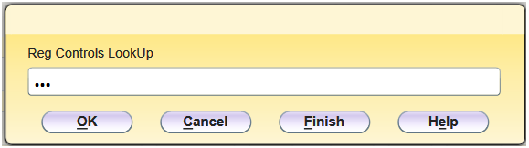

1. As shown in the illustration above, type three periods (which will display a list of all possible codes) and press ENTER.
2. Double-click “ACAD/CE.”

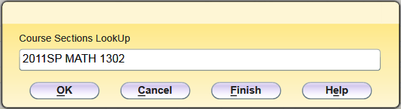

1. As shown in the above illustration, type the semester code and class (do not specify a section) and press ENTER . All sections of the class will be displayed.
2. Click the  button located at the top of the module when finished.

## Counselor Assignment (CNSL)

**Registration Clearance (Greenlighting a Student)**

A student has to be greenlighted before he/she can use WebAdvisor to add or drop classes.



1. In the Form Search box, type **CNSL** and press ENTER .
2. Pull up student via SSN (without hyphens), student ID #, or name search.

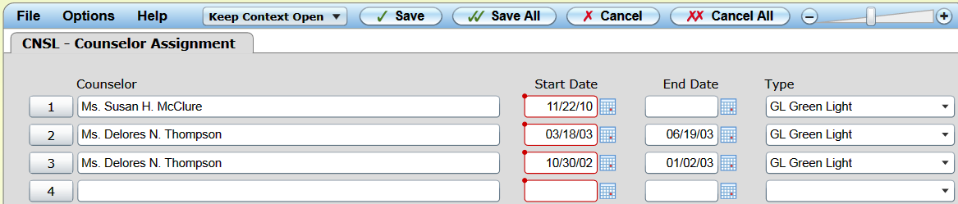

1. In the first empty **Counselor** field, type your name or Colleague number and press ENTER. If you get a list of names, double-click your name to choose it.
2. In the **End Date** field, enter (either type the date or use the calendar icon) the last date that greenlighting authorization will be accepted by your department.   
     
   ***CAUTION****: Ask your department chair what “End Date” your department uses.*
3. In the **Type** field, enter the code “**GL**” and press ENTER .
4. Press the function F9 key.

**Some departments allow Self-Advising**

**for qualified students**

1. Leave “End Date” empty
2. Enter the code “SA” in the “Type” field and press the ENTER key
3. Press the function F9 key

# ADVISING MODULES

The modules in this area of the manual are included in this manual to help you deal with students who need information about other classes, or programs that are offered through Amarillo College.

## Proposed Student Program (PSPR)

This is a “What if I Changed Majors” module to help students understand what classes would be needed if they changed majors.



1. In the Form Search box, type **PSPR** and press ENTER .
2. Pull up student via SSN (without hyphens), student ID #, or name search.
3. Specify the degree program:
   1. If the degree code is known, type it in the field and press ENTER.
   2. If the degree code is not known, type three periods and press ENTER to perform a lookup of all available degrees.
4. Double-click the current catalog year from the list.

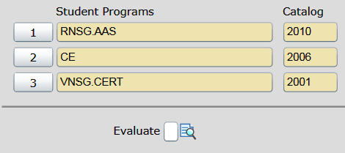

1. As circled in the illustration above, click the  icon next to the “Evaluate” field.
2. Press the function F9 key to display the text file. It will look identical to a normal   
   “Degree Audit” report (explained on page 1 of this manual). The difference is that the classes listed here are classes that pertain to a proposed degree plan.
3. Follow the directions on page 3 to print the report on a local printer.

***HINT****: It is suggested that you physically write, “Proposal” across the report before giving it to the student. Some students think you are actually changing their major. Only the student can change his/her major.*

## Student Academic Credits Inquiry (XSTI)

This module lists all academic classes a student has taken at AC. There may be times when a student claims to not understand why he/she was not allowed to take a class. This module even shows all classes that were purged for non-payment.



1. In the Form Search box, type **XSTI** and press ENTER .
2. Pull up student via SSN (without hyphens), student ID #, or name search.

|  |  |
| --- | --- |
| Enrollment Codes (in the “STAT” Column) | |
| N | New – added class before the 1st day of class |
| A | Added – added class after the 1st day of class |
| W | Withdrew from class |
| D | Dropped the class |
| X | Dropped the class before 1st day of class |
| TR | Transfer Credit |
| NC | Non-Credit |
| P | Student was de-registered (purged from system) |
| C | Class was cancelled |

## Transcript Course Listing (TRCL)

This module allows you to see a listing of all classes taken at Amarillo College for any given student.

**You can specify whether to see:**

* Academic classes
* Continuing Education classes
* Professional Development classes



1. In the Form Search box, type **TRCL** and press ENTER .
2. Pull up student via SSN (without hyphens), student ID #, or name search.
3. Enter one of the following codes, and press ENTER:
   1. **UG** – Academic classes
   2. **CE** – Continuing Education classes only
   3. **PD** – Professional Development workshop (credit only)
   4. **DV** – All academic classes including developmental
4. 

## Student Academic Transcripts (STAT)

This module allows you to see what classes the student registered for in any given semester.

This module also displays the cumulative GPA.

1. In the Form Search box, type **STAT** and press ENTER .
2. Pull up student via SSN (without hyphens), student ID #, or name search.
3. Type the transcript type code (listed below) and press ENTER .
   1. **UG** – Undergraduate (academic classes)
   2. **CE** – Continuing Education
   3. **DA** – Degree Audit
   4. **DV** – Developmental work since 5/96
   5. **PD** – Professional Development
   6. **VCT** – Non-AC students
4. Click the  icon, located in the **Term Creds** column next to the desired semester. A module named “Academic Credit Total Detail” will be displayed showing which classes were taken.
5. 

### Cumulative GPA

***NOTE****: The cumulative GPA will be listed at the right side of the screen, about half way down the screen.*

1. 

# MISCELLANEOUS MODULES

## Student Remark (STRK)

This module allows you to enter information into a student’s record. This is to help explain a situation as it occurs.



1. In the Form Search box, type **STRK** and press ENTER .
2. Pull up student via SSN (without hyphens), student ID #, or name search.

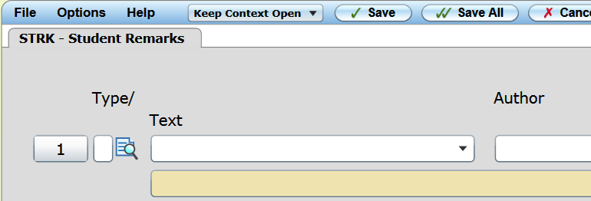

1. Click the  icon.
2. Enter the comment:
   1. Type the comment (see the following warning):

***Caution****: Since the student can view any comments that have been added to his/her academic record, word your comments appropriately.*

* 1. After typing the comment, press ENTER to move down to the next line.
  2. 

1. Press function key F9 to continue.
2. Use the drop-down arrow next to the **Text** field to select the general category of the type of comment being added.
3. In the **Author** field, type your Colleague number and press ENTER .
4. Use the drop-down arrow in the **Reference** field, and specify your position.
5. 

## Student Schedule (STSC)

This module shows if a student is enrolled in at least one academic class in the specified semester.



1. In the Form Search box, type **STSC** and press ENTER .
2. Pull up student via SSN (without hyphens), student ID #, or name search.
3. Type the semester code (Example: 2012SP), and the press ENTER .
4. 

## Registration Billing Summary (RGBS)

After you have registered a student, he/she may ask you how much is owed. The Registration Billing Summary module will list how much is owed.



1. In the Form Search box, type **RGBS** and press ENTER .
2. Pull up student via SSN (without hyphens), student ID #, or name search.
3. Enter the semester code for the current term (or any other one desired) and press ENTER .   
     
   The total amount owed will be displayed at the bottom of the form.