JoyScore #SelfCare Aloe Bud Fabulous Gratitude Journal House Party

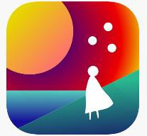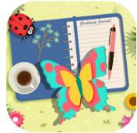

# Virtual Resources

Virtual Calming Rooms

[https://sites.google.com/cnusd.k12.ca.us/cnusdvirtualcalmingroom/home?fbclid=IwAR04ElUkt](https://sites.google.com/cnusd.k12.ca.us/cnusdvirtualcalmingroom/home?fbclid=IwAR04ElUkt3AJSj7aytCGBgTYEf92vPOelcJfMQA0ArjAMuqfTyLbimWYpBM) [3AJSj7aytCGBgTYEf92vPOelcJfMQA0ArjAMuqfTyLbimWYpBM](https://sites.google.com/cnusd.k12.ca.us/cnusdvirtualcalmingroom/home?fbclid=IwAR04ElUkt3AJSj7aytCGBgTYEf92vPOelcJfMQA0ArjAMuqfTyLbimWYpBM)

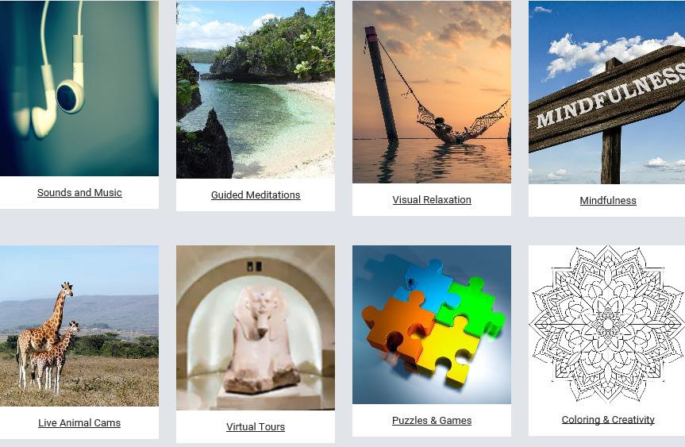

<https://sites.google.com/smusd.org/wpmsvirtualwellnessroom>

