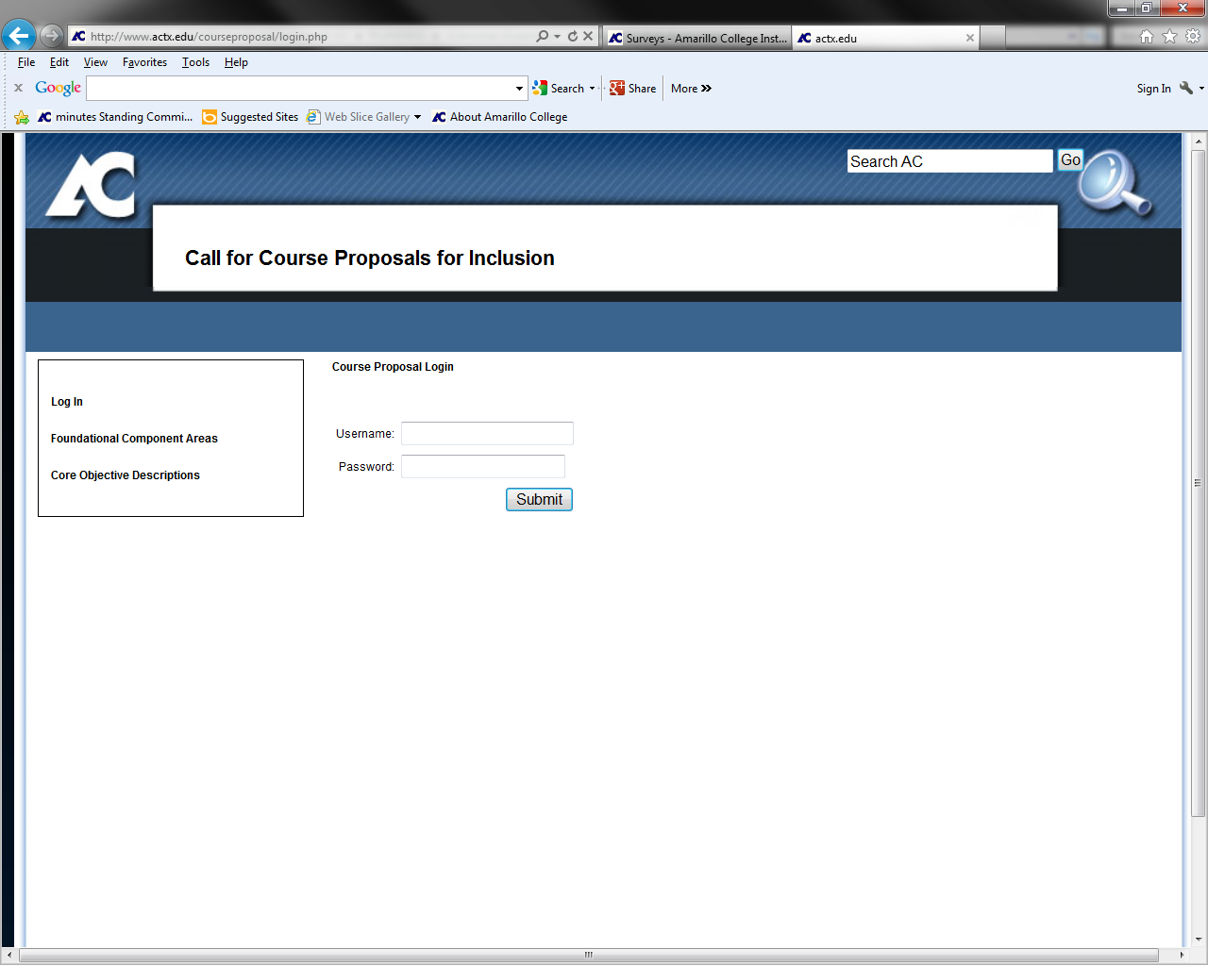

Web Address

Call for Course Proposals for Inclusion Home Page

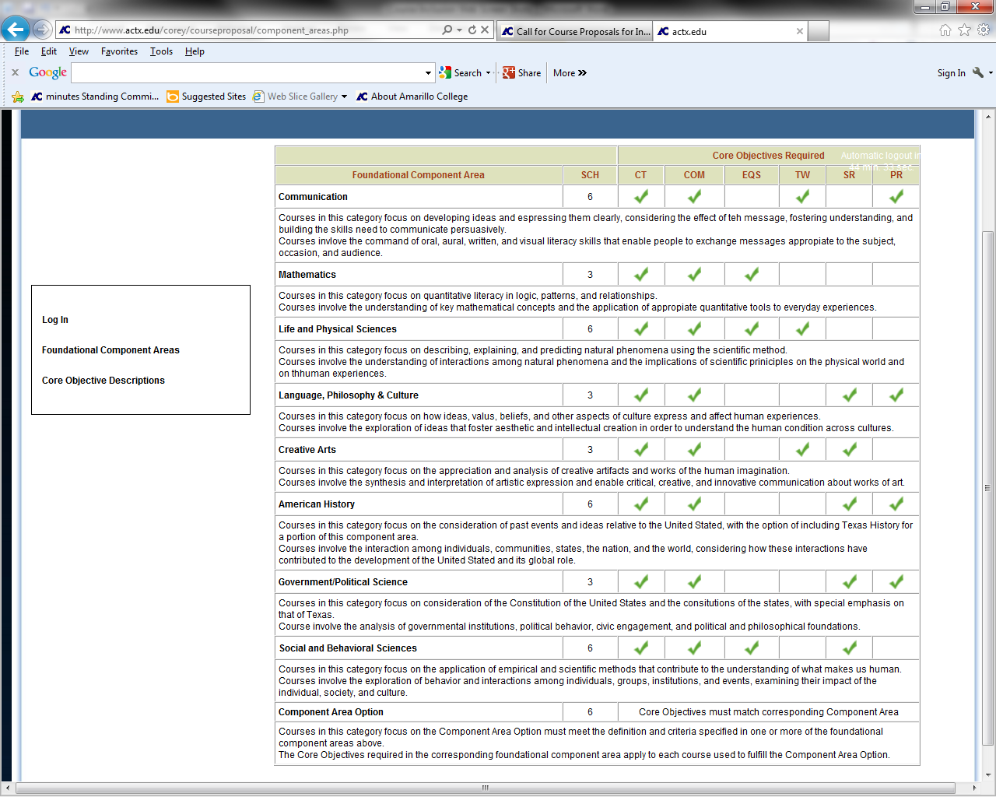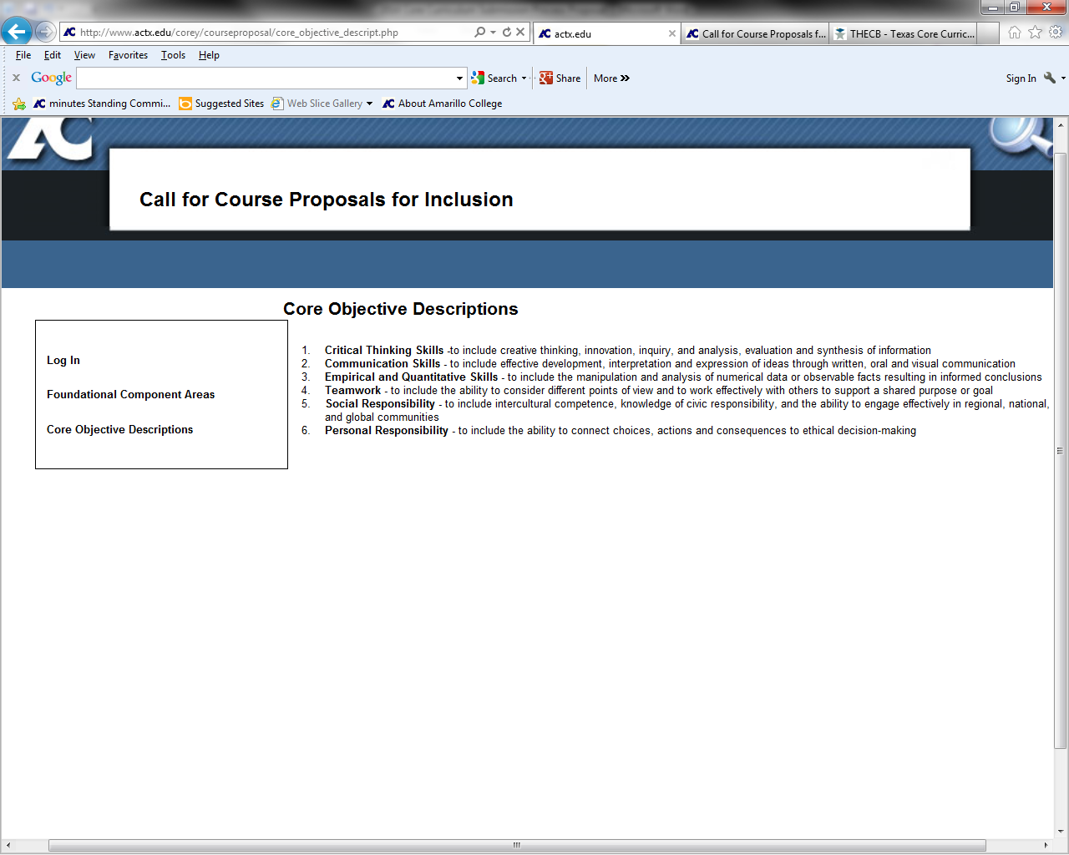

The “Foundational Component Areas” page can help you assure that you select the correct THECB-designated foundational component area for your proposed course.

Note: If you select this option while completing your proposal, it will take you out of your current screen and you will need to select the back button to get back into your proposal. Saving frequently is recommended.

The Core Objective Descriptions page can help you identify the THECB’s required core objectives and descriptions for your foundational component area.

Note: If you select this option while completing your proposal, it will take you out of your current screen and you will need to select the back button to get back into your proposal. Saving frequently is recommended.

The Core Objective Descriptions page is provided for reference purposes



Enter your regular   
AC Username and Password

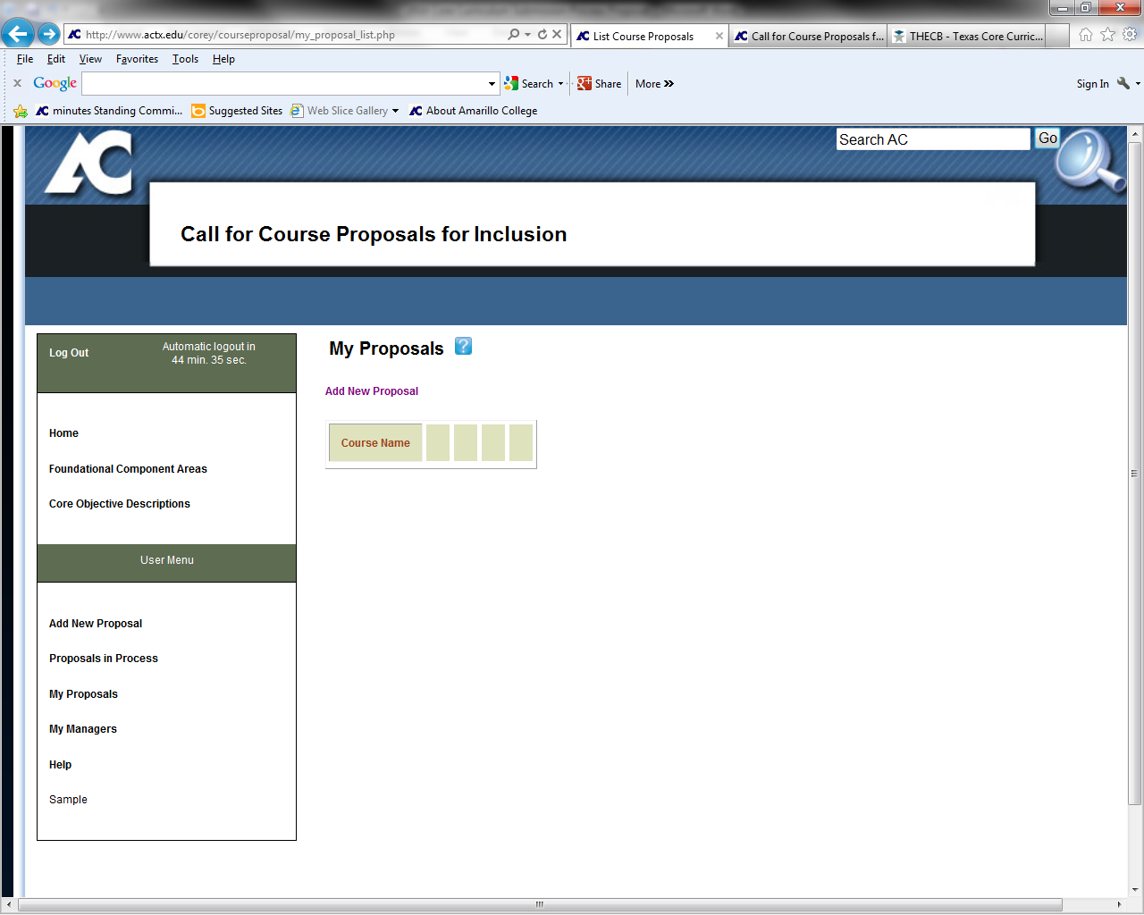

If mouse hovers over box, the following statement appears: “Proposals that you create.”

The “My Proposals” page appears when you login. Any of your existing proposals will be located on this page. If you need to add a proposal, select either of the available   
“Add New Proposal” links.

Note that you have a time limit.

Once you login, you will need to save your information before the automatic logout in order to ensure your information is saved.

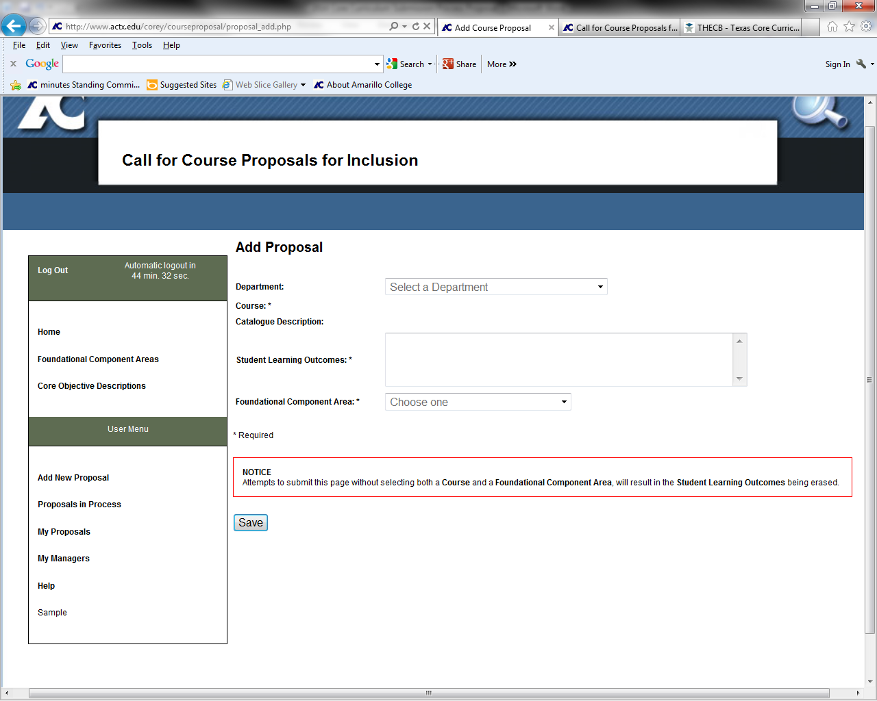

Once you select “Add New Proposal,” be prepared to select your department, course, and foundational component area.   
You will also have to enter the student learning outcome information for your course.

The Catalogue Description field will self-populate.

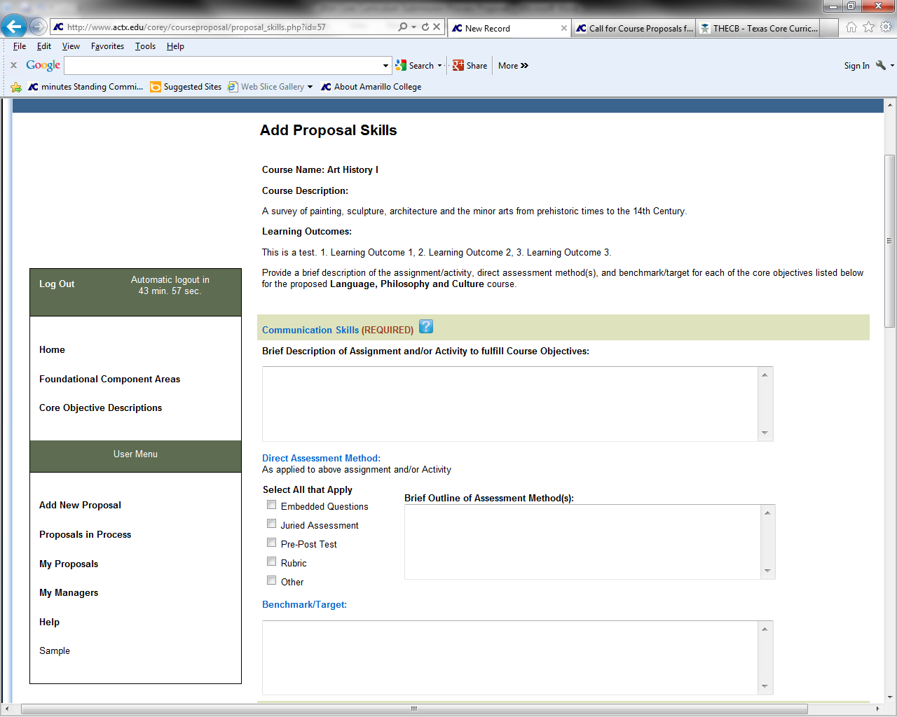

Once you enter your course information, a page will populate with all of the required core objectives for your selected foundational component area.   
You will need to enter the requested information for the four requested fields for each core objective area.

The Benchmark/Target links to a one page [cheat sheet](http://www.actx.edu/iea/filecabinet/424) that deals with defining a benchmark, providing a sample of a benchmark, and provides information on how to identify appropriate benchmarks.

Objective title links to [AC’s Competency Information and Rubrics](http://www.actx.edu/iea/index.php?module=article&id=67) that is used for a separate, institutional assessment initiative at Amarillo College. However, the competency information and rubrics include a paraphrase of the THECB’s core objective statement, AC’s operational definition, and provide a holistic rubric that might provide ideas to faculty as they seek to develop their own assessment method/s.

The Direct Assessment Method links to a one page [cheat sheet](http://www.actx.edu/iea/filecabinet/425) that deals with direct assessment. This sheet is very straight forward for faculty who might otherwise have little assessment background. As a result, the sheet focuses on direct assessment methods that are potentially the easiest to implement.

If mouse hovers over box, the following statement appears: “Proposed Course Must Include This Skill”

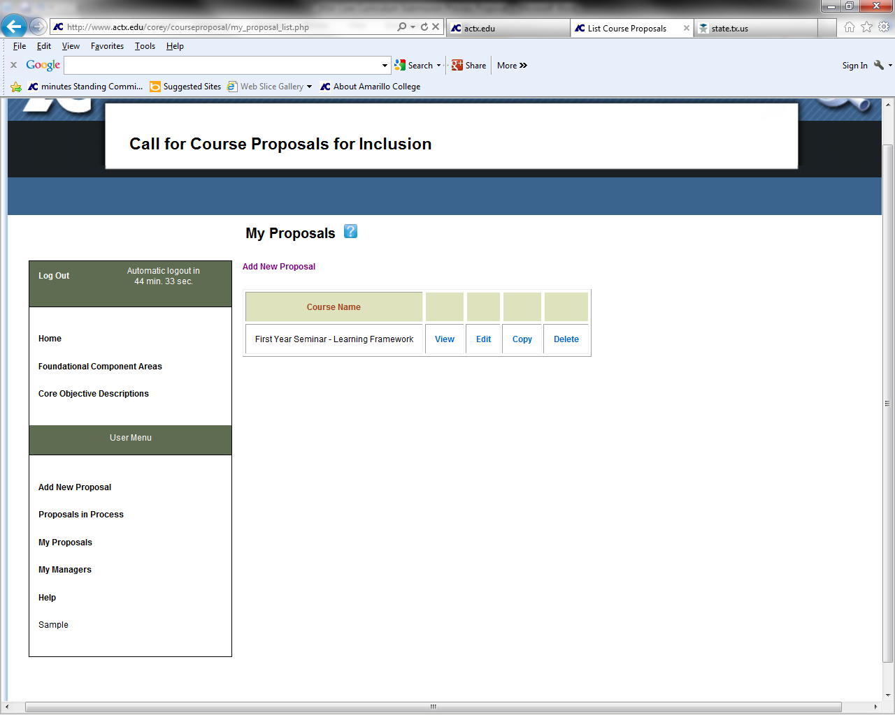

Once a document has been saved on the “Add Proposal Skills” (previous screen shot) page, you will be taken back to your “My Proposals” page.

The “View” option gives you the option to export your proposal to a pdf format.

If you wish to edit or delete your proposals, you must do so on this page.

You may also copy your existing proposal information into the proposals for other closely-related classes that you wish to propose for core inclusion.

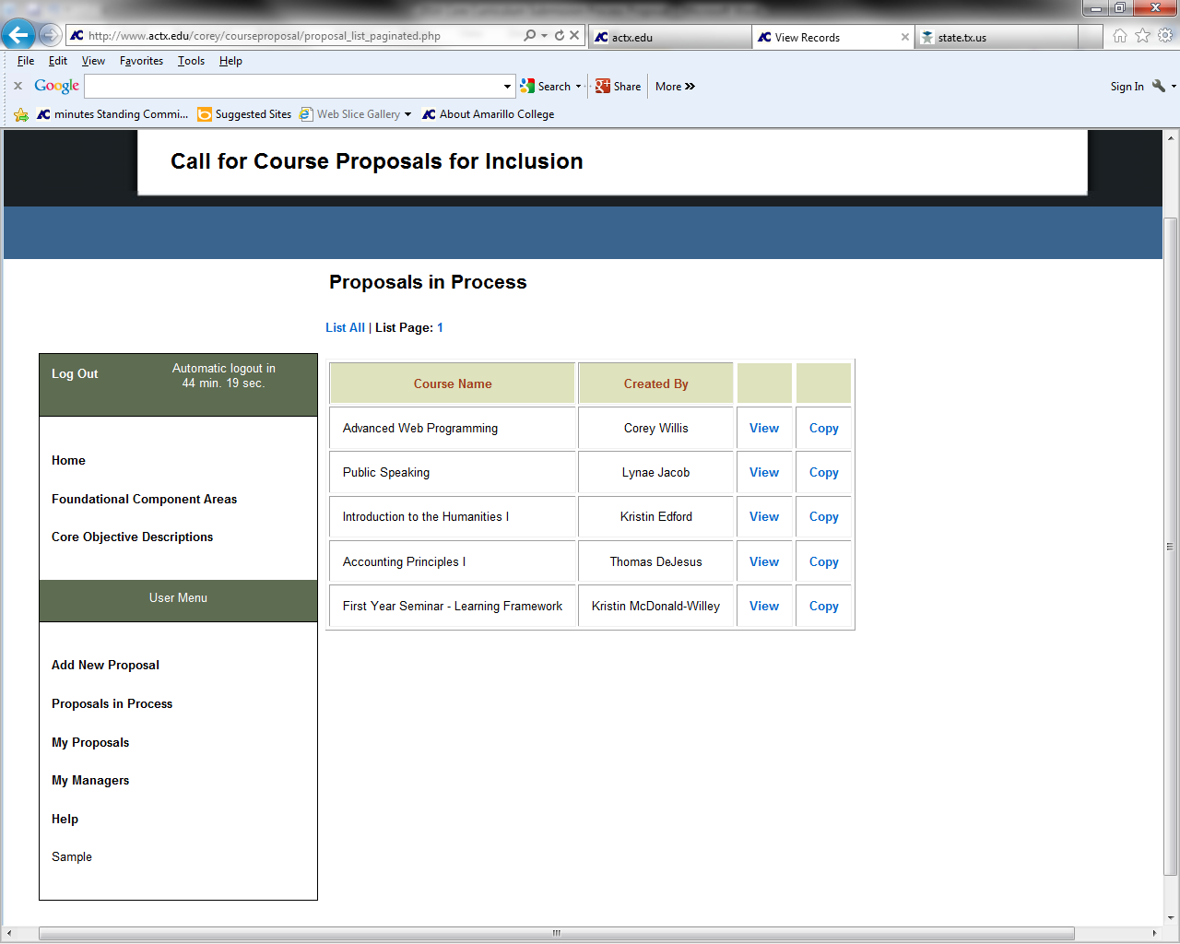

Each faculty member’s saved proposals will appear on the “Proposals in Process” page.

You can view or copy other people’s proposals on this page. Once you view a proposal, you can access a hyperlink at the top of the page that will allow you to export other proposals to a pdf format.

“My Managers” allows more than one person to have access rights to edit a form.

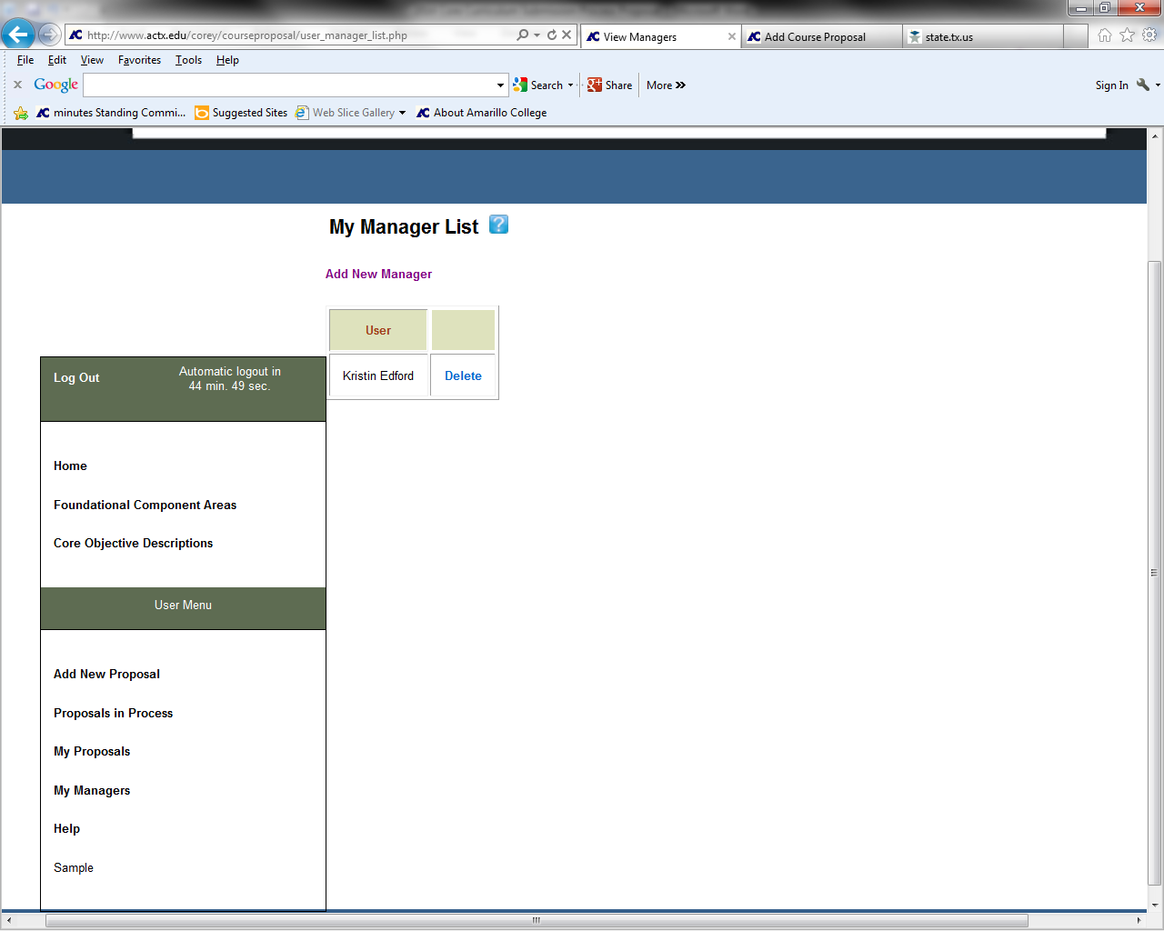

“My Managers” allows the user to grant editing access rights of their form to other AC faculty members/administrators.

To grant access rights, select “Add New Manager” at the top of the page.

If mouse hovers over box, the following statement appears:

“User(s) granted permission to manage any proposal you create. These users are allowed to Edit any proposal you create. ”

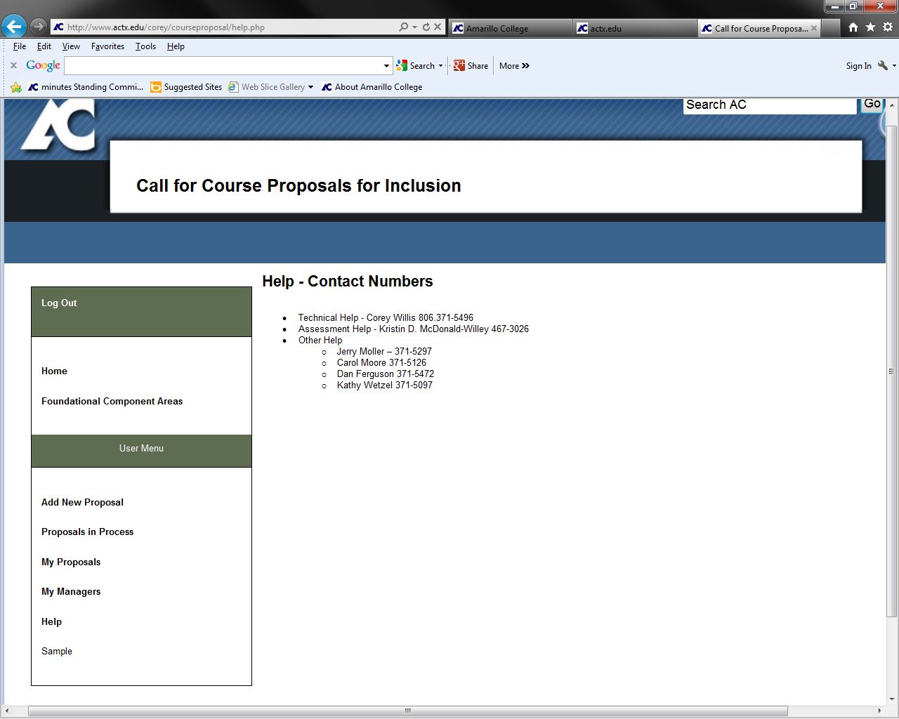

Some members of the Core Curriculum Redesign Task Force have been identified as points of contact for questions regarding the new core curriculum or new core curriculum assessment.

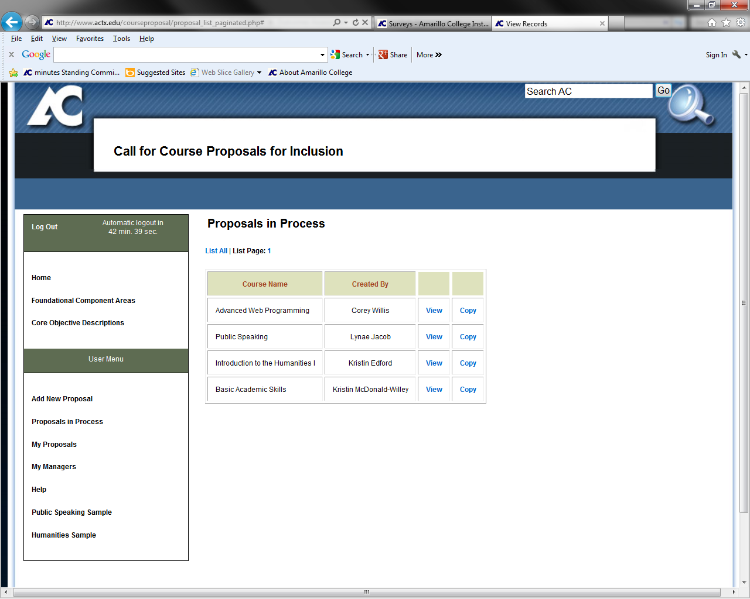

Under the “Help” option on the **User Menu**, at least two sample submissions of completed proposal forms will be available to faculty who complete a form. The samples have been developed by members of the Core Curriculum Redesign Task Force. (On previous screens this said “Sample,” but as long as the samples are active, the actual, full sample titles will appear to the user.)

**ADDITIONAL HELP RESOURCES**

Help resources to those who complete this form are available on the [Core Curriculum Development and Assessment Web page](http://www.actx.edu/iea/index.php?module=article&id=103).