|  |  |
| --- | --- |
| [Home](http://www.actx.edu/iea/index.php?module=article&id=44) [Back To Forms List Page](https://iresearch.actx.edu/iea/noninstructional.aspx?mode=1) | |
| https://iresearch.actx.edu/iea/images/AC2_transparent.gif | Program Review |
| Form for Completion of Self Study |
| Non-Instructional |

The ID number for this form is 196. You will need this number to update or edit your submission in the future.

Name of Division: Academic Affairs

Name of Department: Testing Services

Name of Program: Testing Services

This Program Review is being conducted during year: 2010-2011

**I. Office's/Department's Purpose**

A.) State the purpose of the office/department. How is this purpose within the mission of Amarillo College?

The purpose of Testing Services is to support students, staff, and the community by providing various assessment services for students, prospective students, and members of the community. Testing Services fulfills the Amarillo College mission “Enriching the lives of our students and our community” by offering required exams for students, professional and standardized exams for the community, and services for faculty and staff.

B.) When was the last time the office's/department's purpose statement was reviewed/revised by faculty and staff in the office/department?

Reviewed annually as part of the PET review process.

C.) Is this office/discipline required to receive approval from an external agency or organization in order to offer courses?

no

**II. Office's/Department's Improvements based on Planning, Evaluation and Assessment**

A.) Identify at least on example of an improvement/revision which resulted from the past five-years annual PET forms.

In 2007, Testing Services began tracking the number of students continuing their education at Amarillo College after completing their GED with Amarillo College. In an attempt to increase college recruitment for passing GED examinees, Testing Services composed postcards emphasizing the importance of higher education and explaining the steps required to enroll at Amarillo College. Testing Services mailed these postcards to each passing GED examinee.

Testing also teamed up with Maury Roman-Jordan at Community Link to invite passing GED examinees to visit Amarillo College campuses and enter into drawings for scholarship opportunities. Furthermore, Testing has developed an Excel spreadsheet that will be used to extend a personal call to passing GED examinees in order to offer our services to help examinees enroll at Amarillo College.

Because of our efforts, Testing Services was able to increase GED college recruitment from 6% in 2007 to 21.3% in 2009.

**2010/2011 TESTING PET FORM:**

**Planning and Evaluation Tracking**

**College Year: 2010-2011**

**Division of:** Enrollment Management **Person Responsible:** Robert Austin/ April Sessler

**Department of:** Testing Services **Person Responsible:** Melissa Wilson

**Purpose Statement:** Testing Services supports instruction, academic planning, and the community by providing various assessment services for students, prospective students and members of the community.

**Goal Statement #1:** Testing Services will increase GED college recruitment.

**Objectives/Outcomes (including assessment tools and standards):** After sending our follow up information postcards to passing GED students; GED students will take the appropriate steps to enroll in classes at Amarillo College. Annual comparative studies will show a 2% increase in enrollment from passing GED students.

**Results:**

January 2007-December 2007: 6%

January 2008-December 2008: 17%

January 2009-December 2009:

**Use of Results (including improvements and revisions):**

**Analysis:**

Following up with passing GED examinees has proven to increase Amarillo College enrollment.

**Plan of Action:**

Testing Services has teamed up with Maury Roman Jordan, from Community Link, to help recruit passing GED examinees. Maury and her team have composed letters inviting passing GED examinees to come to Amarillo College and visit Community Link for further information along with scholarship opportunities. Testing Services will close this goal due to the shift of GED recruitment efforts.

**Goal Statement #2:** Testing Services will increase the percentage of passing GED examinees attending the GED graduation ceremony in March and September.

**Objectives/Outcomes (including assessment tools and standards):** After personally contacting GED candidates who are eligible to attend the GED graduation ceremony prior to the graduation date, we will show a 10% increase in graduation attendance.

**Results:**

March 2009: 21.6%

September 2009: 21.4%

March 2010:

**Use of Results (including improvements and revisions):**

**Analysis:**

Due to the increase in attendance, graduates will be encouraged to attend Amarillo College. Others will be encouraged to complete their GED. The community will be more aware of GED services Amarillo College provides.

**Plan of Action:**

We will continue to monitor these results and tweak our communication methods to best reach potential students and increase enrollment.

**Goal Statement #3:** Increase the number of examinees taking the CLEP exam.

**Objectives/Outcomes (including assessment tools and standards):** After promoting the benefits of CLEP by:

a. Updating and reminding Advisors to talk to each student about CLEP opportunities,

b. Building a CLEP segment into our Accuplacer training session for high school counselors,

c. Adding a message to the Accuplacer score sheet notifying students of the benefits of CLEP,

d. Speak with Division Heads to incorporate more acceptable CLEP exams.

Testing Services will show a 10% increase in the number of examinees taking CLEP exams.

**Results:**

*Base Year*

September 1, 2009- August 31, 2010: **176**

September 1, 2010-August 31, 2011:

**Use of Results (including improvements and revisions):**

**Analysis:**

**Plan of Action:**

B.) Identify at least one example of improvements/revisions which resulted from the last Program Review.

In response to the 2003/2004 program review, Testing Services changed the reporting structure for Testing Services. Because of this change, the Director of Testing now reports to the Associate Vice President of Student Affairs, and there is a clear structure for reporting and referral.

C.) Identify at least one example of an improvement/revision that is a response to accomplish a strategy or tactical objective within the Strategic Plan 2010-2015.

Strategy 2.1 of the 2005-2010 strategic plan states that one goal is to, “Identify and remove institutional barriers to college enrollment.” In order to accomplish this task, Testing Services has changed the downloading procedures for Accuplacer, allowing students to go directly to advising to enroll in classes.

In the current strategic plan for 2010-2015, Testing Services is listed in item 4.2.3.1 to create more space for students and the community. Testing is currently waiting on the Master Facilities Plan to begin expansion.

<http://www.actx.edu/strategic/files/filecabinet/folder4/Strategic_Plan_Through_2015.pdf>

D.) Provide names and titles of those who determined the assessment process used to evaluate the office/department.

Robert Austin, Vice President of Student Affairs

April Sessler, Associate Vice President of Student Affairs

Melissa Wilson, Director of Testing Services

E.) For client/student outcome assessments, review the five-year graph(s) *quantitative* results or provide a brief narrative summary of *qualitative* results.

The following question is not applicable to non-instructional departments; however, the information and graph below show the yearly outcome comparison of GED exams that Testing Services has administered over the past 5 years:

|  |  |  |  |  |  |
| --- | --- | --- | --- | --- | --- |
| ***GED - June 2011*** | | | | | |
| ***EXAM*** | ***2005/2006*** | ***2006/2007*** | ***2007/2008*** | ***2008/2009*** | ***2009/2010*** |
| GED | 1,233 | 2,863 | 3,110 | 3,094 | 3,204 |

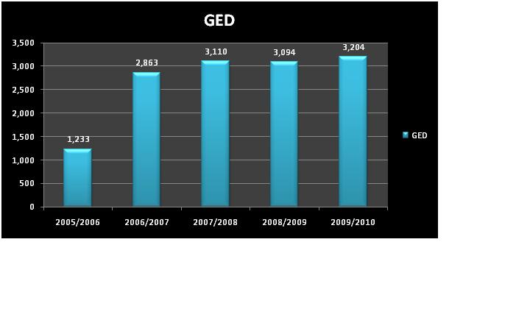Cooperative arrangements with educational partners have resulted in an increase in number of individuals who take the GED through the Amarillo College Testing Center. The graph above illustrates the 160% increase in business.

1. What changes have been made in the services of the office/department because of the analysis of these results?

Because of the increase in GED examinees, Testing Services has decreased Orientation/Registration time and changed the GED testing schedule to accommodate more examinees. Testing Services is looking at reconfiguring the Testing Center lab to transition to computer based GED testing in June 2011.

F.) Provide the five-year graph(s) indicating the demand for the office's/department's services.

1. Assess the need for the office/department

The following information and graph show the number of exams administered by Testing Services for the last four years:

|  |  |  |  |  |  |
| --- | --- | --- | --- | --- | --- |
| **COMPARISION OF YEARLY TOTALS** | | | | |  |
|  |  |  |  |  |  |
| ***EXAM*** | ***2006/2007*** | ***2007/2008*** | ***2008/2009*** | ***2009/2010*** |  |
| GED | 2,863 | 3,110 | 3,094 | 3,204 |  |
| CLEP | 112 | 93 | 176 | 174 |  |
| ACT | 998 | 959 | 1,158 | 1,097 |  |
| SAT | 1,400 | 1,542 | 1,520 | 1,426 |  |
| AC Placement Test | 15 | 40 | 20 | 10 |  |
| Instructional | 3,198 | 2,188 | 2,800 | 2,357 |  |
| THEA | 47 | 33 | 15 | 18 |  |
| THEA Quick Test | 126 | 88 | 174 | 141 |  |
| Accuplacer | 6,817 | 7,683 | 8,339 | 9,630 |  |
| Miscellaneous | 2,139 | 1,855 | 961 | 550 |  |
| ***Total:*** | 17,715 | 17,591 | 18,257 | 18,607 |  |
|  |  |  |  |  |  |

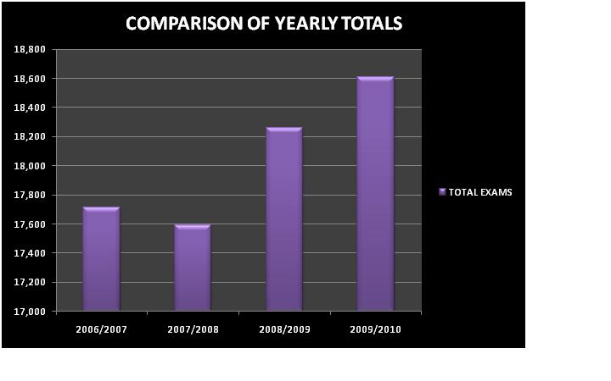

The Texas Success Initiative of the Texas Higher Education Coordinating Board requires that all students entering a public college or university be tested or be exempt from testing, including dual credit students. In order to satisfy the requirements of the state, Testing Services provides this service by administering Accuplacer, THEA, and THEA Quick Test.

In addition to the Texas state requirements, Testing Services parallels the mission of the college by providing [additional testing services](http://www.actx.edu/testing) to our students, staff, and community.

**III. Resources**

A. Library

1.) Which of the following library collections/resources/services have been used by the staff and/or students within the past five years? (Select all that apply)  
  
Interlibrary loan  
Meeting services  
Seminars/conferences

2.) Which 2 or 3 collections/resources/services should be improved to support Amarillo College's mission regarding teaching and service?

The following services could be improved regarding teaching and service:

1. Offer a larger meeting space.

2. Offer extended hours to students.

3.) Does your office/department have an external approver (other than the Texas Higher Education Coordinating Board)?

Yes

A. How has the library participated in the approver's evaluation?

The library has not participated in the approver’s evaluation.

B. What approval schedule is required by the external approver?

To administer SAT, SSAT, ACT, ASE, GED and professional exams, Testing staff is required to receive approval once a year. To administer CLEP and Accuplacer, Testing staff receives training and then updates training materials via the web when necessary.

C. When did the office/department last receive approval?

Test Name Approval Dates

SAT June 2010

SSAT June 2010

Accuplacer June 2008

CLEP July 2010

ACT June 2010

ASE June 2010

GED December 2010

Professional Exams Kryterion – April 2010

Professional Exams IQT/ISO – January 2011

Professional Exams Castle Worldwide – January 2011

B. Technology and Security/Privacy

1.) After assessing the strengths and weaknesses of the office's/department's access to technology, what improvements would ensure that the students have access and training in the use of technology?

The following improvements would insure that students have access and training in the use of technology:

1. Increase wireless reliability in the Student Services Building. An increase in wireless reliability would allow Testing Services to use laptops to administer exams anywhere in the Testing Center. With the unreliability of wireless connections in our building, IT has advised against using laptops because of disruptions and unreliability.

2. Increase in the number of computers available for student access.

3. Increase IT knowledge concerning technology for examinees with disabilities.

2.) What improvements would ensure that students use technology?

To ensure that students use technology, Amarillo College needs to increase the number of computers and space available to students. Students also need clear and direct instructions on how to access information, especially through WebAdvisor and AC Online.

3.) Review office/department operations. Does any operation present the possibility for violations of security, confidentiality, or integrity of student records?

No

C. Support Services for Students

1.) Which support services need to be strengthened to better serve the students in or served by this office/department? Explain what aspects of the services need to be strengthened.

1. Communication between departments within the division would better serve students in Student Affairs. One morning or afternoon a month for the division to get together and discuss changes and ways to streamline the registration process would be beneficial for both staff and students.

2. Transitioning to all online forms would beneficial for both students and staff. Use of College Property forms and Disability forms that could be managed completely online would save staff and student’s time and frustration.

2.) Describe any indicators or problems that prevent a healthy, safe and secure environment for staff and students of this office/department.

1. The air vents on the south side of the Student Services Building not only allow air to flow into Testing but it also allows cigarette smoke to filter directly into the building when anyone smokes in this vicinity.

2. In July 2010, Disability testing was transferred to Testing Services. Testing Services does not have an adequate setup to fully serve our disability students. Testing lacks handicapped buttons on our doors for disability students to enter and exit testing rooms. Testing also lacks dedicated space for disability students to test if they need an individual testing room.

3. During the severe weather months, Testing Services is unable to hear the tornado sirens leaving staff and examinees vulnerable.

4. Lighting and campus security is a concern for Testing staff. Testing Services is open extended hours and is staffed by one or two employees. When the employees leave in the evening, the campus is often dark and deserted, especially when the security and parking lot lights fail to come on. It is also difficult to find police assistance on campus, both during the evening hours and during weekend testing sessions.

5. Testing Services is concerned about Amarillo College’s weapons policy on campus. Amarillo College services a variety of students ranging from students straight out of high school to veterans returning home from war. Currently, Amarillo College’s weapons policy allows students to legally carry certain weapons on campus as long as they are visible. With Testing Services already being a source of anxiety for students and opened extended hours with little staff, Testing would feel safer if no weapons were allowed on campus.

3.) Describe any indicators or problems that hamper adequate physical facilities, both on and off campus, to meet the needs of the office/department.

1. Testing Services has outgrown its current space. Testing rooms lack sufficient computers, desks, and space to meet the demands of our students and community.

2. In July 2010, Testing Services absorbed Disability Testing. In order to service our disability students, Testing needs to add handicapped buttons to all testing room doors and add individual testing rooms for students that need to test in an individual space.

3. The restroom facilities available to Testing Services are difficult to get to and often busy and unsanitary. Testing Services is required to provide close and easily accessible facilities in order to monitor examinees.

**IV. Budget**

A.) Which office/department outcomes have resulted in budget requests to date?

|  |  |  |  |  |  |
| --- | --- | --- | --- | --- | --- |
| 5 YEAR BUDGET COMPARISON | | | | | |
| **Expenses** | | | | | |
|  |  |  |  |  |  |
|  | ***2005/2006*** | ***2006/2007*** | ***2007/2008*** | ***2008/2009*** | ***2009/2010*** |
| Appointed Personnel | $139,679.00 | $136,470.00 | $142,340.00 | $139,327.00 | $143,721.00 |
| Non-Appointed Personnel | 22,366.00 | 32,000.00 | 32,000.00 | 32,000.00 | 34,000.00 |
| Supplies | 37,100.00 | 41,100.00 | 57,600.00 | 59,800.00 | 62,150.00 |
| Travel | 1,300.00 | 1,300.00 | 1,300.00 | 1,300.00 | 1,300.00 |
| Other | 1,500.00 | 1,500.00 | 1,500.00 | 1,600.00 | 1,675.00 |
| Total Expenses: | $201,945.00 | $212,370.00 | $234,740.00 | $234,027.00 | $242,846.00 |
|  |  |  |  |  |  |

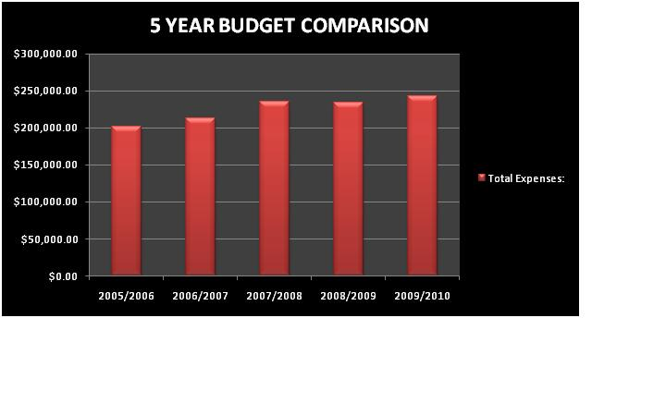

1. Testing increased personnel budget for raises and cost of living adjustments.

2. Testing increased the supply budget to pay for the increased number of students taking Accuplacer exams.

3. Testing’s travel budget remained the same.

4. Testing increased the “Other Pool” for increases in postage and shipping.

|  |  |  |  |  |  |
| --- | --- | --- | --- | --- | --- |
| 5 YEAR BUDGET COMPARISON | | | | | |
| **Revenue** | | | | | |
|  | ***2005/2006*** | ***2006/2007*** | ***2007/2008*** | ***2008/2009*** | ***2009/2010*** |
| Total Revenue: | $103,308.50 | $138,485.19 | $144,278.00 | $175,533.47 | $198,483.05 |
|  |  |  |  |  |  |

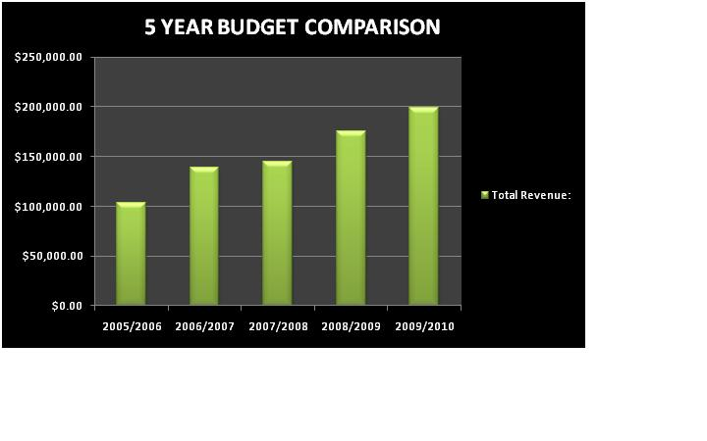

Increases in revenue can be attributed to the increase in the number of students taking Accuplacer and GED.

B.) Project the office's/department's strategic initiatives for the next five years based on the office's/department's outcomes.

During the next five years, Testing services plans to:

1. Increase testing space and the number of computers in the testing lab to accommodate the increased demands of our students and our community.

2. Transition to computer based GED testing allowing a speedier turnaround time for scoring and a flexible schedule for examinees.

**V. Publications**

A.) If the office/department publishes any advertising or recruitment documents (electronic or paper), do the documents accurately represent Amarillo college and the program/department?

Yes

B.) Does the office/department publish any documents (electronic or paper) with references to SACS accreditation?

**VI. Other**

A.) State any additional comments/concerns which may impact this office/department during the next five years.

Testing Services is the first stop for 90% of the student population and serves as the first impression of Amarillo College. Testing lacks the appropriate space and equipment to effectively serve students and the community.

The results of the 2003-2004 program review demonstrate the same concerns Testing faces today. Testing is evolving. More and more exams are transitioning from paper/pencil based assessments to computer-based assessments. To keep up with current changes, Testing Services needs the proper space and equipment for students and the community.