|  |  |
| --- | --- |
| [Home](http://www.actx.edu/iea/index.php?module=article&id=44) [Back To Forms List Page](https://iresearch.actx.edu/iea/noninstructional.aspx?mode=1) | |
| https://iresearch.actx.edu/iea/images/AC2_transparent.gif | Program Review |
| Form for Completion of Self Study |
| Non-Instructional |

The ID number for this form is 209. You will need this number to update or edit your submission in the future.

Name of Division: Enrollment Management

Name of Department: Advising

Name of Program: Advising Services

This Program Review is being conducted during year: 2010-2011

**I. Office's/Department's Purpose**

A.) State the purpose of the office/department. How is this purpose within the mission of Amarillo College?

The mission of Amarillo College is to enrich the lives of our students and communities. The Student Affairs Division coordinates the recruitment and retention of current and prospective students. The Student Affairs Division staff works as a team to serve students, support the academic mission of Amarillo College, and to maintain optimal enrollments. Student Affairs team members strive to provide enrollment-related services that are seamless, customer-friendly, and efficient. The Advising Department, by assisting students and prospective students to identify and achieve their educational and career goals, directly supports this institutional mission. The Advising Department supports the AC mission through a wide range of educational programs, services, and resources for the surrounding area. By offering the following programs and coordinating services to students, staff and the community, Advising Services parallels the Amarillo College mission, enriching the lives of our students and communities:

* **Academic Advising**-- Academic advising is the process whereby advisors and students work together to attain student educational and life goals. Through frequent communication and collaboration, initiated by both student and advisor, students will realize their maximum education potential. Consequently, the advisor serves as a facilitator of communication, a coordinator of learning experiences, and an agent of referral to other campus departments, services, and community resources. At Amarillo College, an institution where we strive to "put the student first," advising is an integral part of the learning process for our students, faculty and staff. Effective advising benefits the entire college community, fosters strong community relationships, and helps us to meet AC's mission of providing excellent, high quality, affordable educational opportunities for our students. Academic Advising, a shared responsibility among the student, advisor and college community, promotes individual growth by developing a dynamic plan to reach the student’s educational, career and life goals. Academic advising strives to develop suitable educational plans and customized programs of study for each student, to teach students how to monitor progress toward established educational goals, to encourage students to utilize college support services and community resources, and to raise graduation and transfer rates at Amarillo College.
* **Career & Employment Services**-- Career and Employment Services provide comprehensive assistance to students, potential students, alumni, and the community. As facilitators of the career life-planning process we offer strategies for making positive career choices which enhance student learning and support students through graduation and their transition from the classroom to the workplace. The department serves community needs by providing a range of services and resources to individuals and to local area employers. These coordinated efforts support student success, foster community partnerships, and address the needs of our diverse job-seeking community.
* **Adult Students Program**-- The Adult Students Program provides financial assistance to adult students (usually 24 years of age & older) who qualify through tuition scholarships, childcare, transportation (gasoline reimbursement), and a textbook lending program to aid today's adult student in getting his or her degree. ASP conducts an annual book sale to raise funds for student scholarships, a Christmas adopt-a-student project, and an annual banquet to celebrate the success of adult students’ victory over life obstacles and achievement of success through education. This program serves community needs by providing a range of services and resources to Amarillo College students to enhance student persistence, graduation and academic success.
* **Transfer Services**—Transfer Services mission is to provide access, guidance, and academic support to students in a nurturing, diverse, respectful, and supportive environment that assists students in making a successful transition to college and appropriate majors, while developing the foundations of civic engagement and lifelong learning. Transfer Services assists students who wish to pursue their education beyond the Associate’s degree by providing programs and services in the form of University Transfer Advisors on campus, updated Transfer Center, information sessions, and ongoing communication with students that attempts to provide a seamless transfer process for Amarillo College students to the four year college or university.
* **Student Success Programs**- Through comprehensive Student Success & First-Year Experience programs, Amarillo College will help students optimize their educational experiences and achieve their dreams, goals, and potentials. First Year Experience (FYE) & Student Success is a unique program that provides new college students with the support that's needed to make a successful transition into college. The focus of FYE is preparing students for the academic and personal challenges they face in college and teaching them the skills that will help them to succeed and thrive in a college environment. As part of the program students develop personal awareness, lifelong learning skills, and connections with other students and faculty. Students receive individual college planning, referrals to college resources, and assistance in meeting their academic and personal goals. Programs include: the Common Reader Program, New Student Orientations (other than badger Boot Camp), and Student Success (STSU 0211) and Learning Frameworks (PSYC 1200) courses.

B.) When was the last time the office's/department's purpose statement was reviewed/revised by faculty and staff in the office/department?

The Advising Department was restructured and put under new direction in 2007. There was a campus wide ad hoc Advising Task Force, which included many advisors from the current Advising Department, that was created with the goal of reviewing the advising structure for the college and to make recommendations to the Vice-President of Development & the Vice-President of Instruction for approval. At that time, the department's mission statement and purpose was reevaluated and rewritten. The vision of the Advising Department is to be a center of excellence at Amarillo College where all Amarillo College resources (faculty, staff, and technology) are aligned to promote a career-focus with our work with students; whereas student needs are our first priority. Mission and goals are also evaluated regularly through the PET process.

[Advising Task Force Recommendations](http://cis7.actx.edu/ACLibrary/student_affairs/Advising/Advising%20Task%20Force%20Recommendations.PDF)

[Advising Department Organization Chart](http://cis7.actx.edu/ACLibrary/student_affairs/Advising/Advising%20Department%20Organizational%20Chart.docx)

C.) Is this office/discipline required to receive approval from an external agency or organization in order to offer courses?

Yes

1. Identify any external approvers for the office/department.

The Advising Department is not specifically accredited or monitored by agencies or organizations; however, the Advising Department follows the CAS Standards and the core values set forth by the National Academic Advising Association.

[CAS Standards for Academic Advising](http://www.cas.edu/getpdf.cfm?PDF=E864D2C4-D655-8F74-2E647CDECD29B7D0)

[NACADA Core Values](http://www.nacada.ksu.edu/Clearinghouse/AdvisingIssues/Core-Values.htm)

Several Advising Department personnel also hold certifications or licensures that are monitored by state or national agencies. These include Texas Licensed Professional Counselor (LPC) monitored by the Texas Department of Health; National Certified Counselor (NCC) and National Certified Career Counselor (NCCC) monitored by the National Board for Certified Counselors; Texas teacher certification monitored by the Texas Education Agency (TEA), and Registered Professional Educational Diagnostician monitored by the Texas Association of Educational Diagnosticians.

2. What approval schedule is required by the external approver(s)?

N/A

3. When did the office/department last receive approval?

N/A

**II. Office's/Department's Improvements based on Planning, Evaluation and Assessment**

A.) Identify at least on example of an improvement/revision which resulted from the past five-years annual PET forms.

See attached PET form below for Advising Department 2009-2010:  
  
[Advising Department PET Form 2009-2010](http://cis7.actx.edu/ACLibrary/student_affairs/Advising/PET%2009.10%20Advising%20Department.doc)  
  
The Advising Department has made numerous improvements resulting from the past five-years annual PET forms. The Adult Students Program has focused advising and scholarship assistance to increase college persistence. We have also restructured our Career Services planning sessions, career assessment used, and student survey based on our PET data from the past five years.

B.) Identify at least one example of improvements/revisions which resulted from the last Program Review.

The last Program Review was completed in 2003-2004. The Program Review Committee made many commendations regarding the Advising Department's services, but also made a few recommendations to enhance services. All were considered and implemented:  
  
1. The present advising plan contributes to a “run around” effect, which reduces efficiency and effectiveness for staff and students. Consider restoring the division liaison plan.  
*In response to this recommendation, the Advising Department created a centralized structure where the Advising Center General Studies advisors report to the Director of Advising, but also created division advisors housed in the division that also report to the Director of Advising. There are currently seven division advisors: 1 for Allied Health/Criminal Justice, 1 for Sciences & Engineering, 2 for Nursing, 1 for Languages/Communications/Fine Arts, 1 for Behavioral Studies, and 1 for Business/ITT. This model has been very successful. This allows for a program specific expert to be housed in the division to advise those majors, but also allows for seamless communication, training, and supervision with the centralized advising model.*2. Technology is not fully utilized by Advising and Counseling staff. In some cases, negative attitudes about the capabilities of technology, primarily WebAdvisor, are communicated to students. The recommendation was that the Advising Department should work with ITS to understand improvements to WebAdvisor software, and build Advising Department staff confidence in using WebAdvisor and encourage student use. *WebAdvisor is utilized fully in the Advising Department, and advisors are trained and also train students in the use of WebAdvisor. The department utilizes technology fully to enhance student advising interactions and to make advising and registration more efficient for advisors and students. The Director of Advising also represents the department on the Administrative Committee for Technology so that the department can be up-to-date on changes, new implementations, and so that concerns can be addressed.*3. The lack of cross training among Advising and Counseling staff contributes to reduced efficiency and delayed project completion. For example, the online Advisor’s Handbook has not been updated since retirement of the counselor who was previously responsible. The recommendation was that the Advising Department should institute cross-training procedures.  
*Cross-training has been implemented in the Advising Center, and each division advisor has a back-up advisor that is trained to be able to step-in to provide advising services for their majors. This is an ongoing process, and will continue to be addressed and fully implemented in the Advising Department.*

C.) Identify at least one example of an improvement/revision that is a response to accomplish a strategy or tactical objective within the Strategic Plan 2010-2015.

Goal 1: Expand Student Success  
1.1.4 Student services, academic support, and faculty will personally assist each student regarding available college and career opportunities.  
  
The Advising Department has addressed, and is addressing this goal directly.The department works consistently to provide students with up-to-date and accurate career & advising information. This is achieved through effective communication college-wide to provide all advisors with accurate information, collaboration with community resources and agencies, and collaboration with other higher education institutions. Advising sessions with students are pointedly directed for students to identify an educational and career goal, and how the student will achieve that goal here at Amarillo College.

D.) Provide names and titles of those who determined the assessment process used to evaluate the office/department.

Robert Austin, Vice President of Student Affairs  
April Sessler, Associate Vice President of Student Affairs  
Jason Norman, Director of Advising

E.) For client/student outcome assessments, review the five-year graph(s) *quantitative* results or provide a brief narrative summary of *qualitative* results.

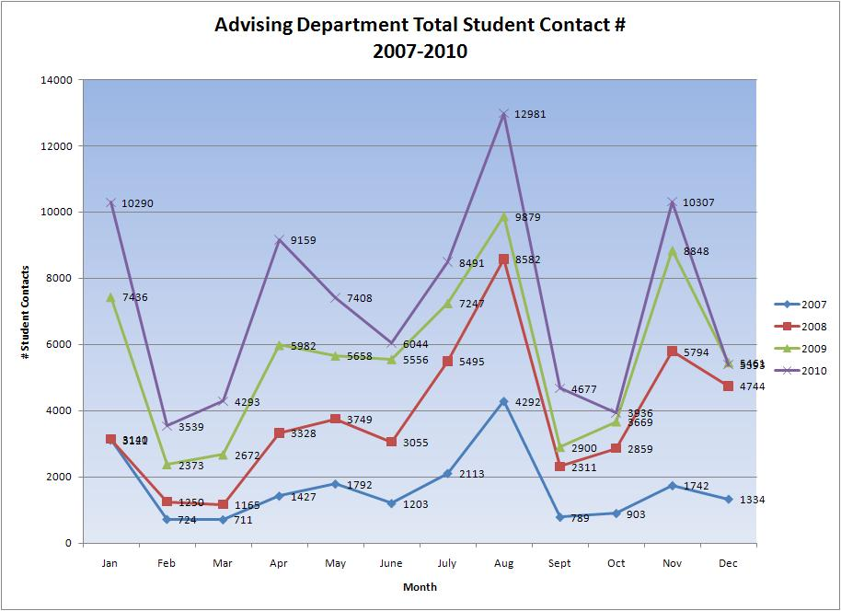  
  
This chart shows the total number of students served in the Advising Department from 2007-2010. Workload for the Advising Department has increased dramatically over the past five years. This is documented in the monthly progress report for the Advising Department sent to Robert Austin, Vice-President of Student Affairs on a monthly basis. Examples of those monthly progress reports are listed below:  
  
[Advising Department Monthly Progress Report for December 2010 & January 2011](http://cis7.actx.edu/ACLibrary/student_affairs/Advising/Report%20for%20Advising.docx)  
  
[Advising Department Data for December 2010 & January 2011](http://cis7.actx.edu/ACLibrary/student_affairs/Advising/Contact%20Numbers%20December%202010%20&%20January%202011.xlsx)  
  
The Advising Department serves thousands of students yearly. The graph below is the Advising Department Load by Division/Advisor:  
  
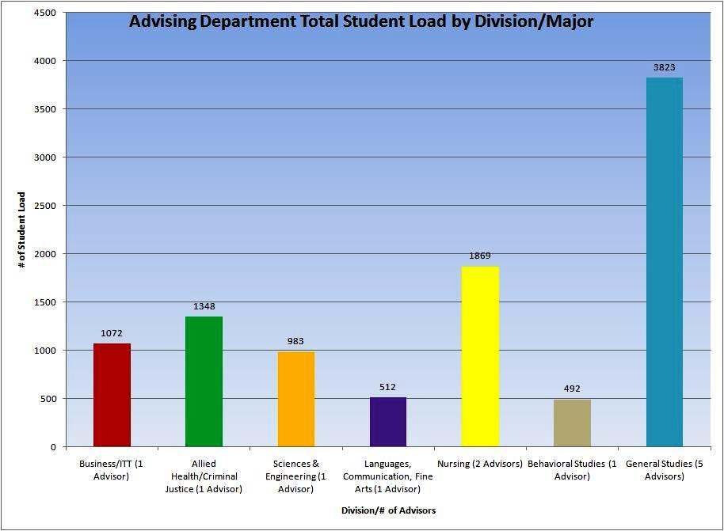

1. What changes have been made in the services of the office/department because of the analysis of these results?

* Based on the above data, the Advising Department has made numerous decisions based on services offered. One example of such changes in services occurred in the 2010-2011 school year. Debby Carey was moved to 1/2 time General Studies advisor & 1/2 time Nursing Division Academic Advisor to assist with large number of advisees in those areas. Also, Ann Britt was moved to Business & ITT Division Academic Advisor to coordinate with the aligning of Career Clusters and the appointment of a new Dean of Career & Technical Program that is over Business & ITT.

F.) Provide the five-year graph(s) indicating the demand for the office's/department's services.

1. Assess the need for the office/department

The Advising Department of Amarillo College is the institution's centralized, front-line department for provision of information and assistance to students, prospective students, and community members. The primary operations are academic advising, career advising, employment services, transfer services, Adults Students Program, Student Success Programs, and instruction/information sharing. The result is access to higher education, in order to meet the individual needs of our students and community; thus, meeting the college's mission. The above graph shows the large number of students serviced by the Advising Department.

**III. Resources**

A. Library

1.) Which of the following library collections/resources/services have been used by the staff and/or students within the past five years? (Select all that apply)  
  
Classroom instuction  
Electronic journals  
Meeting services  
Personalized instruction  
Seminars/conferences  
Video conferencing  
Other:

* Lending Library for Adult Students Program

2.) Which 2 or 3 collections/resources/services should be improved to support Amarillo College's mission regarding teaching and service?

* Larger and more updated meeting spaces.
* Sticky space for students.
* Computer kiosks for students on 1st floor.
* Extended hours
* Transition Librarians from Faculty status to Classified status, like the Advising Department has for Academic Advisors.

3.) Does your office/department have an external approver (other than the Texas Higher Education Coordinating Board)?

No

B. Technology and Security/Privacy

1.) After assessing the strengths and weaknesses of the office's/department's access to technology, what improvements would ensure that the students have access and training in the use of technology?

* Better access to quality wireless service for students.
* Assistance with collecting, organizing, and analyzing data. Student Affairs needs a Divisional Technology Specialist/Programmer for this purpose.
* Computer kiosks all over campus.

2.) What improvements would ensure that students use technology?

* ITS support for implementation of the e-Advising module.
* Need for more computer kiosks for students to use for registration via WebAdvisor.
* User friendly website, WebAdvisor, email system, and portal for students.

3.) Review office/department operations. Does any operation present the possibility for violations of security, confidentiality, or integrity of student records?

No

C. Support Services for Students

1.) Which support services need to be strengthened to better serve the students in or served by this office/department? Explain what aspects of the services need to be strengthened.

2.) Describe any indicators or problems that prevent a healthy, safe and secure environment for staff and students of this office/department.

3.) Describe any indicators or problems that hamper adequate physical facilities, both on and off campus, to meet the needs of the office/department.

**IV. Budget**

A.) Which office/department outcomes have resulted in budget requests to date?

* In 2007, funds were allocated to add another advisor for Languages, Communication, and Fine Arts. Prior, the Business & LCFA divisions had one advisor.
* Increased student enrollment has resulted in the increase in Non-Appointed budget funds to hire part-time advisors in peak periods.
* Student Affairs Division has also increased Student Help budget funds to provide more assistance in serving students. We have hired a peer advisor to assist students with registering for courses via WebAdvisor.

B.) Project the office's/department's strategic initiatives for the next five years based on the office's/department's outcomes.

* Academic Advising quality improvement through training, professional development, and department directives; thus, resulting in increased retention and completion rates.
* Increase number of academic advisors as enrollment increases.
* Enhanced ACE student support.
* Increase New Student Orientation options and enhancing the entire program.
* Increase institutional transfer partnerships through Transfer Services; increase focus on Transfer Services for students.
* Enhance and expand the scope of Career & Employment Services.
* Increase scope of outreach and scholarship funding for the Adult Students Program.
* Implementation and college-wide use of an Early Alert module in Colleague.
* Complete implementation and college-wide use of the e-Advising module in Colleague.

**V. Publications**

A.) If the office/department publishes any advertising or recruitment documents (electronic or paper), do the documents accurately represent Amarillo college and the program/department?

Yes

B.) Does the office/department publish any documents (electronic or paper) with references to SACS accreditation?

Yes

1. Are the references in compliance with SACS approved statement?

Yes

**VI. Other**

A.) State any additional comments/concerns which may impact this office/department during the next five years.

* Increased enrollment in the future will make the hiring of additional advisors essential to student success. Ideally, advising is first a means of exploring careers and majors and then a method for selecting courses and arranging schedules. As partners in the process, students can learn to discover options, frame questions, gather information, and make decisions, which can increase their involvement in college and encourage them to persist to graduation.
* Divisional student loads are also disproportionate from division to division. In the future, advising loads may need to be adjusted by program to balance advisor/student load.
* Technology resources are going to be crucial to enhance Advising Department services for students and advisors.