|  |  |
| --- | --- |
| [Home](http://www.actx.edu/iea/index.php?module=article&id=44) [Back To Forms List Page](https://iresearch.actx.edu/iea/noninstructional.aspx?mode=1) | |
| https://iresearch.actx.edu/iea/images/AC2_transparent.gif | Program Review |
| Form for Completion of Self Study |
| Non-Instructional |

The ID number for this form is 190. You will need this number to update or edit your submission in the future.

Name of Division: Enrollment Management

Name of Department: Customer Services

Name of Program: Customer Services

This Program Review is being conducted during year: 2010-2011

**I. Office's/Department's Purpose**

A.) State the purpose of the office/department. How is this purpose within the mission of Amarillo College?

The Customer Service Department serves students, prospective students and the community by providing service to Amarillo College customers in the way the customer prefers (in person, by phone, email, web and/or chat) with Assistance Centers located on three campuses, a call center (AskAC), extended hours and maintaining new technologies. The purpose statements for each area are:

**Assistance Centers:** The Assistance Center exists to maximize student access to educational services through extended hours and providing combined services in one location at each campus.

**AskAC:** AskAC exists to provide access to Amarillo College services "anytime, anywhere" by phone, email, chat or web and other media to both internal (employees) and external customers (on campus and off campus students).

The Customer Service department exists entirely to fulfill the requirements of the mission statement by providing access to information and services through multiple media, extended hours and services that incorporate all areas of the college. The Customer Services department enriches the lives of our students and our community by providing consistent and accurate information through the use the most current technology and web services available. A friendly face with a caring "can do" attitude encourages a prospect to become an applicant, an applicant to become a student and a student to become a graduate which is the goal and will result in the student's life and the community being enriched.

B.) When was the last time the office's/department's purpose statement was reviewed/revised by faculty and staff in the office/department?

The Amarillo College Mission Statement and the purpose statements for both areas in the Customer Service department are reviewed with each employee during their evaluation. The department purpose statement is typically reviewed and revised when there is a significant change in the department or division by the Director of Customer Services. The last major change was September 2005 when AskAC was combined with the Assistance Center and the Customer Service department was created. The purpose statements have remained different for each area for the last five years. Due to an internal reorganization this year (2010) having one supervisor manage both AskAC and the Assistance Centers, a new purpose statement for the department has been written to be effective January 2011.

[**Customer Services Purpose Statement**:](http://www.actx.edu/contact/index.php?module=article&id=11)

The Customer Service Department exists to maximize customer access to all college services.

C.) Is this office/discipline required to receive approval from an external agency or organization in order to offer courses?

no

**II. Office's/Department's Improvements based on Planning, Evaluation and Assessment**

A.) Identify at least on example of an improvement/revision which resulted from the past five-years annual PET forms.

**2006-2007 Pet Goal Statement**: Improve availability of student support services to meet Strategic Plan Goal 1: Develop responsive new programs and training to meet documented community needs with Strategy 1.1.3 to expand access to Amarillo College courses and offerings by providing" anytime, anywhere" student service. <http://www.actx.edu/strategic/files/filecabinet/folder2/Strategic_Plan_Revision_07_Final.pdf>

* Testing (July 2007) and Financial Aid (March 2008) support services were added to the department responsibilities resulting in an increase of services available in AskAC to the customer that previously was provided by these departments.
* Housing (December 2007) support services added to AskAC responsibilities after training for receipting rent payments. Housing tenants are able and encouraged to call AskAC and pay their rent by phone with a credit card.

B.) Identify at least one example of improvements/revisions which resulted from the last Program Review.

* AskAC exists as a result of a recommendtaion identified in the last Program Review.

**From 2005-2010, the AskAC department has added the following services:**

* + September 2005: AskAC went live with all calls to the switchboard (5000) and START Center (5175) directed to AskAC, all START Center emails responded to by AskAC and all information requests from the recruiters mailed to prospective students by AskAC
  + December 2005: Began receipting payments and removing holds for financial obligations for the Business Office
  + January 2006: Began entering academic admission applications for the Registrar's Office
  + March 2006: Began receiving all calls directed to the Registrar's Office main number (5030)
  + June 2006: Assumed the duties of the Distance Education Help Desk (5116)
  + March 2007: Extended hours of operation from 59 to 72 hours per week (22% increase in service availability)
  + March 2007: The Washington Street Assistance Center counter was remodeled with fewer work stations due to the decline in contacts. The new counter created a more efficient work environment for the staff and easier access for the customer.
  + May 2007: Chat feature added to the phone system software after investigating potential use through an open source software solution (Crafty Syntax).
  + July 2007: Began scheduling ACCUPLACER tests for the Testing Department
  + December 2007: Began receipting rent payments for the Housing Department
  + March 2008: After training, Financial Aid main numbers (5310& 5316) transferred to AskAC
  + January 2009: Process all online admission applications, dual credit applications and web address changes
  + December 2010: Process CE demographic information captured from Web registrations

C.) Identify at least one example of an improvement/revision that is a response to accomplish a strategy or tactical objective within the Strategic Plan 2010-2015.

In response to Strategy 1.1.3 to expand access to Amarillo College courses and offerings by providing" anytime, anywhere" student service. <http://www.actx.edu/strategic/files/filecabinet/folder2/Strategic_Plan_Revision_07_Final.pdf>:

* In September 2005 the call center was established to fulfill the goal of providing anytime, anywhere student service in the 2005-2010 Strategic Plan where all calls to the college go through one central point.
* The call center software purchased provides an accurate measure of the number of calls received, when they are received, lengh of time of each call, wait time and a general description of what the call is about through the use of wrap up codes. During busy times, callers can also leave a callback and not lose their place in the queue.
* The chat software was added in May 2007 providing another option of anytime, any where student service. Access to initiate a chat is available on most Amarillo College web pages. If it is after hours there is an option to leave a message that will be answered as soon as AskAC reopens.
* A knowledgebase for frequently asked questions (FAQ's) was purchased in 2007 to provide accurate and consistent information 24/7 for a self service solution. There is also an option to create a ticket and receive a response to an inquiry within 1 business day. Automated responses are triggered depending on the nature of the inquiry. All tickets are acknowledged with an auto response that thanks them for contacting Amarillo College.

D.) Provide names and titles of those who determined the assessment process used to evaluate the office/department.

Dale Longbine, Director of Customer Services  
Robert Austin, Vice President of Student Affairs

E.) For client/student outcome assessments, review the five-year graph(s) *quantitative* results or provide a brief narrative summary of *qualitative* results.

Statistics for both the Assistance Centers (walk in service) and AskAC (call center) are evaluated monthly. In the past five years the Assistance Center contacts have declined or remained about he same while AskAC contacts have significantly increased ([in person compared to call in contacts](http://s3.parature.com/FileManagement/Download/74a5a4a9606e41bda080450770855c8d)) resulting in a shift in how we provide service to our customer. During the busiest months of January and August, more students are taking advantage of the self-service options for applying for admission, registering and receiving information without coming on campus. The following is a comparison of the WSC Assistance Center contacts in 2005 and 2010.

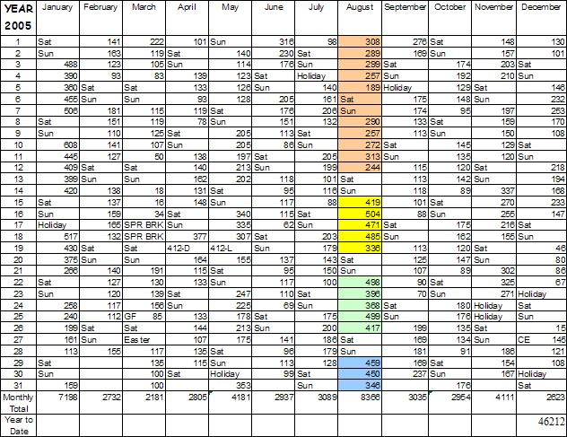

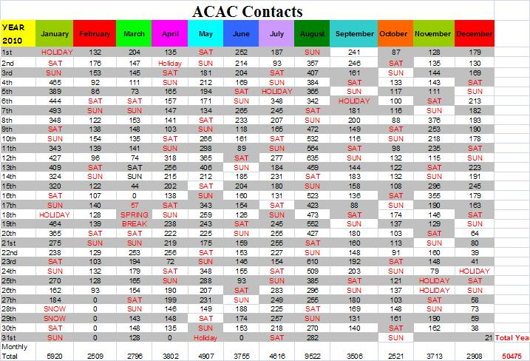

1. What changes have been made in the services of the office/department because of the analysis of these results?

Personnel and duties have been reassigned and operating hours changed for all Assistance Centers and AskAC.

1. The East Campus Assistance Center part time employee was transferred to AskAC and East Campus started closing for lunch.
2. A West Campus full time employee was transferred to the Washington Street Campus and replaced by a part time employee to cover lunches.
3. The West Campus operational hours and daily contacts were evaluated and changed from 9-6 to 8-5 to match the hours of the advisor and other campus departments.
4. The Washington Street Assistance Center Original Hours: 7:30-7:30 (Monday - Friday) & 8:00-12:00 (Saturday). After analyzing the contacts by hour, the following changes were made:
   * + First Change: 7:30-7:30 (Monday - Thursday), 7:30-6:00 (Friday) & 8:00-12:00 (Saturday)
     + Second Change: 7:30-7:30 (Monday - Thursday) & 7:30-6:00 (Friday)
     + Third Change: 7:00-7:00 (Monday - Thursday) & 7:30-6:00 (Friday)
     + Fourth Change: 7:00-7:00 (Monday - Thursday) & 7:30-5:00 (Friday)
5. AskAC increased service hours from 9-6 on Monday - Friday and 8-5 on Friday to 7-7 then 7-9 on Monday-Thursday, 8-5 on Friday and 10-3 on Saturday.
6. New technologies added are:
   * [Phone system](http://s3.parature.com/FileManagement/Download/04827785e0254b76ac0d991f0225a3e0)
   * [Knowledgebase](http://s3.parature.com/ics/support/default.asp?deptID=5592)
   * [Email to Ticket](http://www.actx.edu/contact/index.php?module=phatform&PHAT_MAN_OP=view&PHPWS_MAN_ITEMS%5b%5d=9)
   * [Web Chat](http://acweb1.actx.edu:8080/contactus/request_chat_form.jsp)

F.) Provide the five-year graph(s) indicating the demand for the office's/department's services.

1. Assess the need for the office/department

The Customer Service department exists to fulfill the Amarillo College goal of providing anytime, anywhere student service. The department is open at times when the rest of the college is not. The statitistics that are kept monthly for all areas of the department indicate that there are significant customer requests for service by all methods offered and this department fulfills a critical customer service need. The Assistance Centers and AskAC manages the in person service, self-service (knowledgebase and emails), chat and calls requesting help with self service options. Without this department, the demand would be distributed to other departments and reduce their ability to fulfill their services for students (i.e. financial aid awarding, testing, record management, billing, etc.).

**Annual stats for the Customer Services Deparment include the following**:

* [Calls](http://s3.parature.com/FileManagement/Download/34d5c69db79143838a09f0a8cce11a4a)

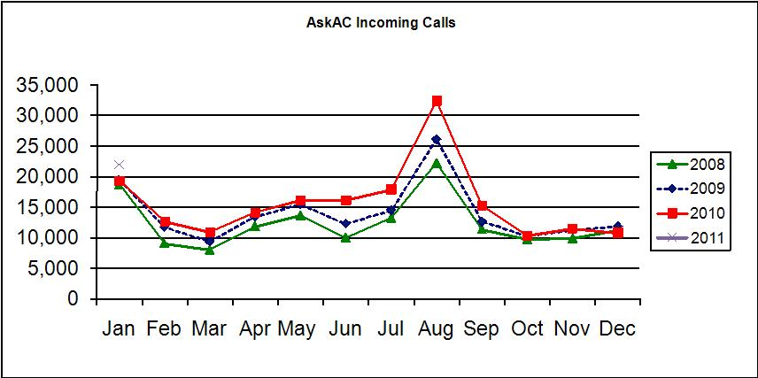

* [Chats](http://s3.parature.com/FileManagement/Download/22ff8511be7f49b2ac926322411d77b1)

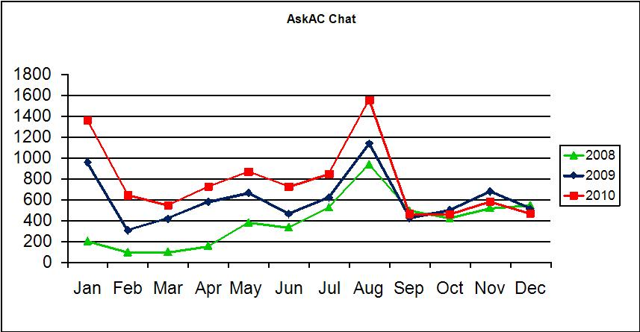

* [Email/Tickets 2009/2010](http://s3.parature.com/FileManagement/Download/749db88532d64d6dabcb0b42dccb394c)

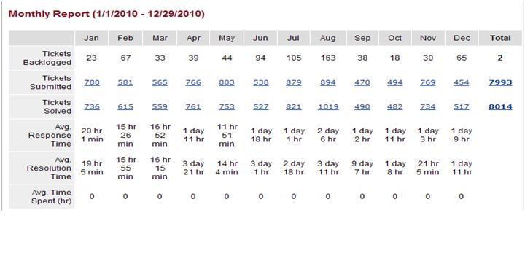

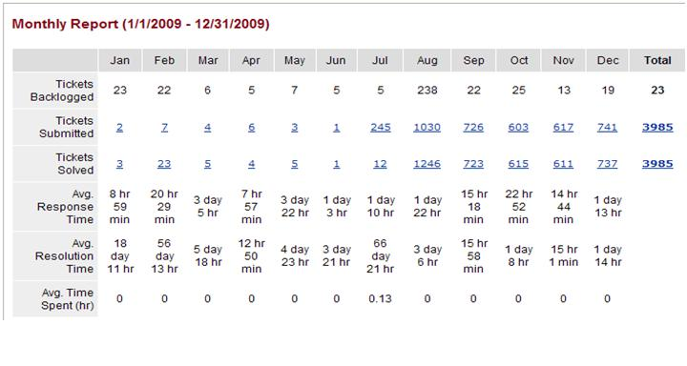

* FAQ's (Knowledgebase)

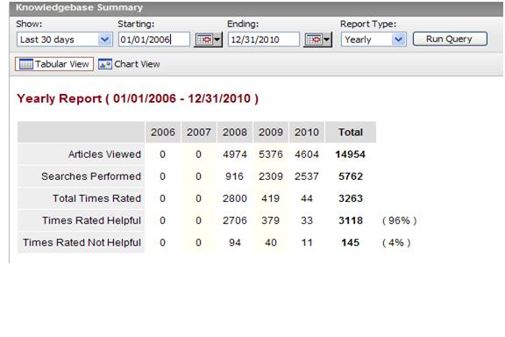

* [Various Services](http://s3.parature.com/FileManagement/Download/307a2b6f17c0457aaf8011e5f881f5b5)
  + Payments
  + Mailing prospective student packet of information (batch)
  + AskAC: Processing all online admission applications
  + Assistance Centers: Processing all applications in person, mailed or by faxed

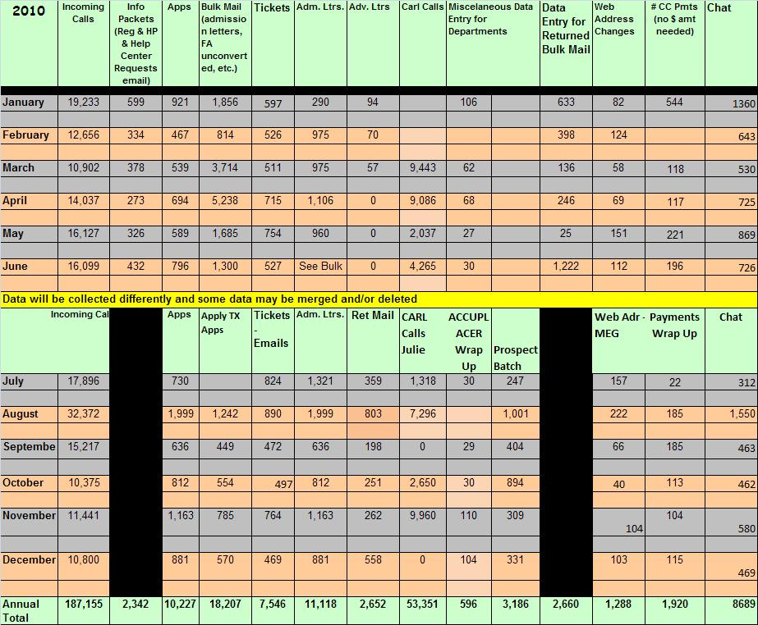

* [Walk in student service during extended hours](http://www.actx.edu/contact/index.php?module=article&id=38)
  + WSC Assistance Center - 7am-7pm (Monday - Thursday) & 7am-5pm (Friday)

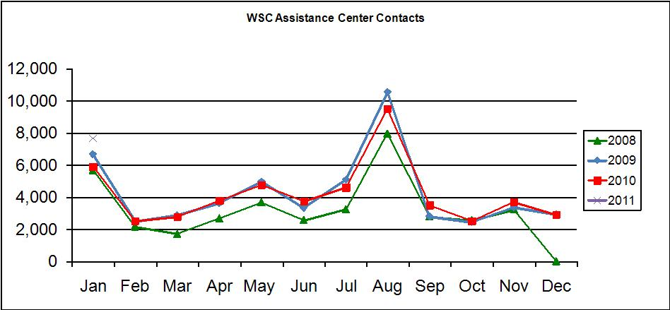

* + West Campus Assistance Center - 8am-5pm (Monday - Friday)

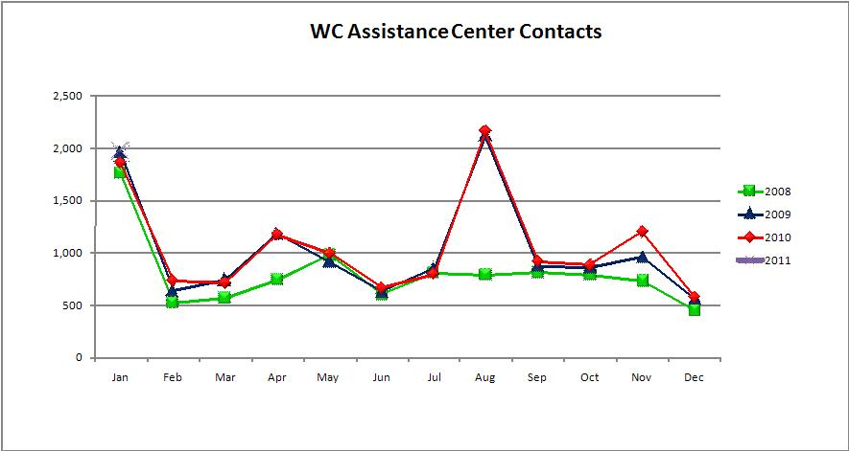

* + East Campus Assistance Center - 9am-6pm (Monday - Thursday) & 8am-5pm (Friday)

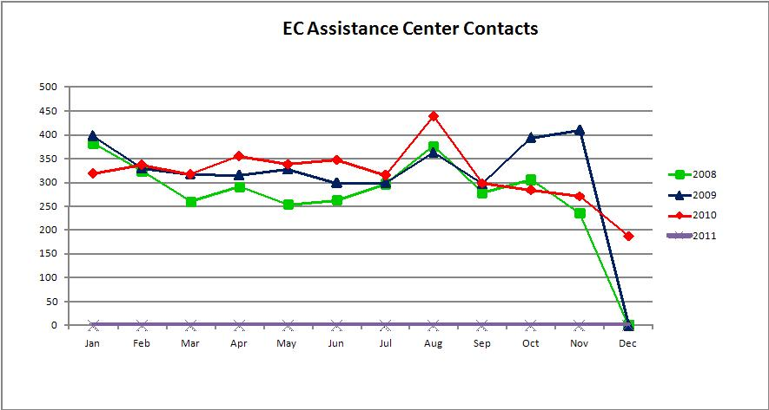

**III. Resources**

A. Library

1.) Which of the following library collections/resources/services have been used by the staff and/or students within the past five years? (Select all that apply)  
  
Meeting services  
Seminars/conferences  
Video conferencing

2.) Which 2 or 3 collections/resources/services should be improved to support Amarillo College's mission regarding teaching and service?

Since there is a shift to customer self service and the use of technology, additional self service options in all areas of the college would be an improvement.

* Providing ATM type kiosks located in convenient and accessible areas throughout the college that would allow printing schedules, checking financial aid status, taking payments etc. would be very useful and could even result in a reduction in staff needed in the department.

3.) Does your office/department have an external approver (other than the Texas Higher Education Coordinating Board)?

No

B. Technology and Security/Privacy

1.) After assessing the strengths and weaknesses of the office's/department's access to technology, what improvements would ensure that the students have access and training in the use of technology?

AskAC is a resource for students when they do not understand how to use technology. The Specialist walk the students through the steps to access WebAdvisor, AC Online and where to access web information through the knowledgebase. CTL has recently set up a helpdesk for referrals when students need additional help with online classes. There are also tutotorials on the web to help with accessing login/password information.

Improvements that would ensure that the students have access and training in the use of technology include:

* Instructor and staff awareness of training that is already available and sharing the knowledge with students
* Instructor and staff training in the use of technology
* AC investing in new technologies that students are familiar with and currently using

2.) What improvements would ensure that students use technology?

To ensure that students use technology, it must be required. For example, submitting financial aid and admission application is now primarily done online rather than on paper. This has been accomplished by limiting access to printed applications. Printed applications are still accepted but more students are using the technology because it is the only option readily available.

3.) Review office/department operations. Does any operation present the possibility for violations of security, confidentiality, or integrity of student records?

No

C. Support Services for Students

1.) Which support services need to be strengthened to better serve the students in or served by this office/department? Explain what aspects of the services need to be strengthened.

Offering combined services in one department for the entire college requires constant training and sharing of information to ensure accuracy and consistency of infomation and knowledge of services provided by all areas of the college. The challenge for training is with extended hours and different shifts on three campuses while covering the counters and phones. We have implemented mandatory staff training with presentations from all areas of the college to address this need although it requires presenters to present twice so all staff can receive the same information. An online training class is in development to use the LMS technology for training new employees. A similar course will be developed to strengthen the training of all others. The knowledgebase is used by the Customer Service staff but not widely used by other employees either because they don't know how to use it or don't know it exists. Training for all employees in the use of the knowledgebase would be an improvement.

2.) Describe any indicators or problems that prevent a healthy, safe and secure environment for staff and students of this office/department.

The Assistance Centers are vulnerable to security and safety issues due to the extended hours. Currently the only measures to provide a safe environment for employees are Campus Police walk throughs and a coded message to Campus Police (Mr. Black) if help is needed.

The East Campus Assistance Center is open 9-6 and has one person working the counter who is usually there by herself from 5:00-6:00pm with a significant amount of money. The counter is in an open area with no where for her to count daily cash and balance without being in the open. There is a customer need for the hours of operation to remain the same for rent payments after 5pm.

3.) Describe any indicators or problems that hamper adequate physical facilities, both on and off campus, to meet the needs of the office/department.

AskAC has twelve employees assigned to work in an area much smaller than other departments with a similar number of employees. The Customer Service department is split on three campuses in four locations and presents problems of using staff efficiently. Suggestions:

* Move AskAC closer to the Washington Street Assistance Center to provide better opportunities for cross training, scheduling and fulfilling department needs
* Investing in technology that would permit home-based agents that could provide services without needing physical space at the college.

**IV. Budget**

A.) Which office/department outcomes have resulted in budget requests to date?

The phone and chat system (Zeacom), knowledgebase and email/ticket software (Parature) and implementations were purchased with Title V grant money but the annual maintenance agreements have resulted in annual budget requests.

B.) Project the office's/department's strategic initiatives for the next five years based on the office's/department's outcomes.

Strategic initiatives for the next five years include:

* Kiosks to be located in Assistance Center lobbies
* Home based agents
* Increase percentage of applications for admission submitted online
* Complete the import to Colleague process of the application for admission
* Web based training
* Communication plan for retaining/graduating students
* Move AskAC closer to the WSC Assistance Center for more efficient workflow

**V. Publications**

A.) If the office/department publishes any advertising or recruitment documents (electronic or paper), do the documents accurately represent Amarillo college and the program/department?

Yes

B.) Does the office/department publish any documents (electronic or paper) with references to SACS accreditation?

**VI. Other**

A.) State any additional comments/concerns which may impact this office/department during the next five years.

The continuous enrollment growth will require additional support staff.