|  |  |
| --- | --- |
| [Home](http://www.actx.edu/iea/index.php?module=article&id=44) [Back To Forms List Page](https://iresearch.actx.edu/iea/noninstructional.aspx?mode=1) | |
| https://iresearch.actx.edu/iea/images/AC2_transparent.gif | Program Review |
| Form for Completion of Self Study |
| Non-Instructional |

The ID number for this form is 187. You will need this number to update or edit your submission in the future.

Name of Division: Enrollment Management

Name of Department: Disability Services

Name of Program: Disability Services

This Program Review is being conducted during year: 2010-2011

**I. Office's/Department's Purpose**

A.) State the purpose of the office/department. How is this purpose within the mission of Amarillo College?

The purpose of the Disability Services Department is to minimize the physical and academic barriers to students with disabilities by coordinating and providing appropriate and reasonable accommodations.

The A C mission statement is to *enrich the lives of students in our community*. The purpose of Disability Services is directly in line with this mission through fostering diversity in the AC student population and enhancing success by the provision of services. Our goal is to assist students in receiving the accommodations, training, education, and support needed to achieve their educational and life-long goals.

Reasonable accommodations include: sign language interpreters, note taking assistance, reader services, specialized chairs and tables, recorded texts, specialized computer access, specialized testing assistance, other specialized equipment, and other individual needs for certain students and circumstances. The program also evaluates student potential, coordinates services between the student and faculty member, provides initial advising services, professional tutoring services, coordinates testing services, provides specialized equipment, faculty training, development of appropriate policies and procedures, maintains budget management, and works with the community to facilitate advocacy and support.

B.) When was the last time the office's/department's purpose statement was reviewed/revised by faculty and staff in the office/department?

The purpose statement is reviewed each year and was most recently reviewed July 2010 when the most recent PET form was developed. Policies and procedures are also reviewed on an annual basis.

C.) Is this office/discipline required to receive approval from an external agency or organization in order to offer courses?

Yes

1. Identify any external approvers for the office/department.

This office is not required to receive approval from an external agency, however the Coordinator of Disability Services is responsible to ensure that the College complies with Section 504 of the Rehabilitation Act of 1973 (Section 504) and Title II of the Americans with Disabilities Act of 1990 (Title II), which prohibit discrimination on the basis of disability. Practically every school district and postsecondary institution in the United States is subject to one or both of these laws, which have similar requirements. For more information please visit the following site: <http://www2.ed.gov/about/offices/list/ocr/index.html>

2. What approval schedule is required by the external approver(s)?

n/a

3. When did the office/department last receive approval?

n/a

**II. Office's/Department's Improvements based on Planning, Evaluation and Assessment**

A.) Identify at least on example of an improvement/revision which resulted from the past five-years annual PET forms.

The Accommodation Form being returned to the department is essential to the provision of this service. Through the years we have developed a spreadsheet to keep track of those returning the plan, called them and sent emails. In the past, the teacher would not get a copy of the plan until the student brought the signed form back to the department. To enable the faster provision of services and noting that the percentage of students bringing back forms is better, but still not 90% we have changed to a new system for the spring 2011 semester. We are now printing copies for the instructor and asking the student to deliver the copy when he has his form signed by the instructor. The student will still need to bring the signed form back to us, but there will be no delay in the accommodation form reaching the instructor.

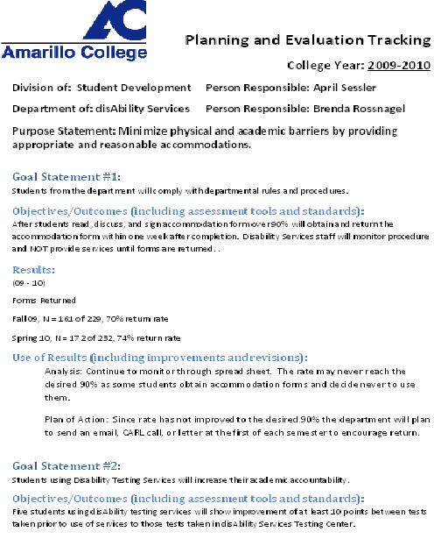

Link: [DisAbility_Services_2009_2010](http://www.actx.edu/archives/filecabinet/1670)

B.) Identify at least one example of improvements/revisions which resulted from the last Program Review.

The last program review was completed in 2003-2004. The Disability Services Department was under the Access Division at the time and called Accessibility Services. The external committee noted this concern.

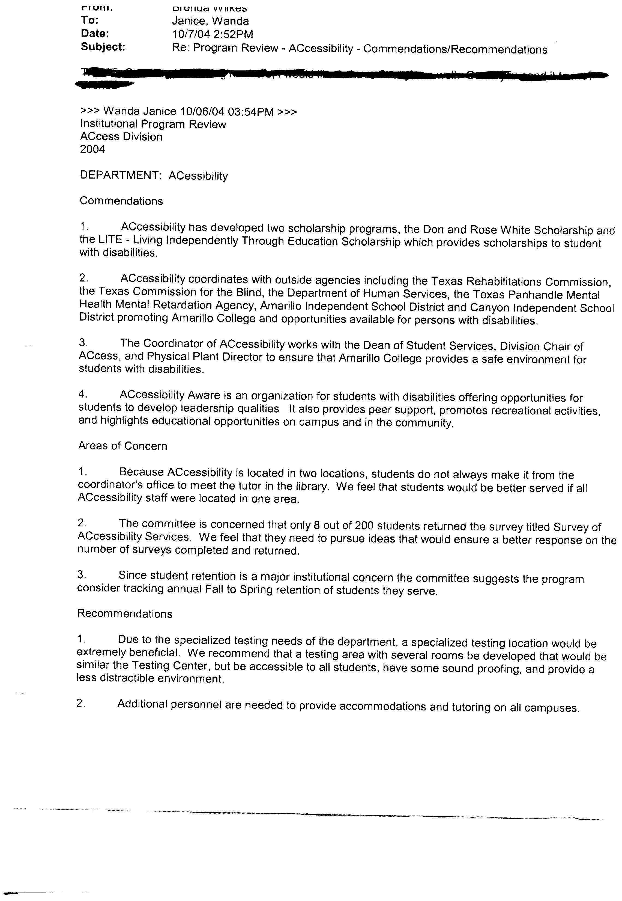

“Because Accessibility is located in two locations, students do not always make it from the coordinator’s office to meet the tutor in the library. We feel that students would be better served if all Accessibility staff were located in one area.” This was accomplished in 2005 when all personnel in this department were housed in the Student Service Center as they are at this time.

The committee also noted under recommendations that: “Due to the specialized testing needs of the department, a specialized testing location would be extremely beneficial. We recommend that a testing area with several rooms be developed that would be similar to the Testing Center, but be accessible to all students, have some sound proofing, and provide a less distractible environment.” This was carried out in 2005 to 2010 by the provision of a testing room in the Disability Services area in the Student Service Center Disabilities Service Area. This room was divided into separate testing areas and monitored with cameras for test security. In summer 2010 this particular plan was changed to allow for budget cuts. Disability Services testing administrator is now a member of the Testing Center staff and all testing is taking place in the Testing Center. The center and Disability Services have worked together to make this the best situation possible. Some improvements are needed to make this an appropriate solution such as; more individual rooms, sound proofing, and individual space.

C.) Identify at least one example of an improvement/revision that is a response to accomplish a strategy or tactical objective within the Strategic Plan 2010-2015.

In the previous Strategic Plan 05-2010, section 2.1states, “Identify and remove institutional barriers to college enrollment”. Through the services provided by this department, students with disabilities are assisted in overcoming barriers to receiving an education. See the numbers of students that have incrementally increased over the past several years.

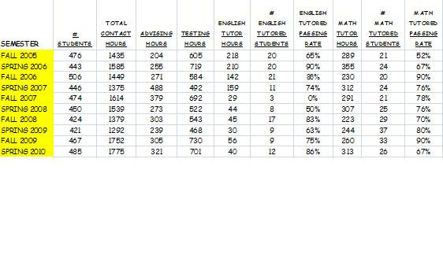

D.) Provide names and titles of those who determined the assessment process used to evaluate the office/department.

Brenda Rossnagel – Coordinator of Disability Services

April Sessler – Associate Vice President of Student Affairs

Robert Austin – Vice President of Student Affairs Division

E.) For client/student outcome assessments, review the five-year graph(s) *quantitative* results or provide a brief narrative summary of *qualitative* results.

Within the past five years we have tracked the pass rate of the math tutoring program. This program continues to grow and serve students effectively.

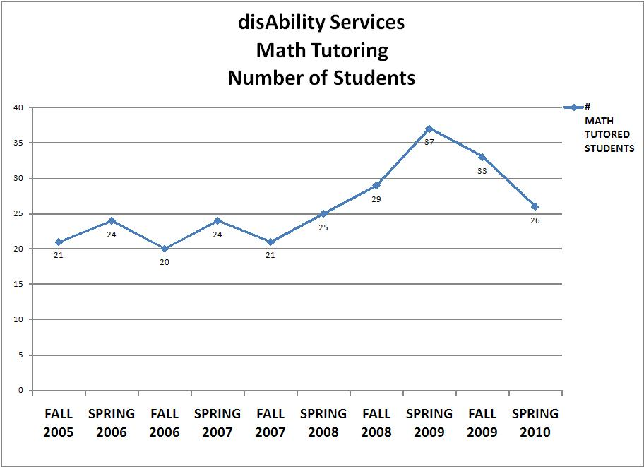

1. What changes have been made in the services of the office/department because of the analysis of these results?

This past year when budget cuts were on the table it was felt that due to the success of the math tutoring pass rates that this program needed to remain if at all possible. This program did remain in this department to meet these special needs

F.) Provide the five-year graph(s) indicating the demand for the office's/department's services.

1. Assess the need for the office/department



Disability Services is needed to ensure access to services and programs at Amarillo College. Note the contact numbers. This also notes the pass rates for math and English/reading tutoring, contact hours, advising hours, and testing hours. Advising includes providing accommodations for students, general advising, and registration assistance.

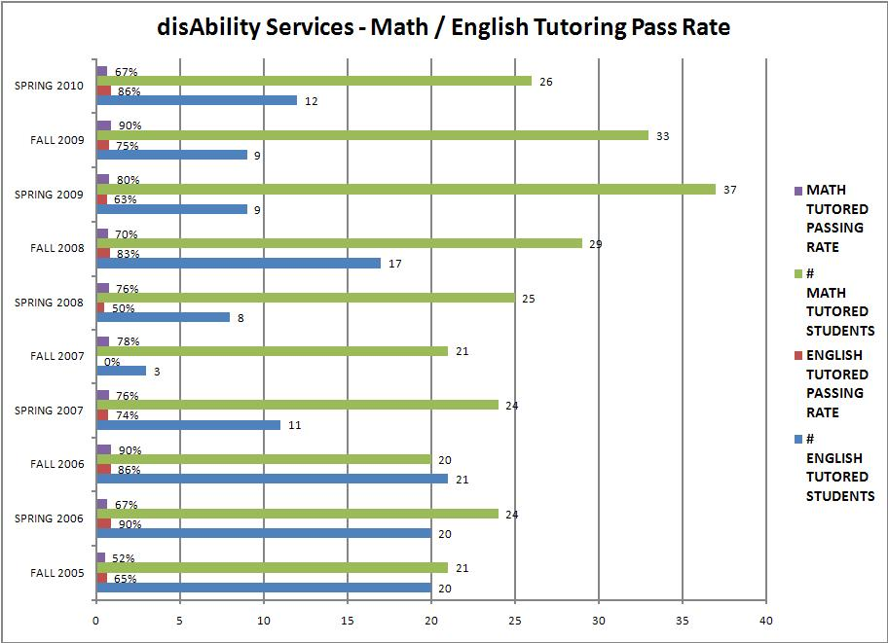

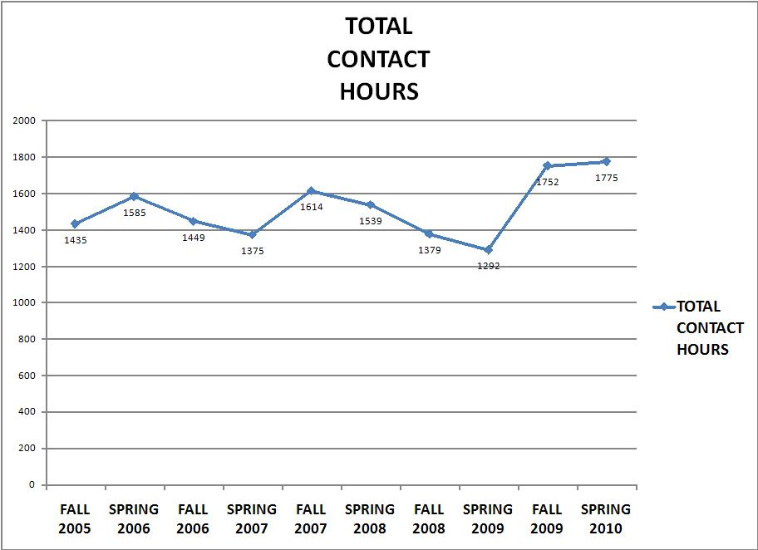

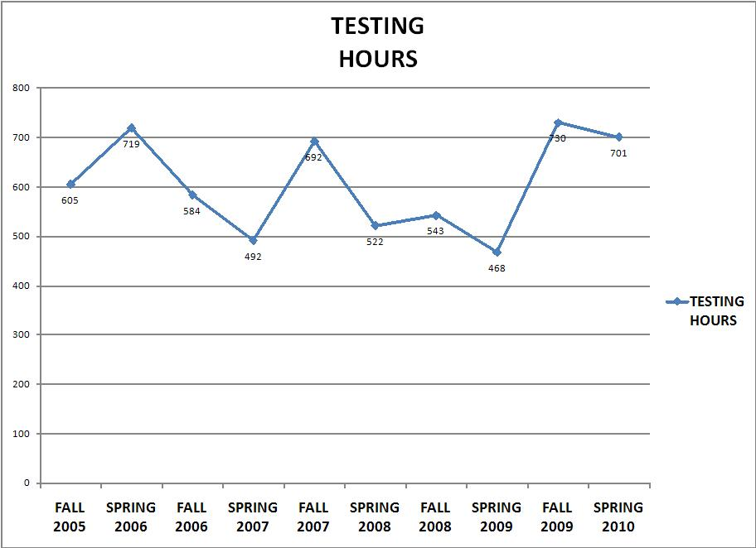

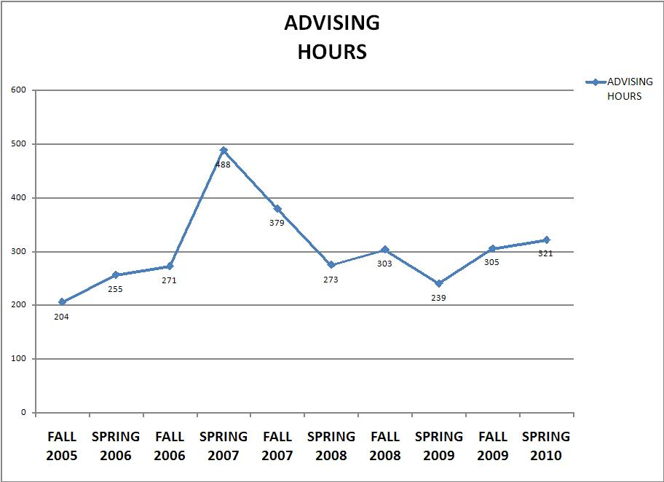

Each semester the department has approximately 500 students on our roster. The numbers noted on the Department ’11 chart are from 12th class day numbers and go up throughout the semester. Therefore, even though these numbers are below 500 the department reaches near or over the 500 mark each semester as students decide they need accommodations. These are students who have self identified to this office that they have a disability which may require specific accommodations. Of these students approximately half of them do register for some type of accommodations each semester.

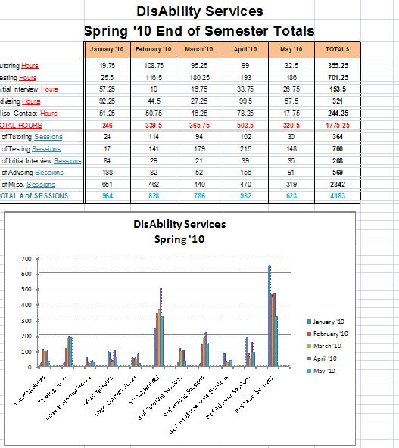

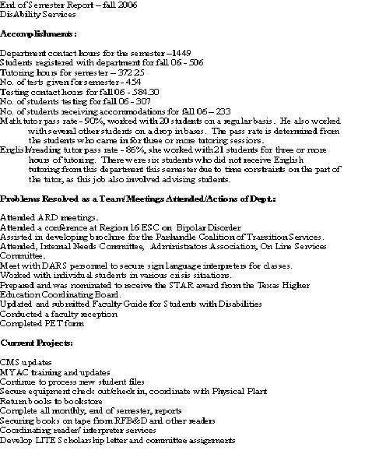

End of semester stats spring 2007

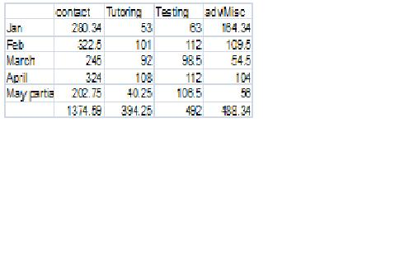

Fall 08 Spring 09 statistics

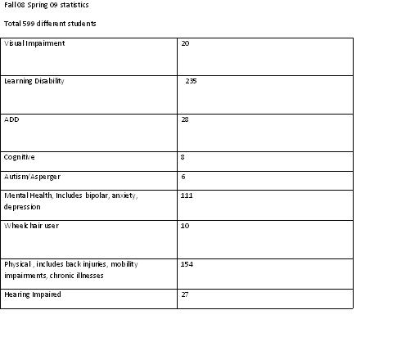

The department is essential in working with students and faculty for the provision of these accommodations and the coordination of services between students and faculty to ensure accommodation needs are met. Diversity on campus is something to be developed and nurtured. Certainly understanding persons, who are different, such as a person with a disability, only enhances the general learning of our students and promotes success in our community.

**III. Resources**

A. Library

1.) Which of the following library collections/resources/services have been used by the staff and/or students within the past five years? (Select all that apply)  
  
Classroom instuction  
Interlibrary loan  
Meeting services

2.) Which 2 or 3 collections/resources/services should be improved to support Amarillo College's mission regarding teaching and service?

While taking some courses I used the resources to access databases. In working with my STSU classes I accessed the training for students on databases, how to use the library, and plagiarism.

2.) Which 2 or 3 collections/resources/services should be improved to support Amarillo College's mission regarding teaching and service?

Access to accessible equipment in all libraries allowing for low vision users. Each library should maintain equipment and staff to manage a low vision unit consisting of computer with specialized software and a CCTV. This allows students with visual impairments to use this equipment when the library is open.

3.) Does your office/department have an external approver (other than the Texas Higher Education Coordinating Board)?

We must comply with the laws mentioned earlier. The Office of Civil Rights oversees the ultimate provision of services as they relate to these laws if a student files a complaint with them. A complaint is filed and may be able to be resolved through documentation maintained in the Disability Services office. A complaint could be broader than one simply regarding provision of a part5icular accommodation and is alleged against the entire institution. An allegation may affect Federal funding of the institution and is not resoled on the basis of the budget of disability services, but on the basis of the entire college budget.

3.) Does your office/department have an external approver (other than the Texas Higher Education Coordinating Board)?

No

B. Technology and Security/Privacy

1.) After assessing the strengths and weaknesses of the office's/department's access to technology, what improvements would ensure that the students have access and training in the use of technology?

The immediate access to computers in or Student Service Center area would allow students the ability to immediately access the computers for registration and possibly financial aid purposes. This access with staff assistance would be very beneficial to students.

As I work with students many are unsure what exactly is involved in an online course and are not sure whether to take a class online or when to refer them to the ELearning center with questions. As these courses become even more popular some additional training for students in what to expect in these classes before enrolling would be helpful.

An IT person to be able to evaluate the software, licensure, and equipment maintenance is needed to provide appropriate services to students using specialized computer software to take exams. Assistance in this area would allow for the best services to students and coordinate and integrate this computer software usage into the AC systems most effectively. It is vital that the specialized software used is compatible with our campus computer system and software.

2.) What improvements would ensure that students use technology?

Access to the technology in the Student Service Center such as several student computers available for student use would assist in technology being more effective. Easier access to student accounts and the wireless system would also be beneficial. A more user friendly web page would be important as well. For student with disabilities having materials offered in alternative formats, for example, not just with Adobe Flash, would allow all students the ability to access documents and publications on the web. It is also essential that the students have the ability to use adaptive technology. To use this student’s need some training occasionally and also staff need training on the technology as well. It would be very beneficial to have an I T person available to investigate technology needs for specialized use and to understand and maintain these products.

In our department we are working toward some automated systems to allow forms to be routed electronically. This would help the distribution of the accommodation forms for students. We did work previously with the I T team and had an electronic form developed. We were subsequently told that this procedure would not do what we wanted, electronic signatures, being a portion of this, and purchasing another program to do this was not approved at this time. Therefore, we are back to a paper format.

3.) Review office/department operations. Does any operation present the possibility for violations of security, confidentiality, or integrity of student records?

Yes

a. What changes need to be made to prevent violations of this nature?

Currently all records are kept in a paper format. School districts are beginning to keep records in an electronic format and if we had a similar system this would facilitate the ease of obtaining these records and facilitate confidentiality of materials.

C. Support Services for Students

1.) Which support services need to be strengthened to better serve the students in or served by this office/department? Explain what aspects of the services need to be strengthened.

Occasionally, we find through a student complaint or our observation that an accommodation need requiring the placement of a table or chair in a classroom may not be met. Items may not have been placed I the classroom before classes started for various reasons, but better communication with the physical plant staff would facilitate providing the proper accommodations in a timely manner. At times there is difficulty coordinating these services when classrooms are not assigned to classes until right before school starts or a class is moved during the first week of class. Currently our office must rely on the student’s schedule for proper placement of items. In order to allow the physical plant personnel time to place items that are requested accommodations in classrooms we provide them this information at least a week or two before classes begin. Better communication between departments would facilitate that the service is provided to the student as requested and required.

Technology support for specialized testing equipment would allow the most up to date services for the students. Assistance in troubleshooting when there is difficulty with the equipment would be very beneficial to our staff, testing personnel staff, and the student.

Continued cooperation with the Testing Center in the development of procedures and policies is essential to providing this as an accommodation. In the summer of 2010 Testing Services became the proctor of exams for most disAbility Services students. Budget cuts required that this staff member previously a part of disAbility Services now become a part of the Testing Center staff. DisAbility Services must be certain the student is provided the accommodation of specialized testing, but the actual testing is generally performed in the Testing Center.

2.) Describe any indicators or problems that prevent a healthy, safe and secure environment for staff and students of this office/department.

In our area we did have cameras in the testing room. This room is not used much for testing now as this task has been generally taken over by the Testing Center and conducted in their area. If this testing room could be used to provide a more quiet and distraction limited environment for students to test it would be very helpful. The cameras are still in the room, but the room is not able to be used as it is very difficult to monitor the cameras according to Testing Center personnel.

3.) Describe any indicators or problems that hamper adequate physical facilities, both on and off campus, to meet the needs of the office/department.

Accessible doors – electronic doors into the Testing Center to allow students with disabilities access to this area.

**IV. Budget**

A.) Which office/department outcomes have resulted in budget requests to date?

Our department kept the math tutor position after evaluating the results of this portion of our services when faced with budget cuts in the summer of 2010. Our department budget has also included a request for additions in the non appointed personnel area. This has been for sign language interpreters. This is due to changes in the management system of the Department of Rehabilitation and Assistive Services and the sharing of expenses for sign language interpreters.

See file: Interpreter Comparison Pay Chart AC DARS 2009 2010.

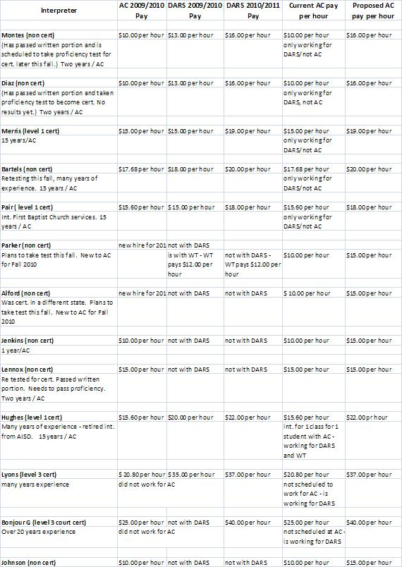

B.) Project the office's/department's strategic initiatives for the next five years based on the office's/department's outcomes.

This department will continue to offer tutoring in mate, Early advising for students in the first semester and/or developmental classes will also continue. We need to do a better job of getting to know our students and the issues related to their disabilities. Students with disabilities are easily discouraged and more consistent communication from our office will improve their chances for graduation. Finally, this office will continue to co-host the LITE (Living Independently through Education) Scholarship Luncheon. Since 2002, this event has awarded more than $130,000 to over 246 students.

**V. Publications**

A.) If the office/department publishes any advertising or recruitment documents (electronic or paper), do the documents accurately represent Amarillo college and the program/department?

Yes

B.) Does the office/department publish any documents (electronic or paper) with references to SACS accreditation?

**VI. Other**

A.) State any additional comments/concerns which may impact this office/department during the next five years.

There is concern over the budget and how this may impact our department. The students we serve are vital to the college and to the community. It is essential to the mission of the college to provide these services. As the staff is charged with more and more duties it becomes more difficult to monitor that all the needs are met appropriately. More collaboration with the physical plant must occur to be certain that new construction not only meets code, but is user friendly. See AHEAD, Association on Higher Education and Disability, website: [www.ahead.org/](http://www.ahead.org/) The entire culture of Amarillo College is enriched by students with disabilities and these students should be encouraged to attend and to persevere to graduation. I am looking forward to the development of curriculum which will encourage short term certificate completion. Short term programs might offer the ability for a student to earn a certificate to fix brakes or transmissions and earn a ‘degree’ in this area. He would therefore be a completer of these courses and be able to enter the job market without having to complete many semesters of college. This would allow some students to develop skills and enter the workforce.