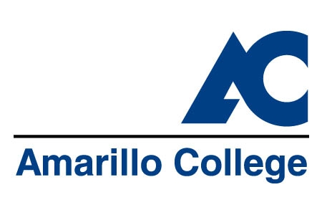
Amarillo College
Principles of Assessment

- The intent of assessment at Amarillo College is to improve “the educational, cultural and community services” as identified in the Amarillo College mission.

- Outcomes assessment focuses on achieving continuous improvement in educational and administrative programs and educational support services rather than identifying these programs’ successes or failures.

- Outcomes assessment of student learning, educational support, and administrative support will be a collaborative process involving faculty, classified staff, administration, and, whenever appropriate, students.

- Outcomes assessment results will not be used for evaluation of faculty, administrative, or classified staff. Results will be used to evaluate and improve the institution.

- Whenever possible, the methodologies for assessing outcomes will be inconspicuous to students or others who are being assessed.

- Whenever possible, submissions used for assessment will come from existing assignments instead of ones specially created for outcomes assessment. What we assess will be what we already do.

- The assessment process itself will be evaluated.

- Amarillo College’s strategic plan includes evaluating student success by establishing and assessing an institutional outcomes assessment program. The President’s Cabinet supports these outcomes assessment efforts.

