**How to Embed Attachments within a Word Document**

**1. Click on Insert Tab**

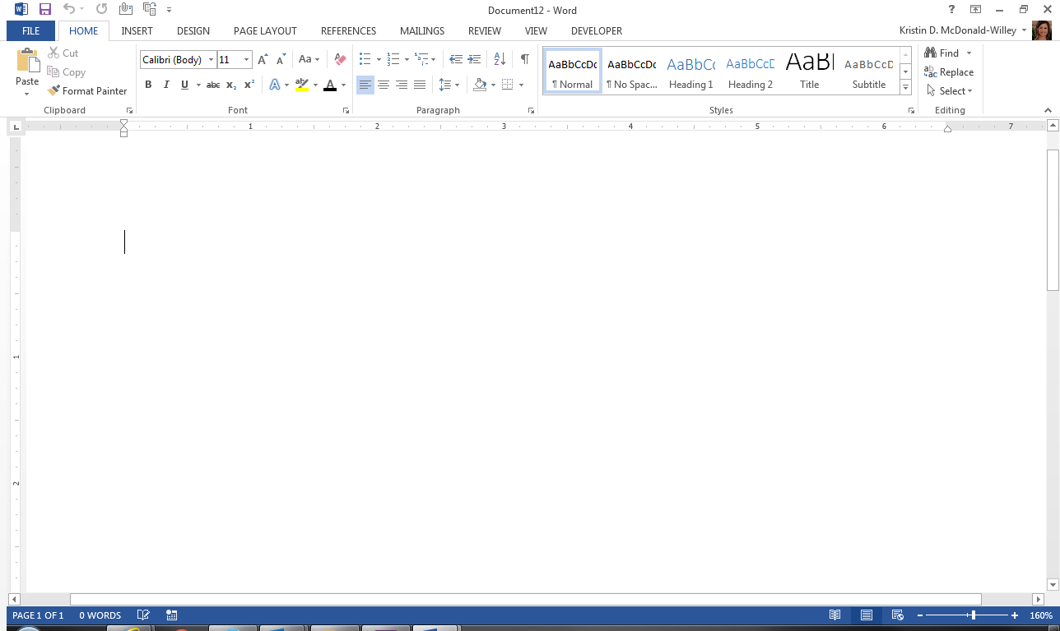

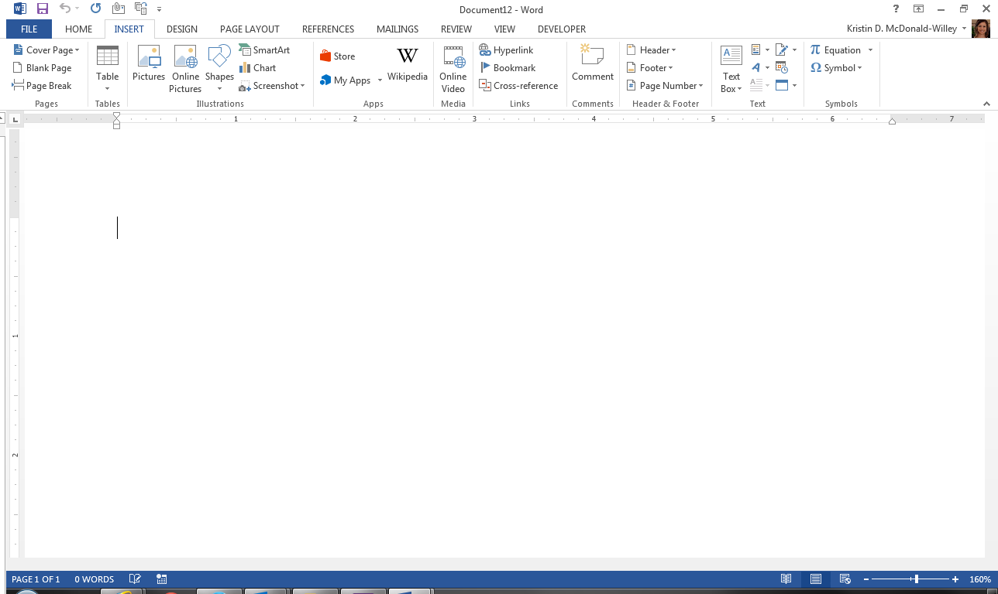**2. Click on drop down arrow in “Object” icon**

**3. Select “Object” from the drop down menu that appears when you select the “Object” icon**

**4. Select “Create from File” tab**

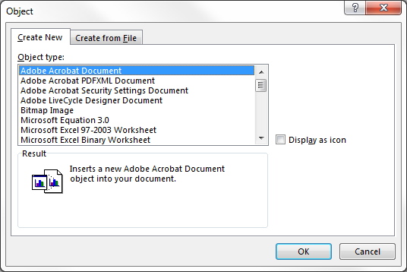

**5. Browse to desired file, select file, and once selected, select “Insert”**

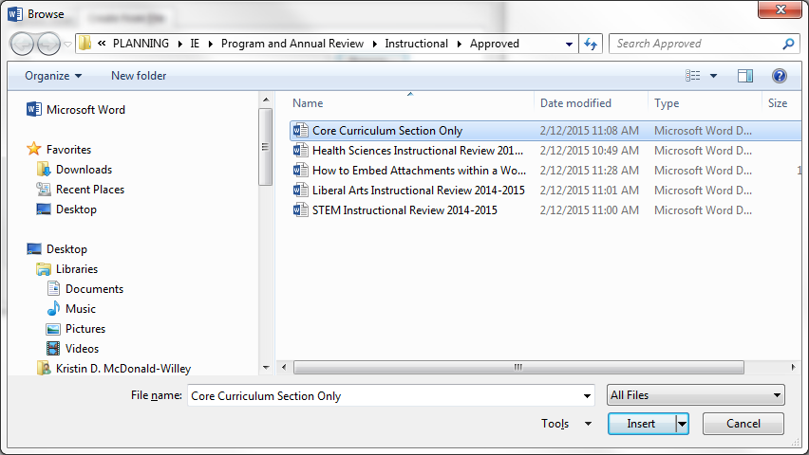

**6. Select Display as Icon Button and then Select “OK”**

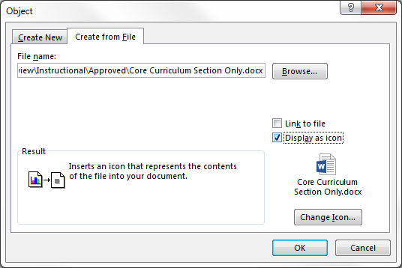

**7. You should now see the object**

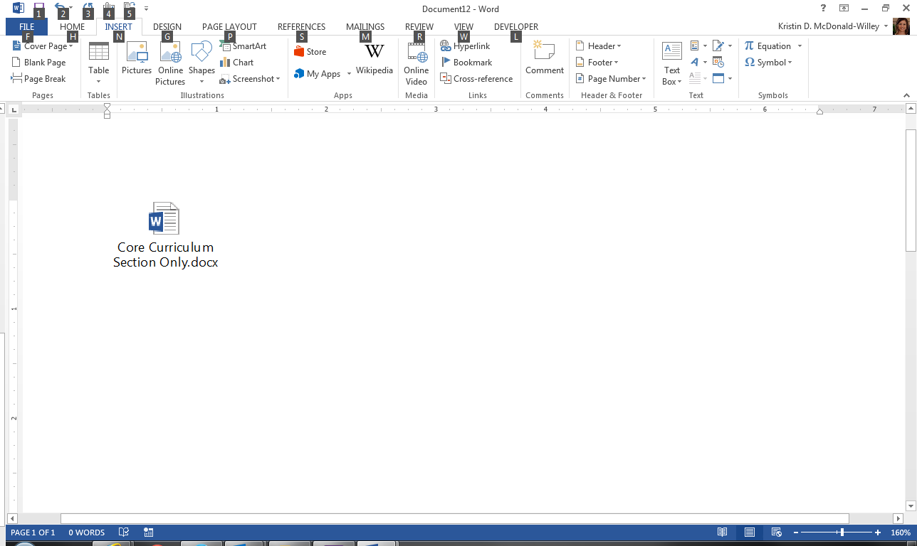

**NOTES: You can continue to use the above 6 steps to embed objects into your document and place them side by side.   
However, if you need to adjust the object:**

* **Adjust the Size of the Icon:** Click on embedded attachment and use sizing arrows to adjust the size.

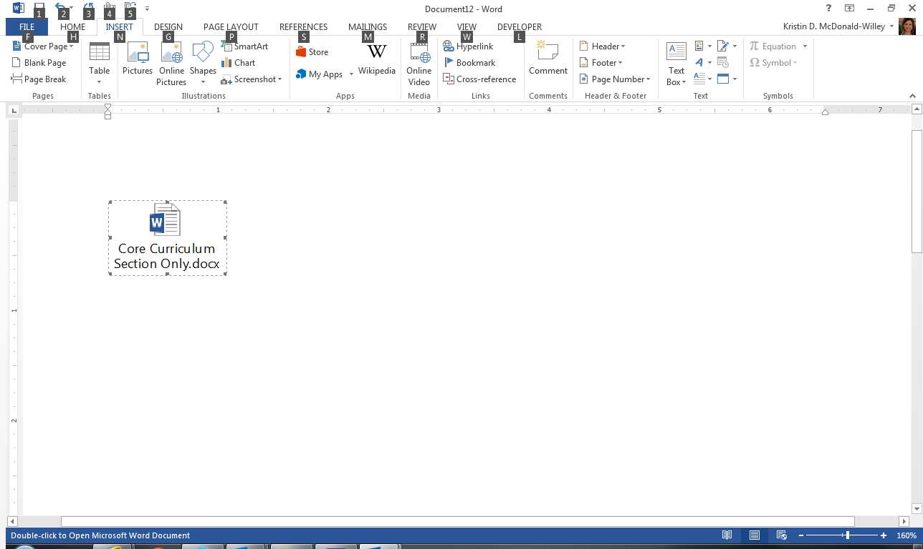

* **Adjust the Location of the Icon:** If you wish to move the icon to specific locations on your page:

**A.** Right click the embedded attachment

**B.** Go to “Format Object” on menu

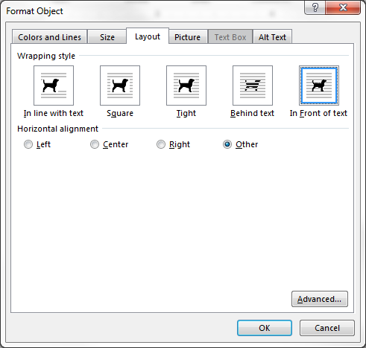**C.** Go to “Layout”, Select “In Front of Text”, and the select “OK”