Change Colleague Password

In Colleague UI 4.5, click on the Options menu and select Change Password:
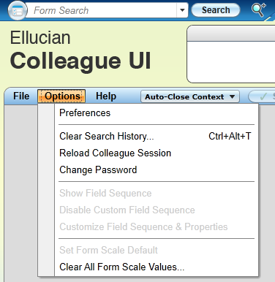
After you click on Change Password, you will get the following screen:
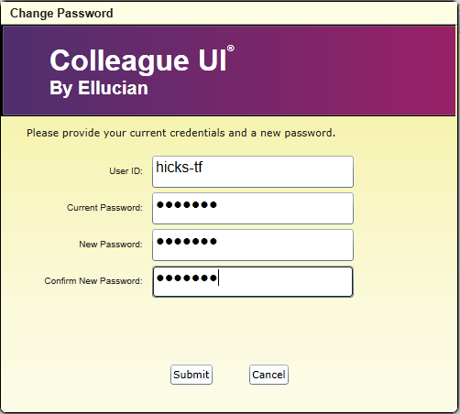
Enter your User ID: and Current Password
Enter a New Password and Confirm New Password and click Submit.
The New Password must be AlphaNumeric and be 7 or 8 in length.
Do not use any special characters eg: !@#$%^&, etc.
You cannot use any of the last three passwords.
The new password must be different from the current password by at least three characters/numbers.

In Colleague UI 5.3+, click on the User Option symbol. You will see the following Menu Options:
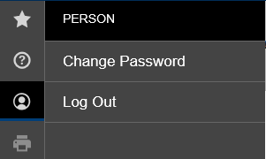
Click on Change Password. The Change Password screen will be blank. Fill in the User ID: and Current Password fields.
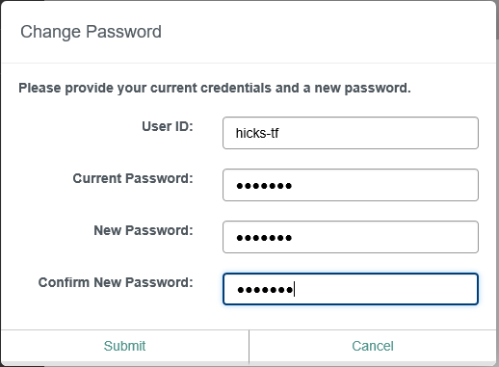
Enter a New Password and Confirm New Password and click Submit.
The New Password must be AlphaNumeric and be 7 or 8 in length.
Do not use any special characters eg: !@#$%^&, etc.
You cannot use any of the last three passwords.
The new password must be different from the current password by at least three characters/numbers.

