Checking Wireless Procedures on LaptopCarts

Check if connected to wireless network

If not you may connect it to the network with hard wire usally blue/black wire.

Check if connected to AC-students/Guests

If not connect to AC-Student/Guest

Password is AmarilloCollege

You should be able to login

Check Installed Updates Using Settings App
Follow the steps below to View Installed updates in Windows 10 using the Settings App.
1. Click on Windows 10 Start button and then click on the Settings icon.
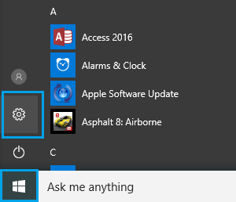
2. On the Settings screen, click on Update & Security icon.
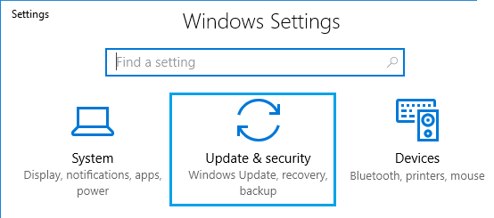
3. On the Update & Security screen, click on Windows Update in the left pane and then click on View Installed update history link in the right pane.
